Larchmont Barracudas Custom Cap Order Form

Name ________________________________________

Address ________________________________________

Phone ________________________________________

Email ________________________________________

NAME ON CAP: _________________________________

Caps are $9 each. Must order a minimum of two (2) caps. Each set of caps will have the same name on it. Total cost for 2 will be $18.
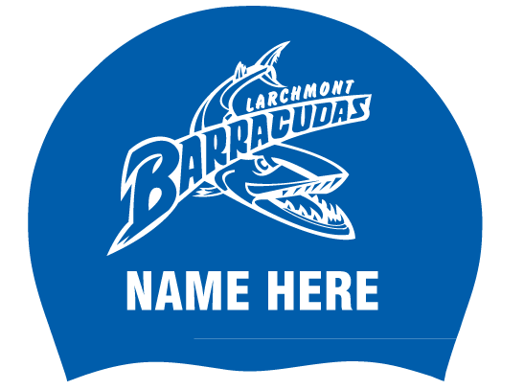
LAST DAY TO ORDER CAPS IS MAY 31st

