Swim Meet Information
Pack the night before:
- Team Swimsuit
- Team Shirt & Swim Cap (plus a backup in case yours rips)
- Goggles: with a second set as backup
- Towels: Bring an extra to dry off with. Extra towels during colder months helps stay warm as it takes longer to dry.
- Change of clothes: Be sure to check weather conditions and bring appropriate clothes in between races. They will be getting wet after races.
- Entertainment: Deck of cards, games, books, electronics, music with headphones
- Cooler: With healthy snacks and drinks, water, granola bars, fruit, and sandwiches. Most places do have a snack bar as well so bring some cash.
- Sharpie Marker, Highlighter & Pen
- Summer: Sunscreen, hats, sandals
- Winter: socks, pants, jackets/parka, beanie, hand and foot warmers, closed toe shoes.
- Shade structure- most places require you to use buckets of water (water from pool) and bungee cords to anchor down from the wind.

Before the meet:
- Arrive at least 15 minutes before the scheduled warm up time begins, consider time for parking
- Seating: know if there is stadium seating or lawn chair seating. Bring a cushion for stadium seating, and a lawn chair/blanket/tent for lawn seating.
- Know the location of where the team is sitting so, we can all try and sit some what together.
- Find your swimmer’s coach and check in so they know where to go during the meet for questions

BEFORE THE MEET STARTS
- You have the option to purchase a HEAT SHEET to check your swimmer’s events per day or they will be posted around the pool as well.

- Write on your swimmer: Event (E), Heat (H), Lane (L) in permanent marker
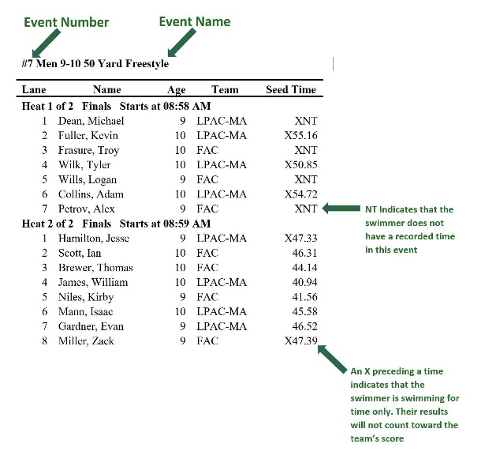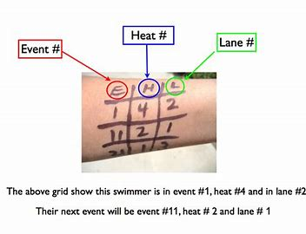

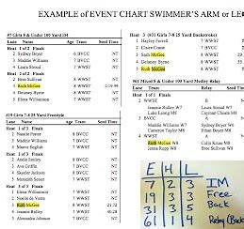

- Swimmer will warm-up with the team, very important that swimmers are on time to meets.
- After warm-up, they should return to their seating area and put on appropriate clothing
- Meet will usually start 10-15min after warmups are over
- Know what events they are swimming -If this is their first meet, make sure you let your coach know so they can guide and help you more.
- Listen for event announcements, check the event board
- Certain events require positive check-in, which means that you will need to intital next to your name that you are committed to the event. Check with your coach if you need to, but normally happens with distance events.

ONCE THE MEET STARTS
- Swimmer should check in with their coach 1-2 events prior to their event to receive guidance and warm-up tips.
- One event prior, swimmer should head to the starting block prepared to race with swim cap & goggles on
- Swimmer should check in with their lane timer to make sure they are in the correct heat and lane
- The Meet Official will blow one SHORT whistle - Stand behind your block or at the water’s edge if you are swimming backstroke
- The Meet Official will blow one LONG whistle - Stand up on the block or jump in the water if you are swimming backstroke
- Official will announce “SWIMMERS TAKE YOUR MARK” – Swimmer will take place and hold still
- Official will sound a loud horn to initiate your swim
- When you have finished your race: - Stay in the water and congratulate fellow swimmers next to you. If the scoreboard has your time, you can look at that as well.
- The Meet Official will blow one SHORT whistle for the NEXT swimmer to get behind the block - Pull your body tight against the wall and stay still until they are off the blocks - You can then exit the pool
- Check with the timers to see what time they gave you
- Take any belongings you took left at the block (towel, shoes, water bottle, etc.)
- Check back in with your coach: for guidance and post swim discussion
- Perform a warm down and be proud of your performance
- Go back to your seat, get warm, and have a snack or drink if time permits
- Prepare to do it all over again for your next event

ONCE YOUR RACES FOR THE DAY ARE DONE
- Check in with your coach prior to heading home to make sure you don’t have another event you were unaware of, or a relay.
- Change out of your race suit and put on dry clothes
- Gather all your belongings, don’t leave anything behind, it may not be there the next day
- Pick up any trash that might be left around so we leave the facility as clean as we arrived
- Be proud of your performance!

- SWIM TERMINOLOGY
- Long Course: in competitive swimming, means racing in a 50m pool - used in the Olympic games
- Short Course: in competitive swimming, short course is racing in a 25y/m pool
- Meet: competition designed to measure progress by implementing what has been learned in practice, the swimmers test themselves against the clock, their person best and others
- Heat Sheet: often purchased at concessions, list of all swimmers’ events, heat and lane assignment with swimmers’ seed by time or no time (NT) if they haven’t competed in the event before
- Event: a race, identified by a number, distance and stroke
- Heat: term for one race in an event, if more than 8 swimmers are competing
- Lane: the space between lane lines where the swimmer will compete
- Blocks: platform at the end of each lane used to dive from
- Seed Time: Used to assign swimmers to heats and lanes for an event
- Personal Best (PB): Swimmers fastest times they have achieved in an event, this will always be their seed time if it remains their fasters time
- Official Time: A time achieved in a race during a sanctioned competition
- Dry land: Training done out of the water that aids and enhances swimming performance: usually includes stretching, calisthenics, and/or weight training
- Qualifying Time: Time necessary to compete in a particular event and/or competition, often labeled as A, B, C, etc.
- Scratch: To withdraw from an event in a competition
- Disqualification: When a swimmer breaks a rule of swimming, they are disqualified, the time will NOT be counted, and they will receive a “DQ” as their time. Officials normally tell the swimmer what they did incorrectly or tell a coach
- False start: A swimmer leaves the starting block before the event start sounds
- No Time (NT): A swimmer has never raced the event before
- Deck: The area around the swimming pool reserved for swimmers, officials, and coaches
- Positive check-in: A swimmer must check in at the beginning of a meet for certain distances
- Pre-Seeded Events: Events in which swimmers know their heat and lane assignments by looking at a posted heat sheet or the meet’s program
- Timer: Volunteer at a swim meet who stands at the finish end of the pool and is responsible for timing the swimmer in their lane. They will use stop watches and electronic timing systems
- Touch pad: A soft, black pad placed in the water across each lane that stops the clock for the lane when the swimmer hits that pad, they must hit the pad with enough force to stop the clock
- Soft touch: When a swimmer doesn’t stop the touch pad with enough force, the lane timer results are typically input into the system

- QUICK TIPS
- Meets typically last 3-4 hours and will be at various pools throughout the area for local meets
- Check swimmers’ entries, typically a few days out from the meet. Find them the same way you registered your swimmer for the meet.
- Heat sheets are posted the day of the first day of the meet
- Parents are NOT allowed behind the blocks unless they are timing
- Pictures and videos are NOT allowed to be taken behind the blocks or swimmers. For taking pictures or videos, go to the side of the lane or in front of them. This is part of SAFESPORT rules.
- Meet Mobile is an app for your phone or electronic device (app has a fee) that allows you to track your swimmers’ times during the meet. Most meets use this application.
- Meet flyer is posted with the event is found online on our homepage. Click on the meet name that is bold. The flyer will be the pdf link. The zip file is for a special program to create the meet for coaches of other teams who are attending (basically ignore the zip file!)
- Boys- suits cannot go past the knee and only tie is at the waist band. No rash guards are allowed.
- Girls- suits cannot have ties on them and must be a one piece. No rash guards are allowed.
- Meet fees will be billed with your monthly dues. Normally we have an LSC charge of $8, and then a small charge for each event that you’re signed up for.

MEET JOB DESCRIPTIONS
- C-6- With the admin tent and helps control the scoreboard with each race. Training for a day preferred.
- Clerk of course- organizes within the admin tent and helps the meet run smoothly
- Meet Marshall- certified position and must take test to qualify. If interested, please email admin@sahuaritastingrays.com. This position makes sure that athletes are safe and not running on the pool deck, parents aren’t taking pictures behind the blocks, swimmers aren’t playing in the warmup/warm down pool, etc.
- Head timer- A watch is provided for use. Runs 2 backup watches in case one of the timers’ watches fails in the middle of a race
- Timer- A watch is provided for use. Starts the watch when the flash goes off near the starter. And stops the watch when any part of the swimmer touches the wall. Record the time on the paper provided next to the name that just swam.
- Runner- Helps collect timer paperwork once the event of an event happens. Papers are given to the admin table.
- Concessions- Helps sell programs, snacks, and drinks.
- Hospitality- Helps pass out snacks and drinks to officials, coaches, and timers while they have eyes on the pool deck. Helps organize the hospitality room for coaches and officials for breakfast and lunches while they have breaks.
- Computer admin- Certified position with USA Swimming. Uses a computer program to make sure times go in properly and any meet sheets that are needed to be printed. If interested, please email admin@sahuaritastingrays.com for more information on training.
- Officials- Certified position with USA Swimming. Officials start the races; watch turns and finishes and keep the swimmers “legal” while swimming. If interested, please email admin@sahuaritastingrays.com for more information on training.

TIME STANDARDS FOR ARIZONA SWIMMING
Has each age group, boys, girls, long course and short course all listed.
https://www.azswimming.org/wp-content/uploads/2021/05/ArizonaSwimmingTimeStandardsABC5-31-2021.pdf

HELPFUL WEBSITES
USA swimming website: https://www.usaswimming.org/
Arizona swimming website: https://www.azswimming.org/

