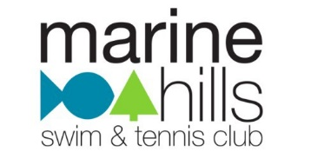
Marine Hills Recreation Association
600 South 302nd St Federal Way, WA 98003
253-839-4690 www.marinehillspool.org
Submit to: mhswimteam@marinehillspool.org

APPLICATION FOR EMPLOYMENT — Swim Coach
*Please submit a Cover Letter and Resume with your application*

Last Name: |  |  | First Name:
Address:
City: |  | State: |  | Zip Code:
Phone: |  |  | Cell Phone:
Email Address:

EDUCATION
Grade Level Completed
College Level Completed
 | Completion Date | Expiration Date |  | Completion Date | Expiration Date
Lifeguard |  |  | CPR
First Aid |  |  | Other
Instructor or Aide

WORK EXPERIENCE
Employer | Dates | Position | Responsibilities
1.
2.
3.

PERSONAL REFERENCES
Name | Telephone | Address | Comments
1.
2.
3.
AVAILABILITY
First day available for work:
Are you available for Pre-Season (5/13 – 6/21)
Vacation dates planned:
COACHING STRENGTHS
GOALS FOR THE 2019 MHRA SWIM TEAM SEASON
SIGNATURE: ___________________________ DATED: _________________

**Please submit a Cover Letter and Resume with your application**
Submit your application to: mhswimteam@marinehillspool.org

