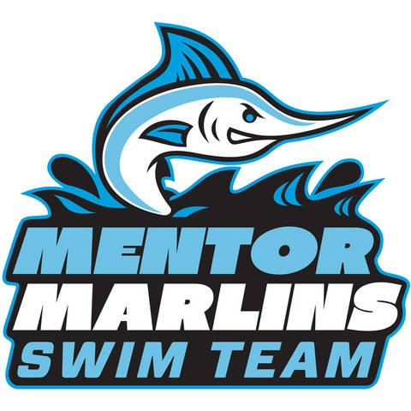

(insert date)

(insert company address)

Dear (insert business owner):

The Mentor Marlins Swim Team provides an environment where swimmers of all levels of ability can develop their technical skills and character values through recreational competitive swimming. We strive for excellence in and out of the pool by providing quality leadership that motivates our swimmers to grow and succeed as individuals and as a team. Our philosophy is to build on successes of the individual and to combine that with a strong team atmosphere where all swimmers feel good about their contributions. We focus on sportsmanship, hard work, positive mental attitude and healthy physical conditioning, all while having fun! We are the only recreational competitive swim team in Mentor and our team size usually ranges from 120 to 150+ swimmers, ranging in ages 4 to 18 years old. No other sport provides the opportunity for this vast age differential for children to compete on the same team. Our older swimmers serve as mentors and role models and often volunteer extra time to help younger swimmers that are new to the team and competitive swimming.

The Mentor Marlins is a member of the Suburban Swim League (SSL) of Northeast Ohio in which we compete against 10 other league member swim teams. Our season begins the week after schools close for the summer, and runs through the end of July. Dual swim meets are held weekly, followed by SSL Championship Weekend, in which all teams compete together, to finish the season. As one of the larger teams within the SSL, we are the only team that is not funded or supported by its name city or local YMCA. As an independent 501(c)(3) non-profit organization, we are managed and operated by an all-volunteer parent board. The Mentor Marlins is responsible to the City of Mentor for pool rental and lifeguard fees, required to conduct swim practices and home meets. Additional costs include insurance premiums, SSL team fees, coaching fees, awards, equipment and supplies. In order to offset these costs, we must seek charitable contributions from within our local community to help keep our team sustainable while keeping the cost of membership comparable with other local summer recreational programs for children.

Our families live, work and shop in the surrounding area. We ask that you consider making a donation in support of our team for the 2021 swim season. We appreciate any contribution you can provide that will ultimately invest in our community youth while providing an opportunity for your business exposure! We have included our Sponsorship Levels for your consideration. We do hope you will consider supporting the Mentor Marlins Swim Team! Thank you.

Sincerely,

(insert name)

