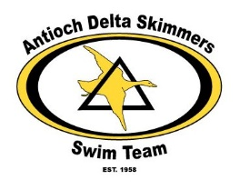ECI Program Swimmer
Recognition/Dedication
Have your Swimmer/Swimmers recognized for their hard work and swim accomplishments in our ECI Program
Your team and parents may place a good luck ad/wish in the ECI Program.

If interested in a “good luck swim-a-gram” for your swimmer or place an ad for your business, follow the following steps:
1.) Final ad should be “ready to print/copy”. Provided in PDF format.
2.) Email completed ad to: SkimmerPresident@Gmail.com
3.) Provide either a check or we can send an invoice for you to pay from the privacy of your home.
4.) Deadline for inclusion in program is July 8, 2019.
5) Please confirm that email was received. (ADS will reply if received)

¼ Page Ad 4“wide by 5“tall | $ 20
½ Page Ad 8“wide by 5“tall | $ 30
Full Page Ad 8” wide by 10” tall | $ 50

Skimmer/parent Name____________________________________________

Business Name__________________________________________________

Email address___________________________________________________

Size___________ Date .PDF e-mailed____________________
Once we have confirmed your ad we will e-mail you with confirmation.

