Equipment
These items can most likely be found at Sports Basement in Walnut Creek, NorCal Swim Shop in Walnut Creek or if you don’t want to leave the comfort of your home, you can order them on‐line from Outlet.com just click on the link below.
These items are in addition to swimsuit, goggles (dark mirrored please), caps, water bottles, game face, etc. that Coach Ray has requested for possible use at all practices. Just a reminder that you shouldn’t need to purchase multiple sets if your children swim at different times.
http://www.swimoutlet.com/?Click=1719049&gclid=CN7fitWZmKgCFQQ7gwodyFkoDA
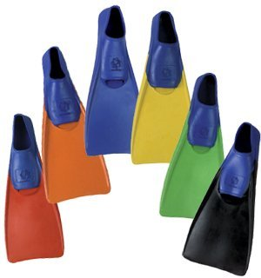Fins (any type)

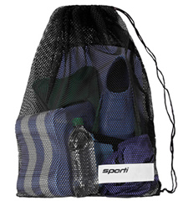Mesh Bag to hold gear

