WRITTEN ACKNOWLEDGEMENT OF MINOR ATHLETE ABUSE PREVENTION POLICY
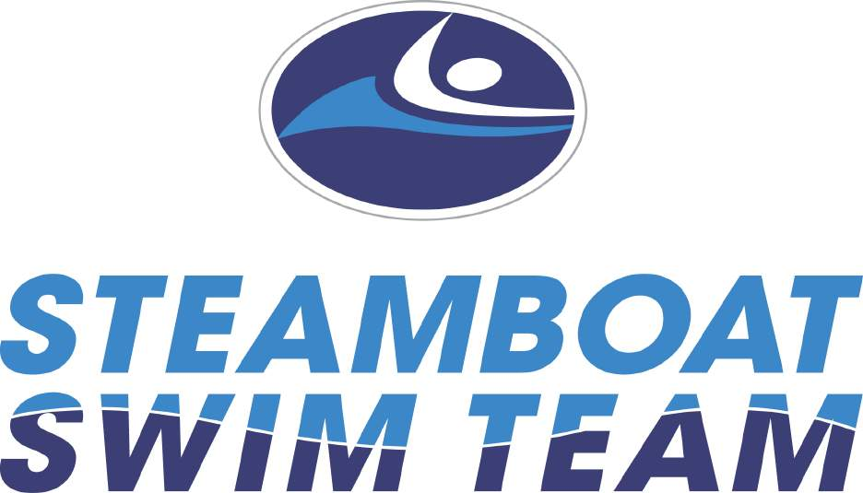

I acknowledge that I have received, read and understood the Minor Athlete Abuse Prevention Policy and/or that the Policy has been explained to me or my family. I further acknowledge and understand that agreeing to comply with the contents of this Policy is a condition of my membership with Steamboat Springs Swim Team and USA Swimming. Complete one form per parent or guardian.

Your Swimmer’s First and Last Name: ________________________________________

Name: _________________________________________________

Signature: _______________________________________________

Date: _______________________

