

SPORTraits by Kevin Hurley Photography

1360 Maple Ave SW Roanoke VA 24016 540.345.3055
www.kevinhurleyphotography.com hurleyphoto@cox.net

*Please complete this order form, select a package, attach your payment (cash or check only, please!) and return to KHP on your picture day. All packages must be paid for on picture day.
*Please complete one order form for each child, unless you’d like to have your children photographed together.
*Please make checks payable to Kevin Hurley Photography.

Swimmer’s Name _________________________________________________________________

Team Name: Ashley Plantation Stingrays

Parent’s Name _________________________________________________________________________________

Mailing Address ___________________________________________________________________

City/St/Zip __________________________________ Phone________________________________

Email ____________________________________________________________________________
(you will be added to our email list, from which you can unsubscribe at any time)

Step 1. Select your package:
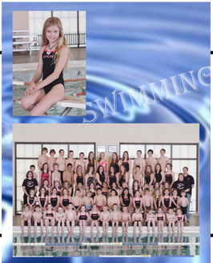
_____ Pkg A: $35 1 8x10 Memory Mate; 1 8x10, 2 5x7. 4 3x5 & 8 Wallets Individual

_____ Pkg B: $25 1 8x10 Memory Mate; 2 5x7, 2 3x5 & 4 Wallets Individual

_____ Pkg C: $15 1 8x10 Memory Mate

_____ Pkg D: $10 1 5x7 Team Only

Step 2. Select your add-ons (available only with the purchase of a package):

Additional Units, $24 each Fun Stuff

1 8x10 _____ qty. 1 4x6 Magnet $8 ______ qty.

2 5x7 _____ qty. 6x9 Notepad, set of 4 $47 ______ qty.

4 3x5 _____ qty. Dog Tags $23 ______ qty.

8 Wallets _____ qty. iPhone 4/4s/5 Case $47 ______ qty.

Total $__________________ (All packages must be paid for on picture day)

STUDIO USE ONLY:
Amount Paid________ Initial________ File #______________________

