MANTAS SWIMMING CLUB
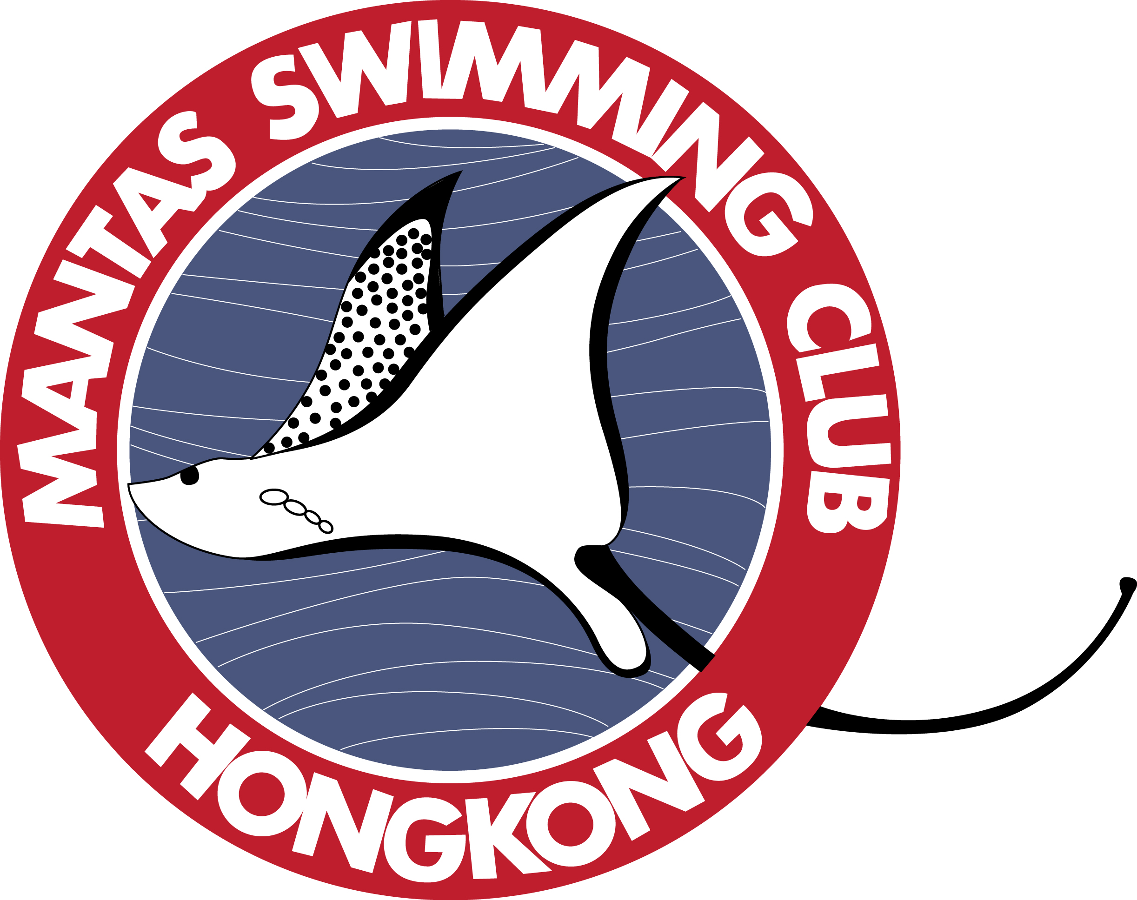
Membership Application Form – by email/ post/ via coach
Official Use only
Date distributed
T-shirt size
Shorts size
Last name: ___________________________ Parents’ names: ____________________________________
Phone number: _______________________ Email: _______________________________________________
Swimmer’s First Name | Date of Birth dd/mm/yyyy | Chest size (cm) | Waist size (cm) | Height (cm) | Squad/ Venue

All correspondence from the club will be sent by email. Please write your email address very clearly, and notify us if it changes.
Mantas has its own swimming costume, which must be worn in competitions. These and other accessories are for sale by contacting the membership secretary.
Registration Fee per swimmer: $600 (includes one issue of Mantas T-shirt and shorts)
Annual Family membership fee: $400 per family
Payment methods:
1) CHEQUES should be made payable to MANTAS SWIMMING CLUB and sent to Mantas Swimming Club, 2C Kwong Ga Building, 64 Victoria Road, Kennedy Town, Hong Kong.
2) CREDIT CARD via PAYPAL. Send the form to the above address, Bev will send you an invoice by email.
For further information, please contact MANTAS SWIMMING CLUB, 2C Kwong Ga Building, 64 Victoria Road, Kennedy Town, Hong Kong OR phone 25756279. Email: bev.wright@harrywright.com.hk
Declaration:
We promise that we will make every effort to participate in the Swimathon and Home Meet and will be willing to help as officials.
I enclose a cheque for $400, plus $600 per swimmer, a total of $__________. Cheque No.: ________________ OR by PAYPAL, please tick here _______.
Parent’s signature: _____________________________________ Date: ________________________________

