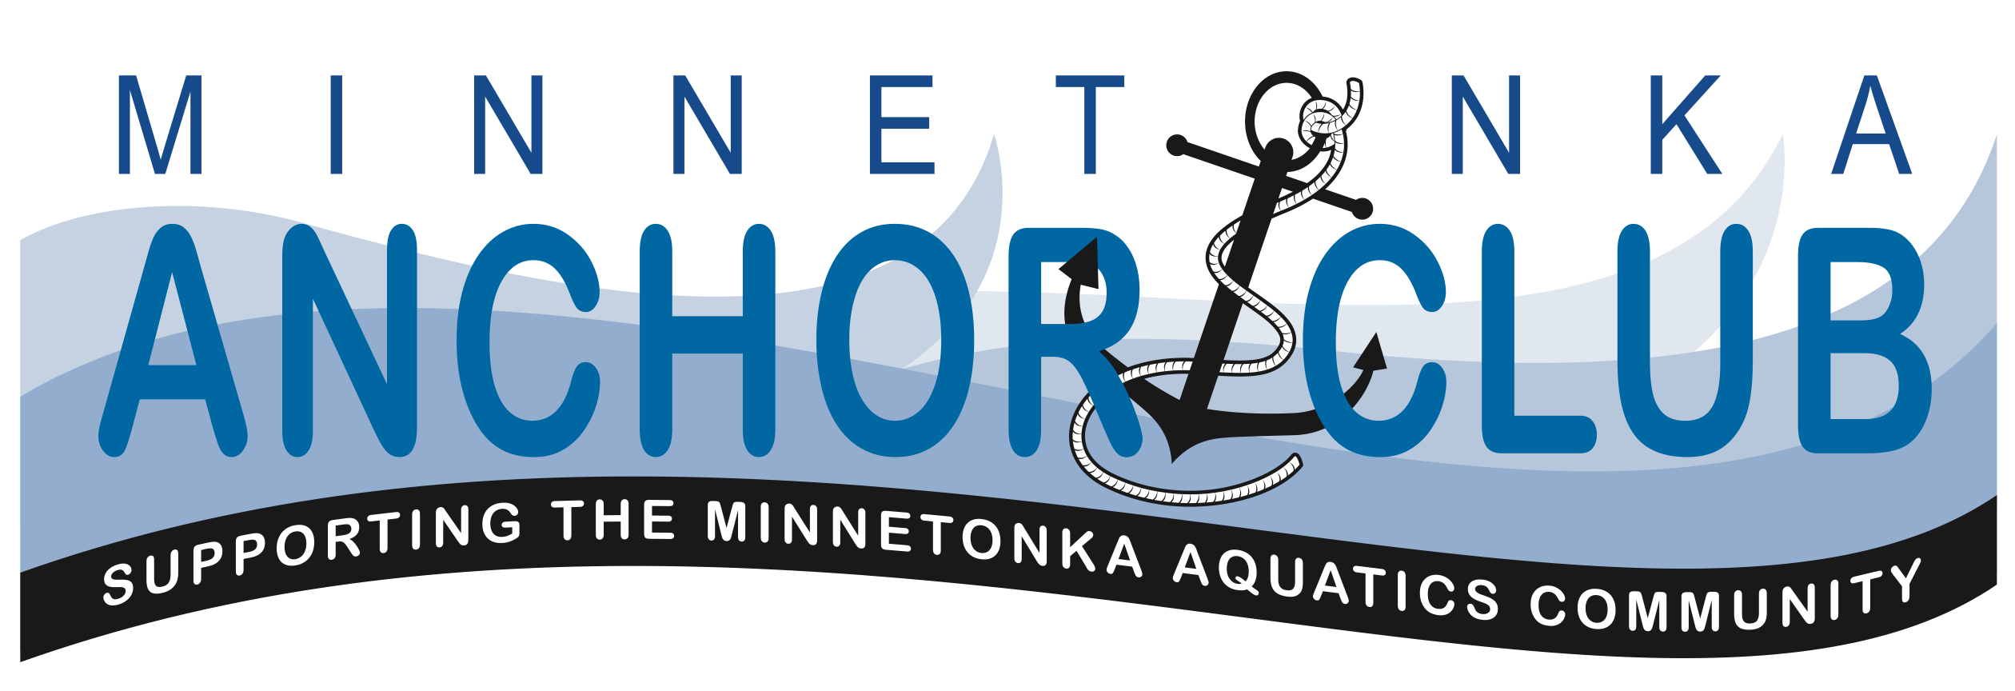

Oct 12, 2014

Meeting Agenda

- Friends and families of Minnetonka Aquatics Community
  - Aquatics Director Report
  - Swim-a-thon 2015 plans (Kelli Binder)
  - Current Priorities
  - Support Needs
  - Community Q&A
- Official Business
  - Call to order
  - Approval of minutes from July 13, 2014 meeting
  - Treasurer’s Report
  - Committee reports and open items
  - New business
- Next meeting & Adjourn

