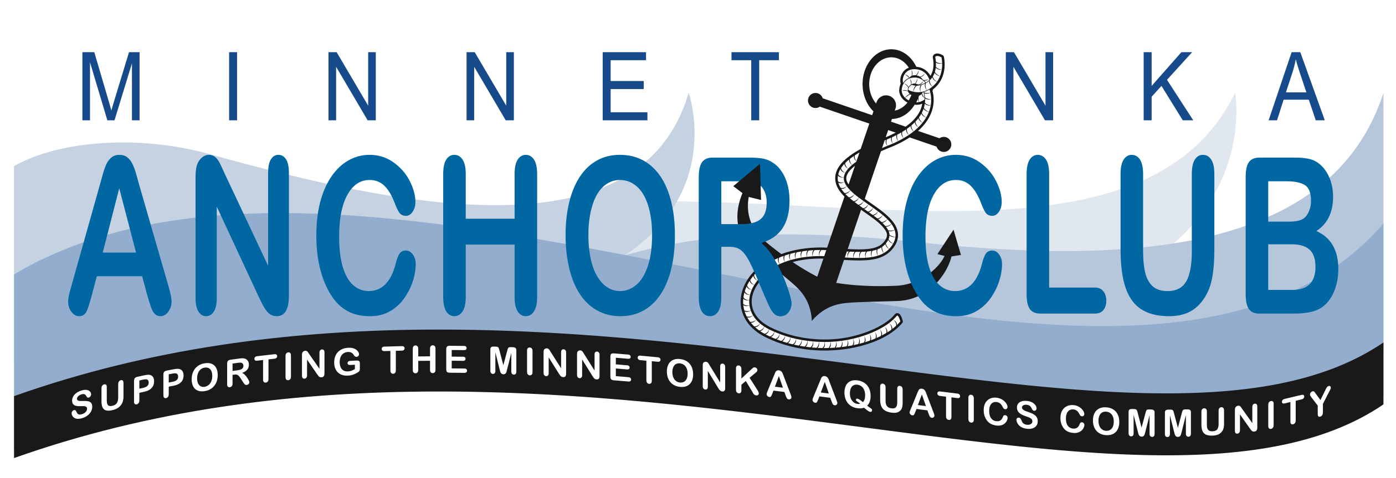

Dec 14, 2014

Meeting Agenda

- Friends and families of Minnetonka Aquatics Community
  - Aquatics Director Report
  - Swim-a-thon 2015 update
  - Banquet plans
  - Education Outreach - Spring and Summer Seminars
  - Learn to swim program for financially challenged families
  - Scholarship program – conceptual design
  - Support Needs
  - Community Q&A
- Official Business
  - Call to order
  - Approval of minutes from Oct 12, 2014 meeting
  - Treasurer’s Report
  - Committee reports and open items
  - New business
- Next meeting & Adjourn

