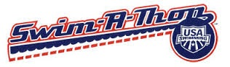
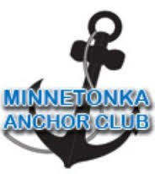

2015 Swim-A-Thon Sponsorship Levels

Title Sponsor - $1,500
- Prominent logo on banner the week of the event and at post event celebration
- Logo on website with a link to company website for 12 months
- Prominent logo in athlete’s donation packet
- Recognition in our weekly newsletter that is distributed to over 300 members
- Recognition on the Minnetonka Swim Club Facebook page
- Sponsorship recognition in pre/post event press releases to over 7,000 households of the Minnetonka School District

Event Sponsor - $750
- Color Logo on banner the week of the event and at post event celebration
- Logo on website with link to company website for 2 months
- Logo in athlete’s donation packet
- Recognition in our weekly newsletter that is distributed to over 300 members
- Recognition on the Minnetonka Swim Club Facebook page

Lane Sponsor - $400
- Lane signage on the day of the event
- Name recognition on website

Prize Donations
- Donations in cash, gift cards, or products
- Recognition for $100+ value

Sponsor Name: _________________________________
How should we recognize you? (company, family name, etc):_____________________
Contact person: _________________________________
Phone/email: ___________________________________

Payment: Minnetonka Anchor Club
Corporate Sponsorships must be turned in by February 28th, 2015.

Mail to: Minnetonka Anchor Club Treasurer
4166 Lakeridge Road
Excelsior, MN 55331

Contact: Kelli Binder- mtkaswimathon@gmail.com or 952-933-2223

The Minnetonka Anchor Club is a registered 501(c)3. Our non-profit tax ID # is 26-2642485

