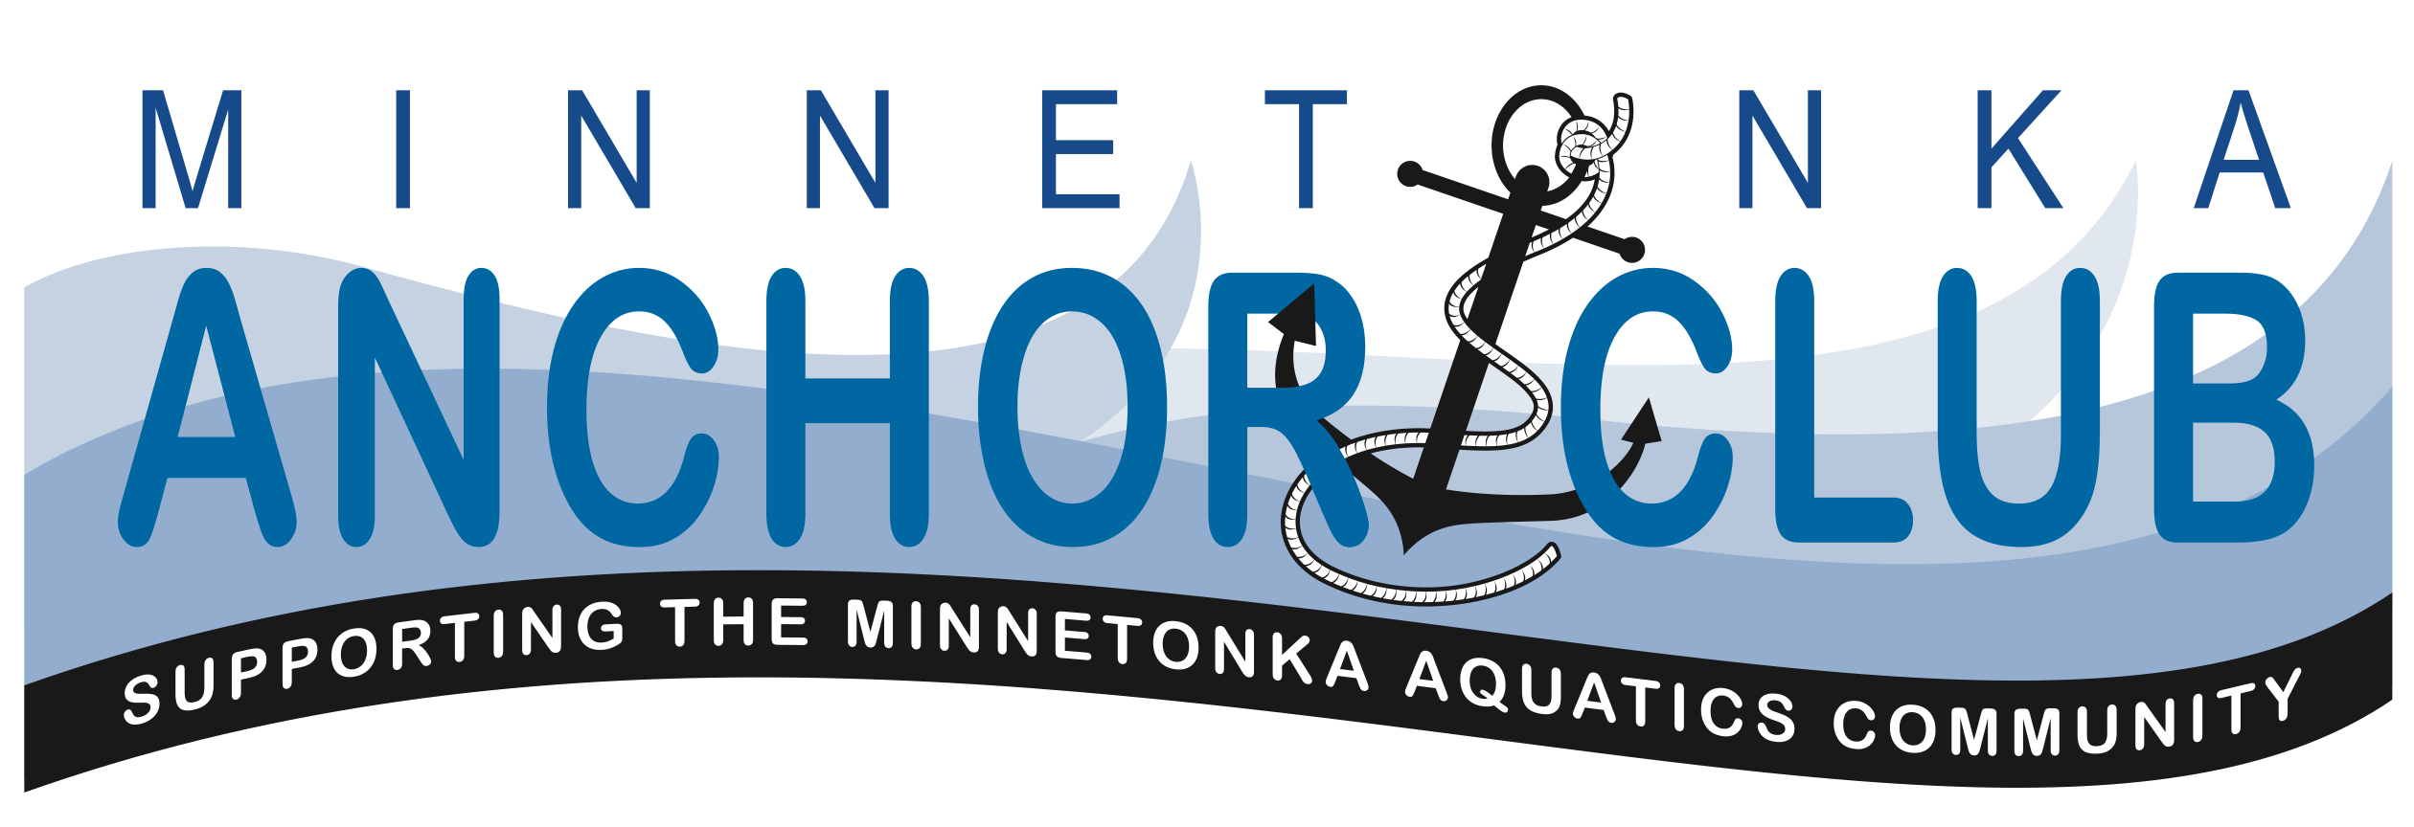

July 19, 2015

Meeting Agenda

- Friends and families of Minnetonka Aquatics Community
  - Aquatics Director Report
  - Swim-a-thon 2015 results
  - Education Outreach
  - Learn to swim partnership with the Y update
- Official Business
  - Call to order
  - Approval of minutes from May 3, 2015 meeting
  - Treasurer’s Report
  - Board changes
  - PCA request
  - Committee reports and open items
  - New business
- Next meeting & Adjourn

