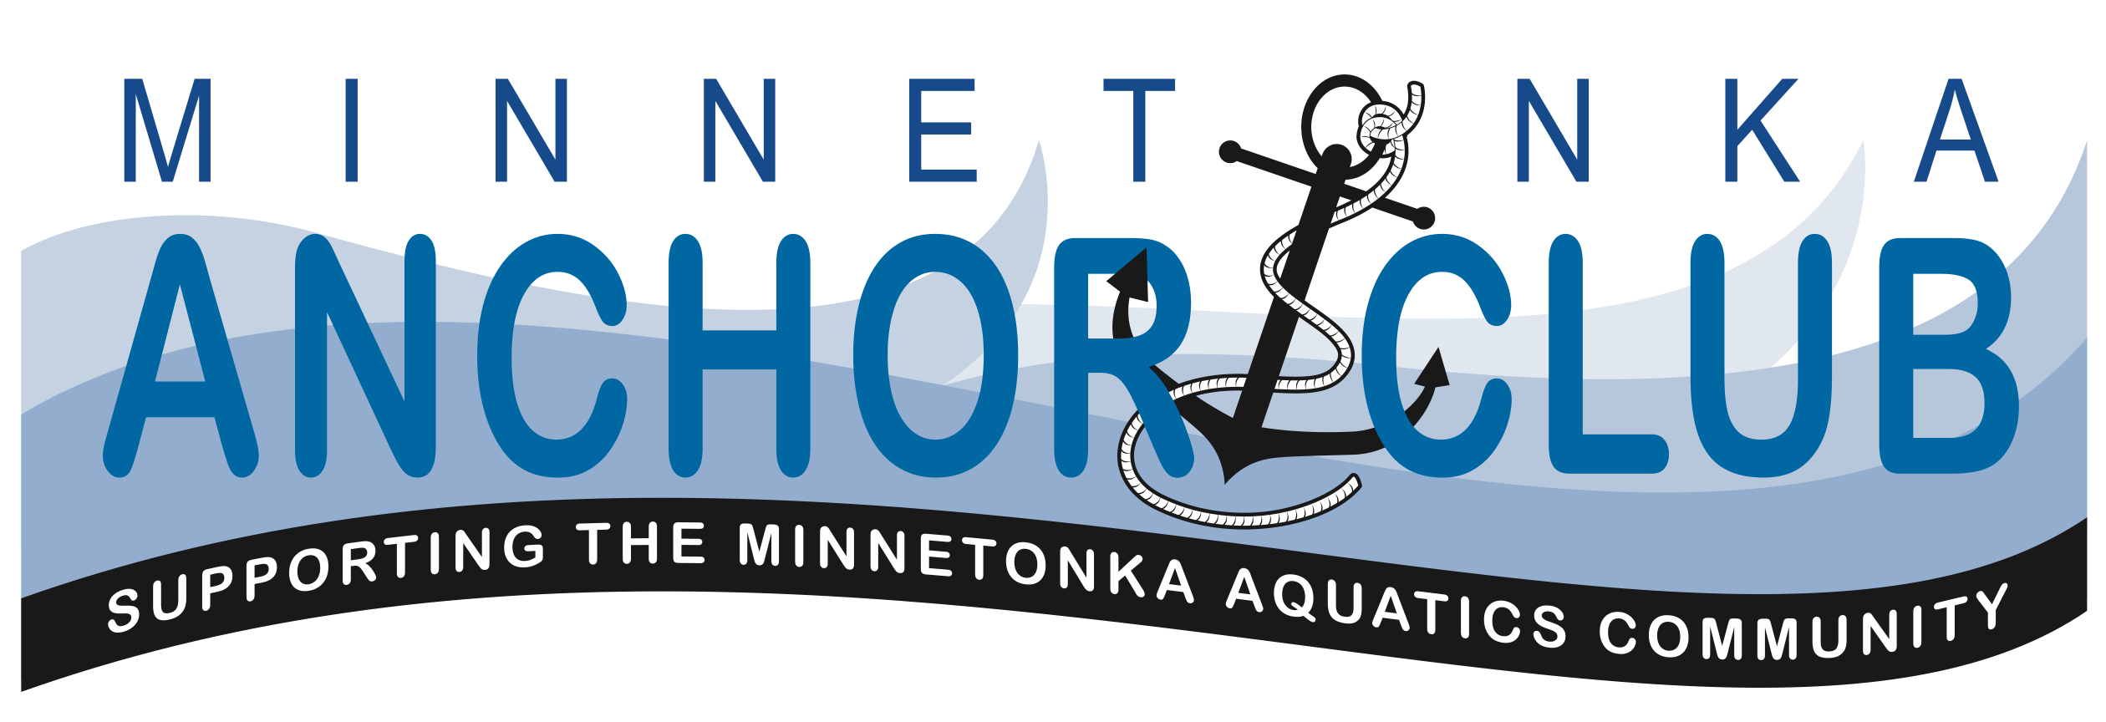

January 10, 2016

Meeting Agenda

- Friends and families of Minnetonka Aquatics Community
  - Aquatics Director Report
  - Swim Club Report
  - Culture & Education Outreach (See Swim Club Update report)
  - Banquet 2016
- Official Business
  - Call to order
  - Approval of minutes from October 4, 2015 meeting
  - Treasurer’s Report
  - Sub Committee for policy of use of funds
  - Volunteer resources strategy, plans, and survey
  - Future Facilities Update
  - New business
- Next meeting & Adjourn

