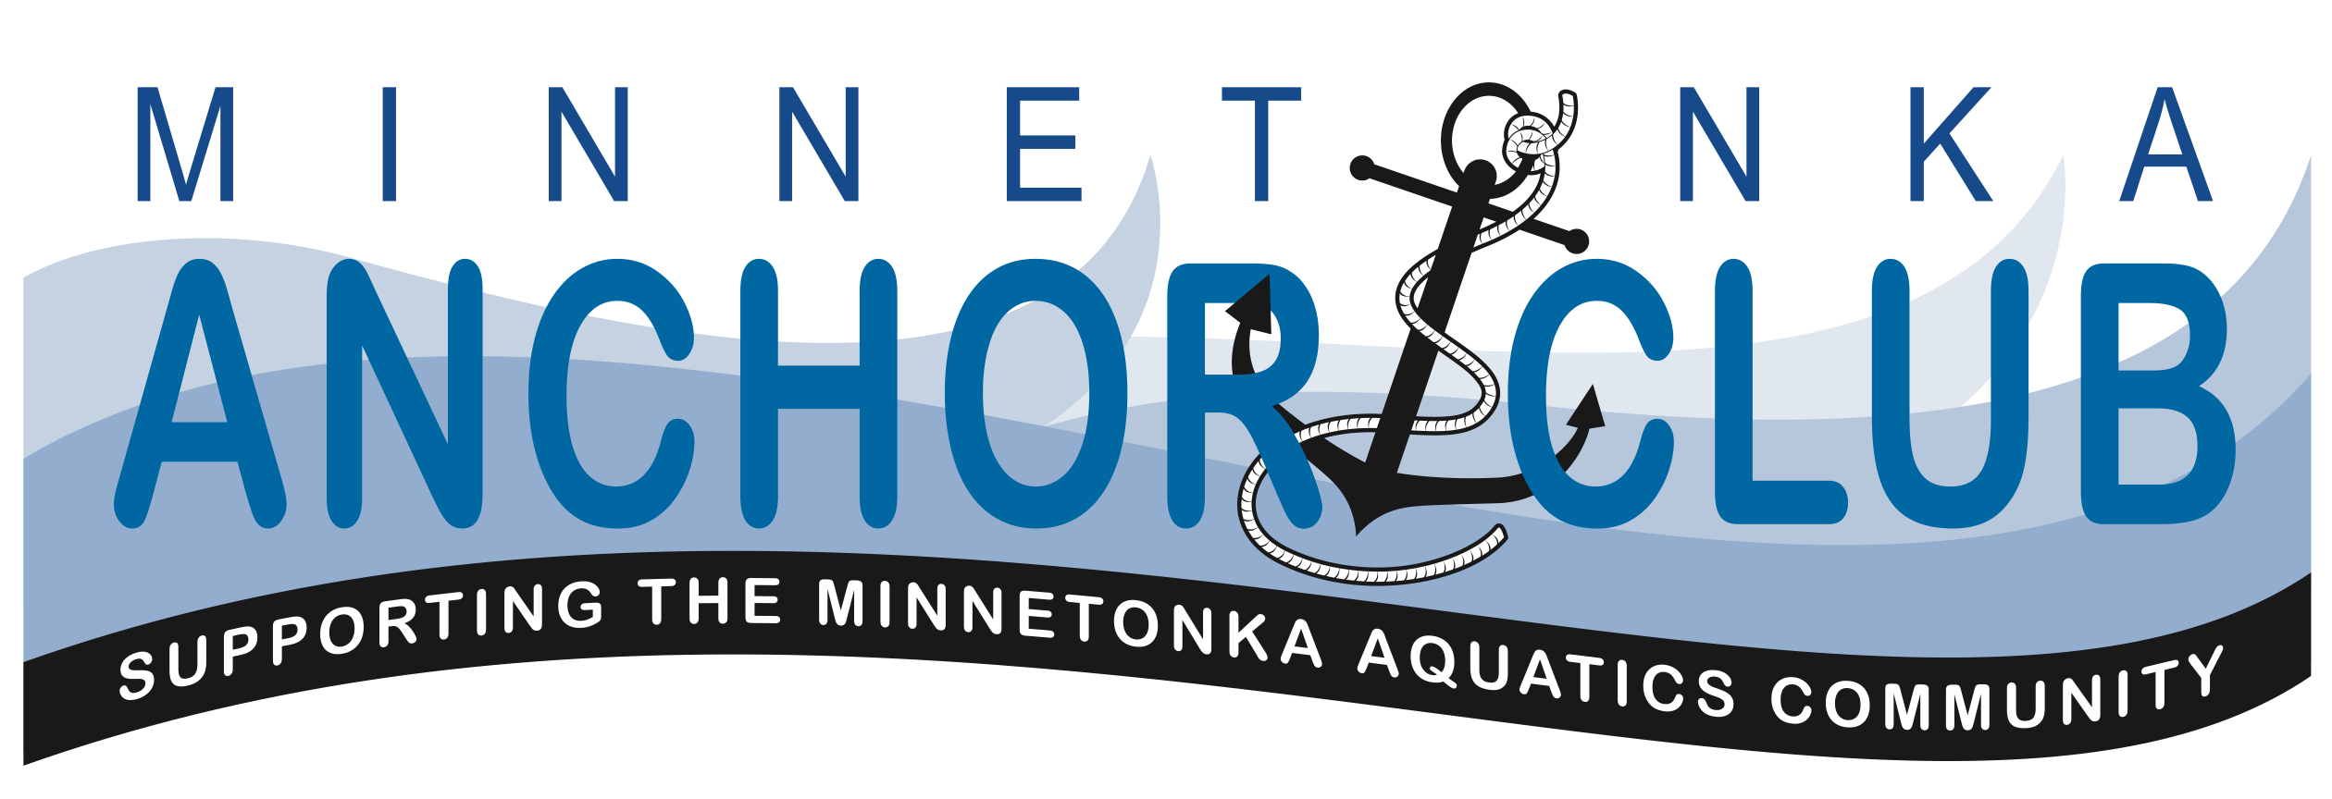

April 15, 2018

6:30 p.m. – 8:00 p.m.

Anchor Club Board Meeting Agenda

- Minnetonka Aquatics (6:30)
  - Aquatics Director Report/Questions: Dan Berve
  - Swim Club Head Coach Report/Questions: Erich Welton
- Official Business (6:45)
  - Call to order
  - Approval of minutes from January meeting
  - History of Anchor Club – Mark Ambrosen
  - Volunteer Committee Report: 7:00
    - Volunteer Dinner
  - Website Update – Robb Ball 7:10
  - Swim-A-Thon Update: 7:25
  - Future Facilities Update 7:30
  - Budget Update: 7:45
  - New Member Nomination Committee 7:50
  - New Business 8:00
- Next meeting & Adjourn

