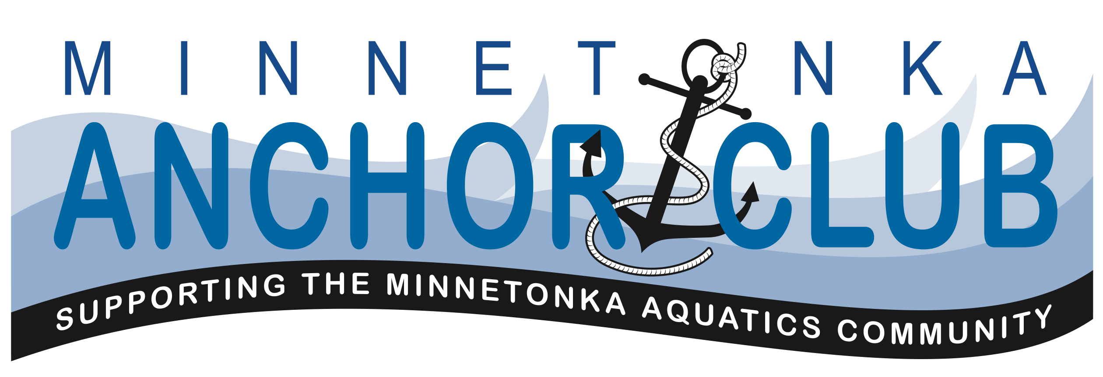

July 17, 2018

6:30 p.m. – 8:30 p.m.

Anchor Club Board Meeting Agenda

- Minnetonka Aquatics (6:45)
  - Aquatics Director Report/Questions: Dan Berve
  - Swim Club Head Coach Report/Questions: Erich Welton
- Official Business (7:00)
  - Call to order
  - Approval of minutes from April meeting
  - Volunteer Committee Update – Robb Ball 7:10
  - Budget Update: Cindy LeSage 7:20
  - Anchor Club Identity/Building Awareness: Rich Diaz 7:30
  - Communications: Back to Swim Night: Erik Kitt 7:50
  - New Member Recruitment: Pierre LaMere 8:00
    - Legal Advice
  - Middle School Program: Dan Berve/Maren Reeder 8:10
    - Outcome of Strategic Planning: Raise income level for scholarships
  - Proposal: Committees and Membership: Maren Reeder 8:20
- Next meeting & Adjourn (8:30)

