Make sure to login first.

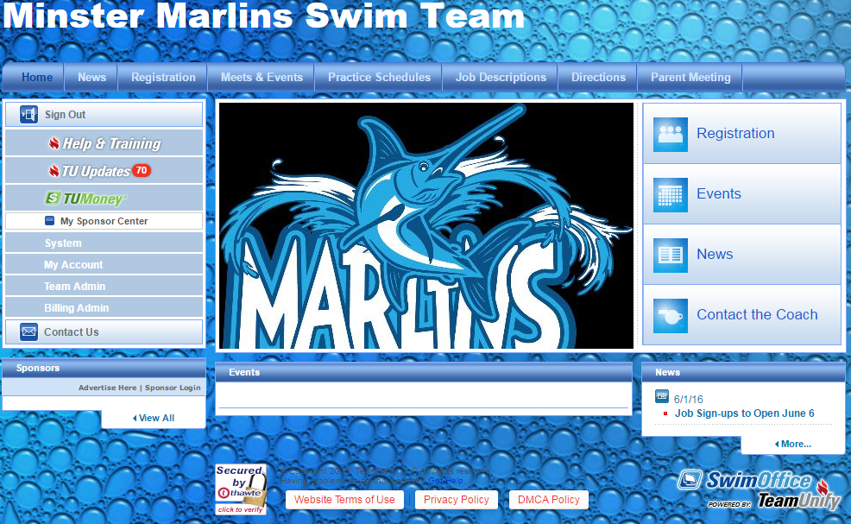

Click on My Account.

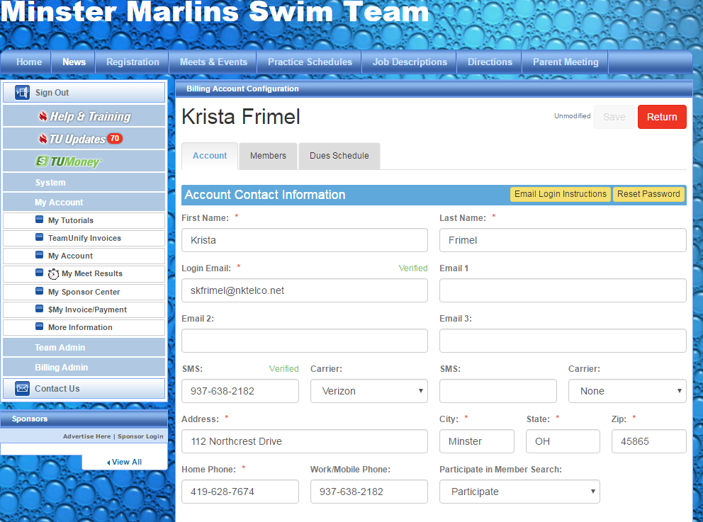

Enter your cell phone number in the SMS field, and your cell phone carrier in the Carrier field. A Yellow button will appear above Carrier saying Unverified. Click on that Unverified button and a text will be sent to the number you entered. Once you receive the text, it will give you a four-digit code to enter. Enter that code in the website. After you enter that code, it should now show Verified in Green like above. Make sure to click on the Save button in the upper right hand corner.

Click on My Account.