What is Synchronized Swimming?

Consider: A gymnast performing underwater…
A 400-meter freestyle event in swimming with little opportunity to breathe…
The figures, leaps and spins of a figure skater performed on an unstable medium…
The water polo player’s ability to emerge above the surface of the water with power and strength; then add a touch of elegance….
A dancer’s artistic flair with choreography, musical expressions and audience contact; add grace and fluidity and multiply by two, three or eight individuals synchronizing each part of every movement and…
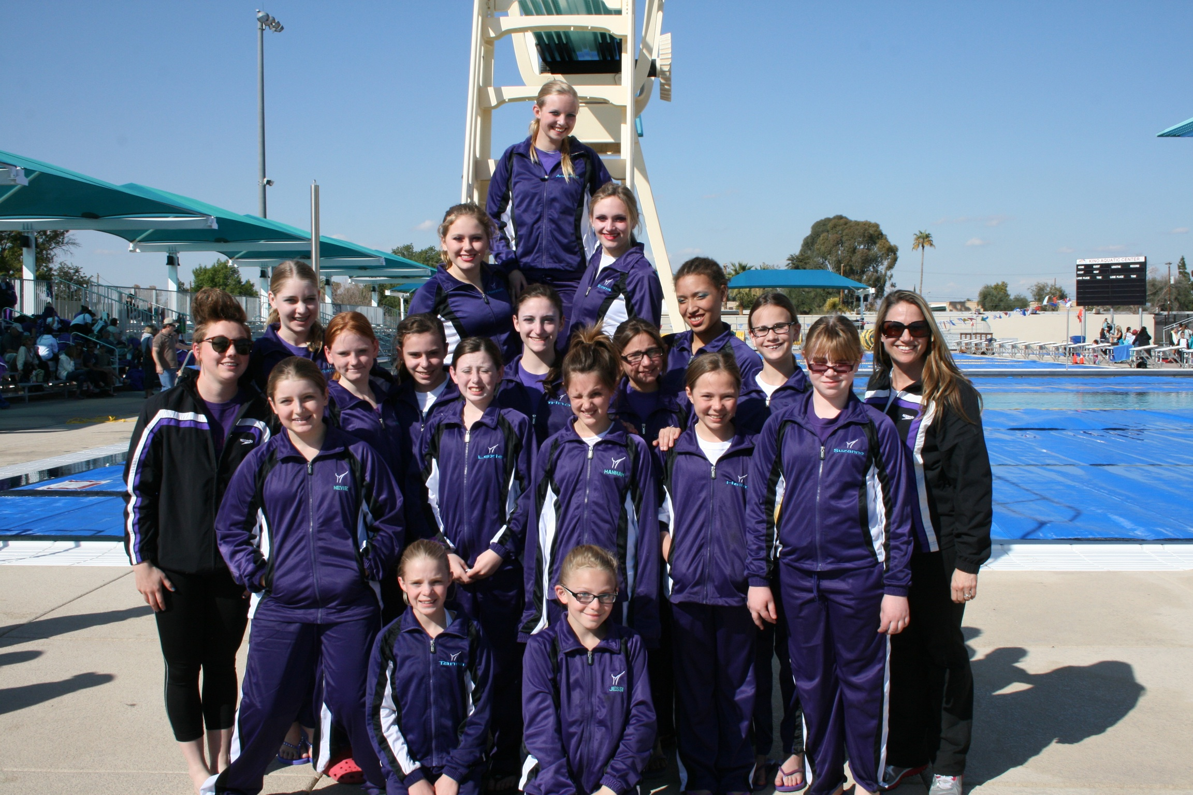
THAT IS SYNCHRONIZED SWIMMING!

Synchronized swimming is a sport requiring overall body strength and agility, grace and beauty, split-second timing, musical interpretation, and dramatic flair. It is a unique sport in which power, strength, and technical skill are displayed in an artistically choreographed piece. The competitive rules and manner of judging synchronized swimming are similar to its counterparts; figure skating and gymnastics.

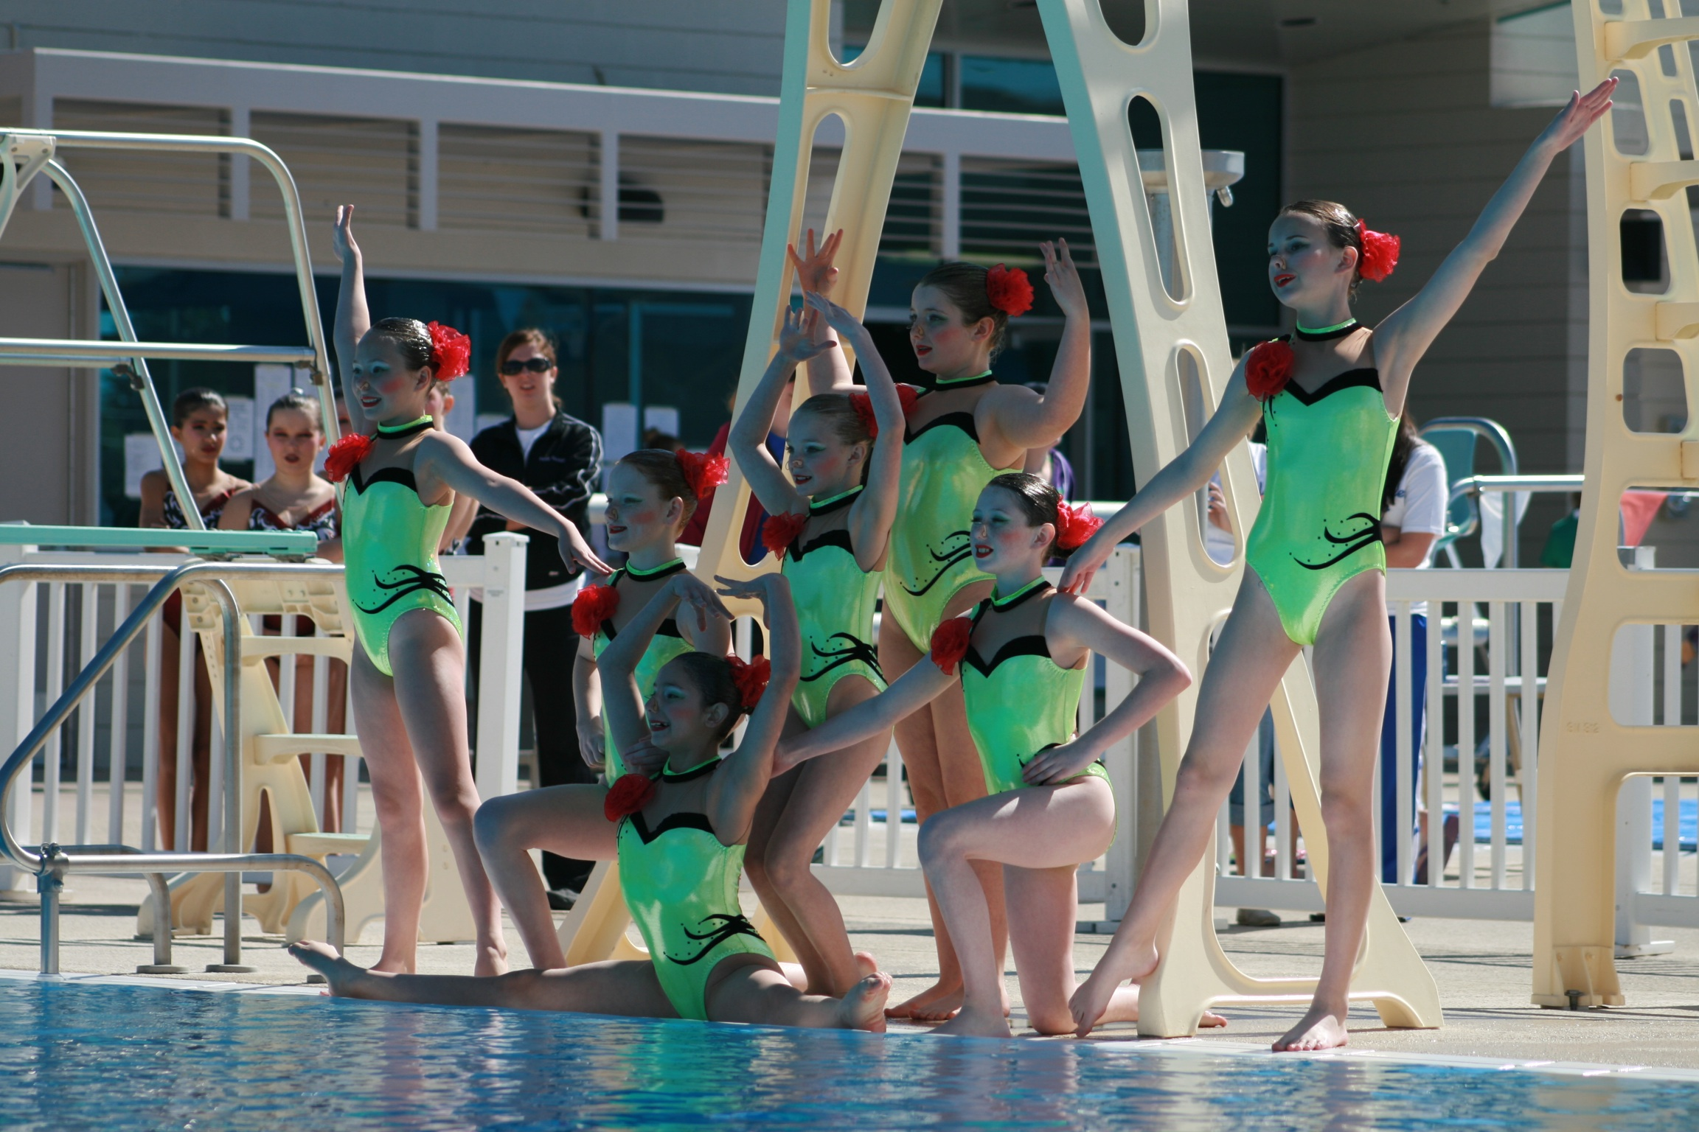

There are three events recognized internationally in synchronized swimming: solo, duet, and team. In addition to these routine events, each competitor must participate in the compulsory figure competition. The scores earned in this event are added to those of the routine competition to determine each events winner.

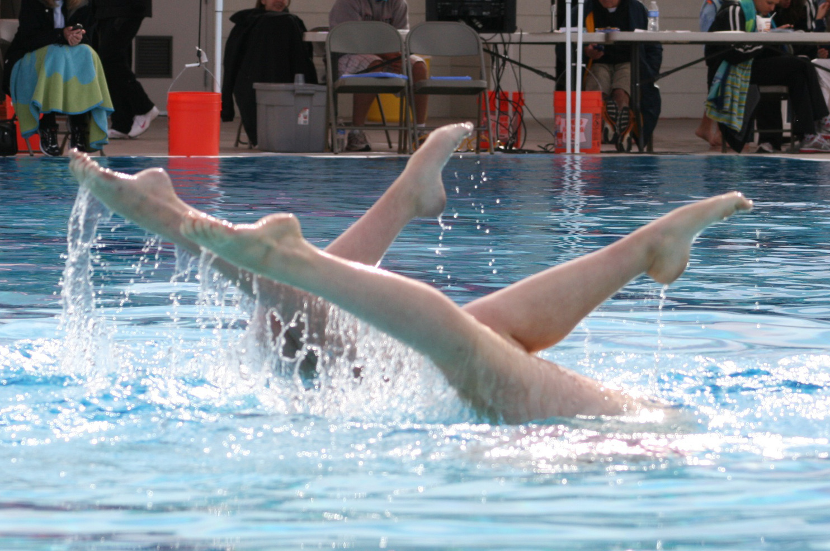
To perform a strenuous routine while maintaining an effortless appearance is a very difficult and important quality that is expected by the judges. To understand the physical demands and endurance needed to perform the 3.5 to 5 minute routines; consider running while holding your breath for lengths of time up to 30 seconds. The routines demonstrate what has made “synchro” so popular with audiences. Much of the appeal is found in the use of the music to demonstrate the athlete’s skills, technique and creativity. Routines are enhanced by the use of original and expressive movements, patterns and rhythms.

www.NevadaDesertMermaids.com or contact Head Coach, Ludi Perrin-Stsepaniuk (702) 782-5766

