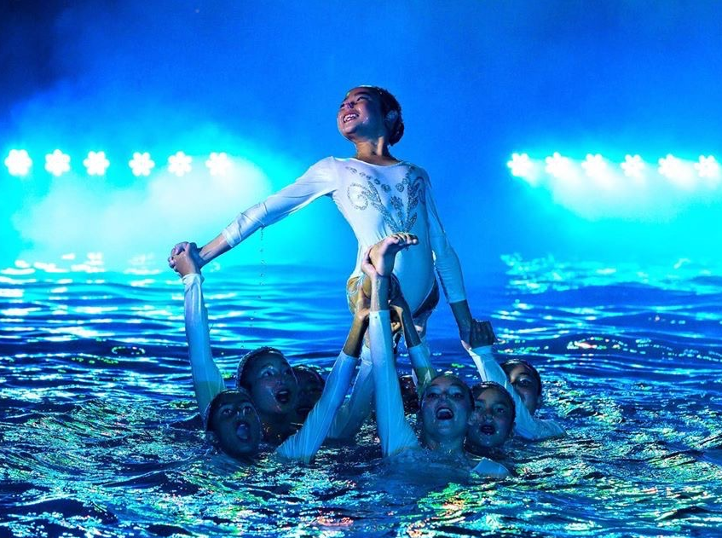
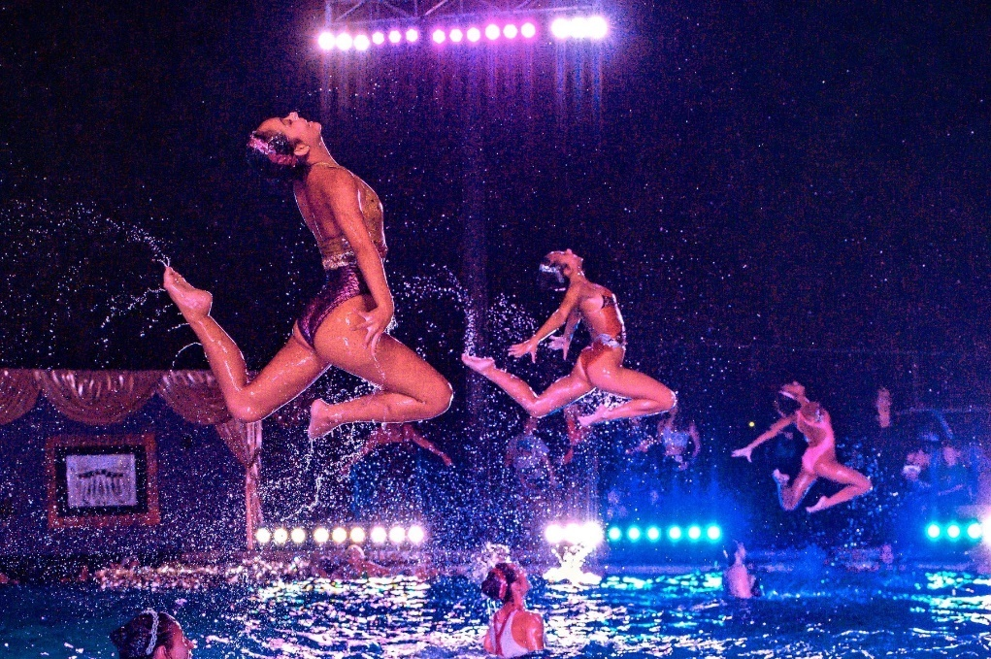

Sponsor the 2021 Aquanuts Today!
The Walnut Creek Aquanuts is the Bay Area’s premier artistic swimming team with more than 100 athletes. In its 53-year history, the club has won more than 200 national and world titles, and has produced over 4,000 elite level athletes, 17 Olympians, and eight Olympic Gold Medalists.
As a registered 501c3 nonprofit, WCA develops athletes from novice to elite. Beyond developing swimming skills—strength, flexibility, endurance, speed, and timing—the club is truly committed to fostering teamwork, sportsmanship, self-confidence, healthy lifestyles and empowering girls and young women to be leaders.
Thanks to the generosity of our community, WCA athletes have the opportunity to compete nationally and around the world. We just returned from the U.S. National Artistic Swimming Championships with Aquanuts taking Gold and Silver in the Junior age division, Gold and Bronze in the 13/15 age division, and Gold in the 11/12 division. The teams also won high point awards and coaches of the year. Several teams are now headed to the Junior Olympics in June.
Fall Swim Show - TBD September 2021 - Clarke Memorial Swim Center
Back for 2021 is our iconic Fall Swim Show, a professional-level theatrical swim show complete with lights, props, and a 3-D stage that attracts thousands of guests, including East Bay business leaders and VIPs. The iconic evening show dazzles more than 4,000 attendees over Labor Day weekend. Participants enjoy synchronized swimming in its most artful form with lighting, spectacular staging and colorful costumes.
We have expanded our sponsorship offerings to include more benefits than ever before. Your donation is tax deductible and sponsorship levels are outlined in the following pages. As we are headed into the 2021 Tokyo Olympic games where one WCA coach will compete and another will be the NBC Olympic commentator, there has never been a better time to partner with the Walnut Creek Aquanuts!

2021 WCA Sponsorship Opportunities
Due to the COVID-19 Pandemic and the uncertainty of our events, we are testing out a DIY Sponsorship Option. We realize this is a difficult time for businesses, so we have reduced our sponsorship fees by more than 50% to help our sponsors maximize value. ALL of our sponsorships will include: logo placement on our website, recognition in event programs, by event emcee, via our monthly newsletter and on social media.
Sponsorship Opportunities | Amount
$5,000 Marquee Sponsor – Includes full page program ad, on stage emcee thank you + 15 second video commercial played during show, VIP event tickets, and your choice of one additional option from the benefits below. | $
In-Kind Donation – If you would like to donate a gift card, product, tickets, or experience for our online auction or event raffles, include the item description on the following page and insert the value here. | $
VIP Event Tickets – $600 per table of 10, or $60 per ticket | $
$200 – ¼ page program ad, B&W | $
$400 – ½ page program ad, B&W | $
$800 – Full page program ad, color | $
$1,000 – Full page back cover ad, color | $
$500 – Event Product Drop – You provide a logoed or sample product given to all swim show guests. Examples: pens, sunscreen, chapstick, flashlights, hand sanitizer, water bottles, wrapped cookie or chocolates, etc. | $
$1,000 – Private synchro swim show  Note: Show includes 2 routines from junior team swimmers, performed twice over 3 hr period at your pool or pool associated with your planned event. Will need to abide by all county health and safety protocols around COVID-19, social distancing and mask wearing. | $
$1,000 – Flowers for Swimmers - Flowers will be given to all swimmers with your logo and message on the tag of all flower bouquets. | $
$1,000 – Ticket Sponsor - Includes your business name, logo, contact information, on the back of event tickets. Creative use of the space could be a coupon or discount to maximize customer engagement. | $
$1,500 – On stage emcee thank you + 15 second video commercial played during show. | $
$1,500 – USA Synchro Olympian guest speaker for a corporate retreat or virtual keynote. | $
Monetary Donation – If you are not interested in the benefits above, but would like to make a flat donation of any amount, please include that here. | $
Insert Total Contribution Here

For More Information: www.aquanuts.org, or sponsorship@aquanuts.org

Yes, I would like to support the Walnut Creek Aquanuts!

Contact information:

Company: _____________________________________________Contact: _________________________________
Address: ______________________________________________________________________________________
City: _________________________________________________ State: ___________ ZIP: ___________________
Phone: _____________________________________Email: _____________________________________________
Contribution total: _______________________________________________________________________________
If you are donating an in-kind contribution for our silent auction or raffles, please describe your contribution below:
______________________________________________________________________________________________________________________________________________________________________________________________________________________________________________________________________________________________________

Please mail sponsorship form and check or credit card payment to:

Walnut Creek Aquanuts, PO Box 3068, Walnut Creek, CA 94598

Name on card: ______________________________________ Card number: _________________________________
Security code: ___________ Expiration: _______________ Card type: AmEx Discover Mastercard Visa
Billing Address: __________________________________________________________________________________
Signature: ______________________________________________________________________________________
Walnut Creek Aquanuts is a non-profit 501c3 (Tax ID: 23-7103045)

Thank you for your generous support of the
Walnut Creek Aquanuts!
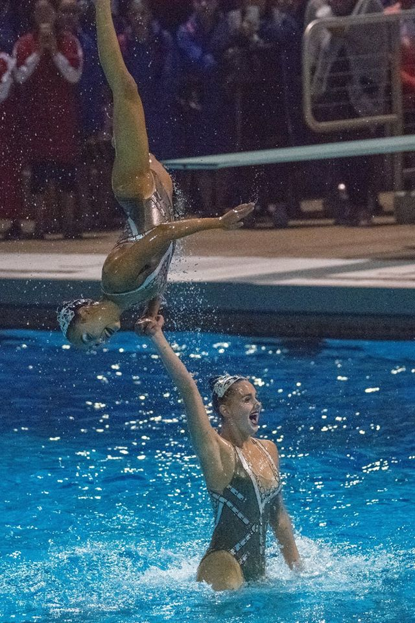
Board of Directors
Head Coach: Kim Probst
Administration: Kristen Smidstra
President: Brett Kawakami
CFO: Veronica Cerruti
Treasurer: Lei Xia & Karen Yuen
Secretary/Fundraising: Le Chu
Sponsorship: Amy Merriweather
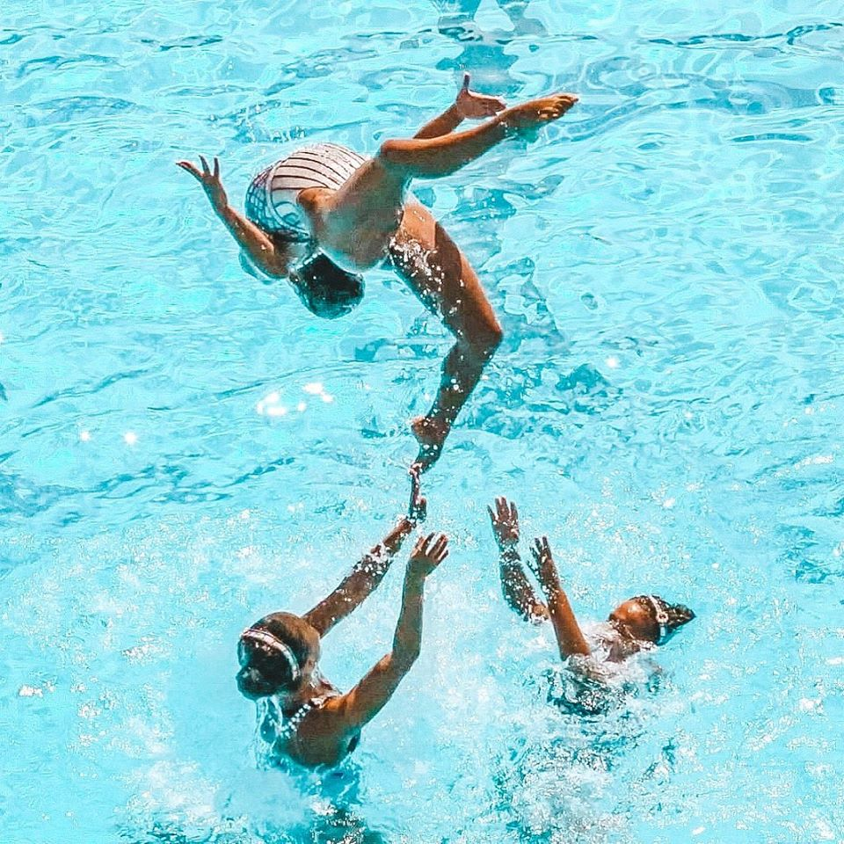
Publicity: Heather Olson
Recruitment: Andrea Flores
Travel: Heather Tiernan
Parent Participation: Lisa Horn
Bingo: Katherine Ovdia
Athlete Representative: Marlena King

