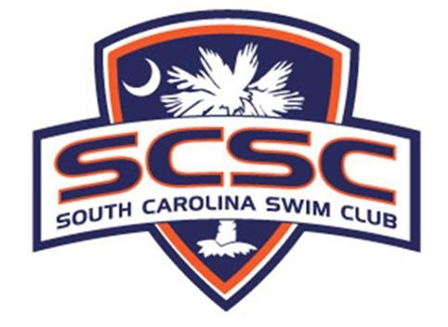

Electronic Communication Policy

As approved at June 2014 MPSCPA Board Meeting with notes added by coaches August 2015 for clarification on a few topics. Document updated February 2016 by SCSC Integration Committee.
Purpose
South Carolina Swim Club (SCSC) recognizes the prevalence of electronic communication and social media in today’s world. Many of our swimmers use these means as their primary method of communication. While SCSC acknowledges the value of these methods of communication, we also realize that there are associated risks that must be considered when adults use these methods to communicate with minors.

The purpose of this policy is to ensure best practices are followed as determined by USA Swimming. This policy is not intended to encourage swimmers to register for membership in the various forms of electronic social media. Parents are still responsible for ensuring they are adhering to the rules and regulations for each of these sites.

General Content

All communications between a coach (or other adult) and an athlete must be professional in nature and for the purpose of communicating information about team activities. The content and intent of all electronic communications must adhere to the USA Swimming Code of Conduct regarding Athlete Protection.
For example, as with any communication with an athlete, electronic communication should not contain or relate to any of the following:
- drugs or alcohol use
- sexually oriented conversation; sexually explicit language; sexual activity
● the adult’s personal life , social activities, relationship or family issues, or personal problems
- inappropriate or sexually explicit pictures
- Note: Any communication concerning an athlete's personal life, social activities, relationship or family issues or personal problems must be transparent, accessible and professional.

Whether one is an athlete, coach, board member or parent, the guiding principle to always use in communication is to ask: “Is this communication something that someone else would find appropriate or acceptable in a face-to-face meeting?” or “Is this something you would be comfortable saying out loud to the intended recipient of your communication in front of the intended recipient’s parents, the coaching staff, the board, or other athletes?”

With respect to electronic communications, a simple test that can be used in most cases is whether the electronic communication with swimmers is Transparent, Accessible and Professional.

Transparent: All electronic communication between coaches and athletes should be transparent. Your communication should not only be clear and direct, but also free of hidden meanings, innuendo and expectations.
Accessible: All electronic communication between coaches and athletes should be considered a matter of record and part of the club’s records. Whenever possible, include another coach or parent in the communication so that there is no question regarding accessibility.
Professional: All electronic communication between a coach and an athlete should be conducted professionally as a representative of the program. This includes word choices, tone, grammar, and subject matter that model the standards and integrity of a staff member.
If your communication meets all three of the T.A.P. criteria, then it is likely your method of communication with athletes will be appropriate.

Facebook, Blogs, and Similar Sites
Coaches may have individual social media pages, but they are not permitted to have any athlete member of SCSC join their personal page as a “friend,” even if it is a professional account. A coach should not accept any “friend” request from an athlete. In addition, the coach should remind the athlete that this is not permitted. Coaches and athletes cannot “private message” each other through Facebook and are not permitted to “instant message” each other through Facebook chat or other IM method.
SCSC has an official Facebook page that athletes and their parents can “friend” for information and updates on team-related matters.
Coaches are encouraged to set their pages to “private” to prevent athletes from accessing the coach’s personal information, unless the coach’s page is intended for professional purposes (meaning, not for personal connections). It is at the coach’s discretion whether or not he/she allows swimmers to “friend” them after they have graduated high school and moved on. Even then, it can only be after the swimmer has completely departed from the SCSC program and is at least 18 years of age.

Twitter
SCSC has an official Twitter page (@SCSCswimming) that coaches, athletes and parents are encouraged to follow for information and updates on team-related matters. Coaches and athletes may follow each other on Twitter, as long as the contact is professional. Coaches cannot “favorite” or “retweet” an athlete’s post unless it pertains to the program and is not inappropriate or condescending in any context. Coaches and athletes are not permitted to “direct message” each other through Twitter.
A reminder to swimmers: be cognizant of what you are posting, the language you use, and how others may perceive it. If you plan on going to college (and continue swimming or not), this is a popular outlet for admissions offices to decide whether or not they accept a student to their school.

Texting
Subject to the general guidelines mentioned above, texting is allowed between coaches and athletes during the hours from 8 am until 8 pm. All texting shall only be used for the purpose of communicating information directly related to team activities.

Email
Athletes and coaches may use email to communicate between the hours of 8 am and 8 pm. When communicating with an athlete through email, a parent, another coach, or a board member must also be copied.

Request to Discontinue all Electronic Communications
The parents or guardians of an athlete may request, in writing that their child not be contacted by coaches through any form of electronic communication.

