How to Mark Up Your Swimmer
Swim Meet Prep

What is arm marking?
You must mark your swimmer to reflect which event, heat and lane they are racing. This is used to help remind the swimmer of their events and age group tent or ready bench volunteers. Use the Heat Sheet to find and highlight your child's events. Mark the arm as illustrated below in the picture in the order of Event/Heat/Lane.
Write on clean dry skin with no sunscreen. It is best to do this the night before in order to minimize sunscreen washing it away. Please also write your child's full name on their upper back.
Heat Sheets will be posted on website (posted on the meet sign up page).
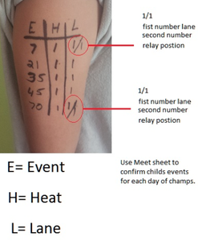
Example of Arm Marking
Write Clearly and Legibly on your child's LEFT arm as illustrated in the picture.
Stroke: If you'd like to note the stroke do so after the lane designation.
- FR = Freestyle
- BA = Back Stroke
- BR = Breast Stroke
- FLY = Butterfly
- IM = Individual Medley
- FRR = Free Relay (All swimmers swim freestyle)
- MR = Medley Relay (Each swimmer swims a different stroke: 1st = back, 2nd=breast, 3rd=fly, 4th=free)
Relay Marking: This will designate the relay leg the child is swimming.
- 1/1 = Lane 1, first relay leg
- 4/2 = Lane 4, 2nd relay leg **If the Medley Relay this will be Breast Stroke

