How to Create a Login & Register a New Swimmer
- Open Web Browser and navigate to https://www.usaswimming.org/.
- In the top right-hand corner, you will see a link to “Login/Register”. Click this link.
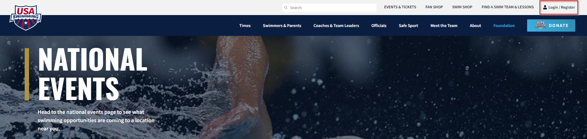
- You will see the Login screen. Click the “Create a Login” Button.
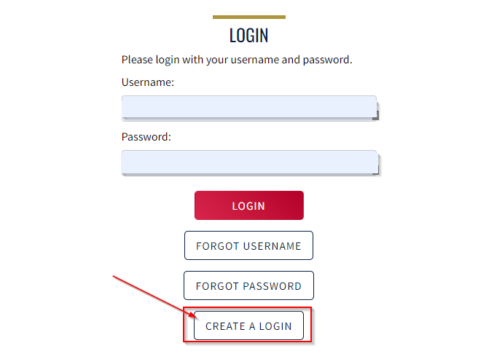

- Enter your email address and click “Continue”.
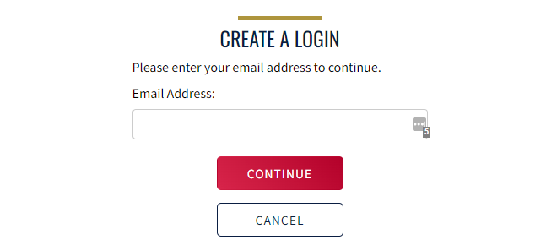

- A validation code will be sent to your e-mail address. Enter the validation code and then click
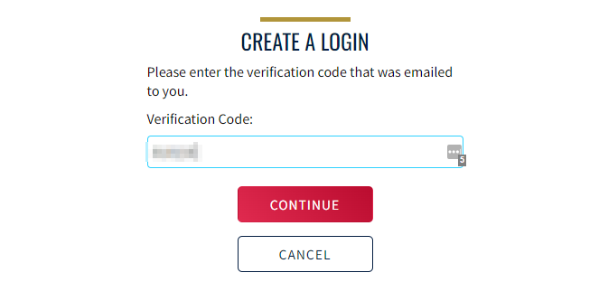

- Enter a Username and then create a secure password. Your password must have at least 10 characters and contain 1 number, 1 special character, 1 lowercase & 1 uppercase. Click Save.
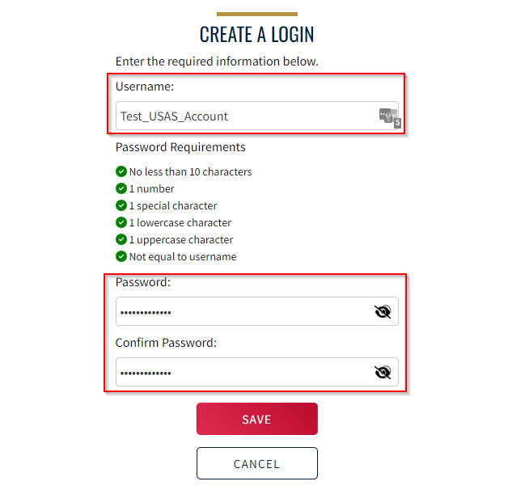

- You will be brought back to the login screen. At this point, enter the credentials you just created and click login.
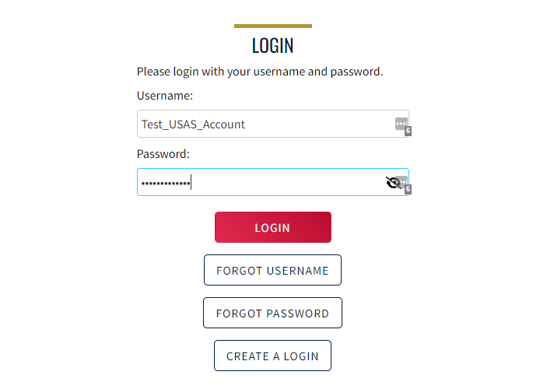

- Finalize your account setup by answering whether you have ever had a USA Swimming Membership.
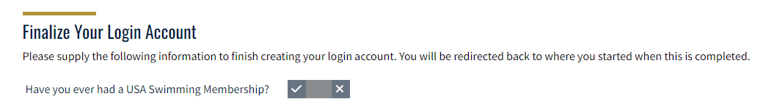

- If you have never had a USA Swimming Membership, choose “No” and enter the below information. If you have previously been a member of USA Swimming (Official, Coach, Athlete, etc), you will need to ask for alternate instructions from this point on. PLEASE DO NOT CREATE A NEW ACOUNT.
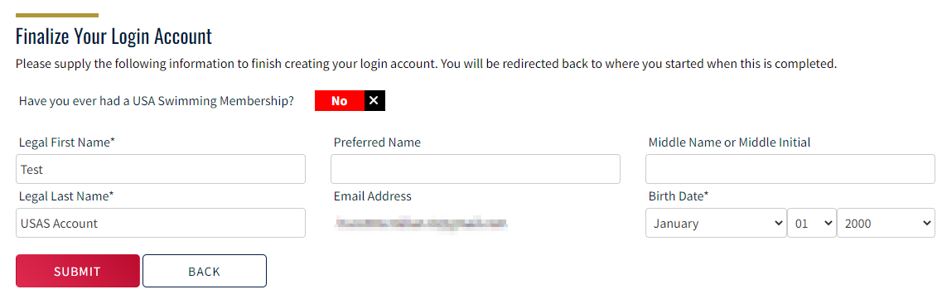

- Once you click “Submit”, you will see a series of “Legal Acknowledgements”. Once you answer “Yes” to all of the toggle buttons, you will be able to click the “Continue” button and you will be taken to the “Parent Dashboard”.
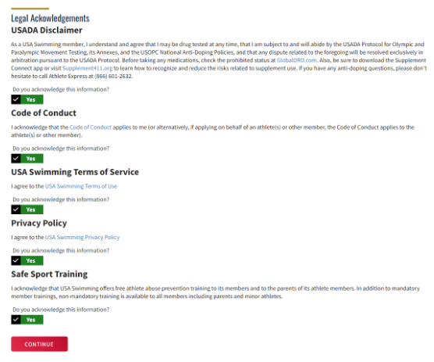
- Verify that you are logged in and then click the link that you received from your club or LSC. Click Continue.
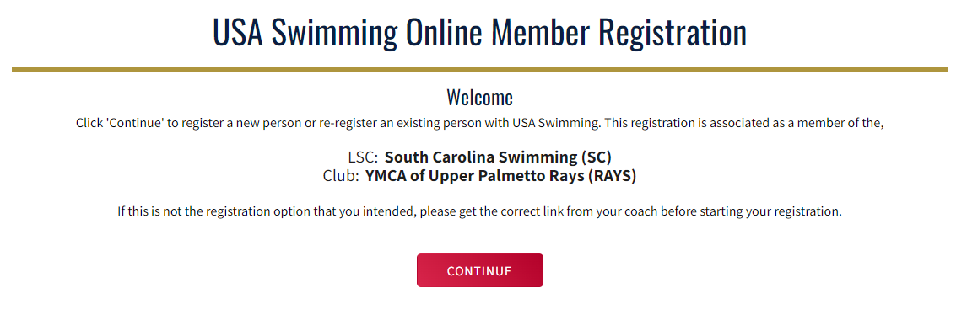
- Choose “The membership is for someone other than the logged-in user”.

- Select “No” when asked if this person has ever had a USA Swimming Membership.
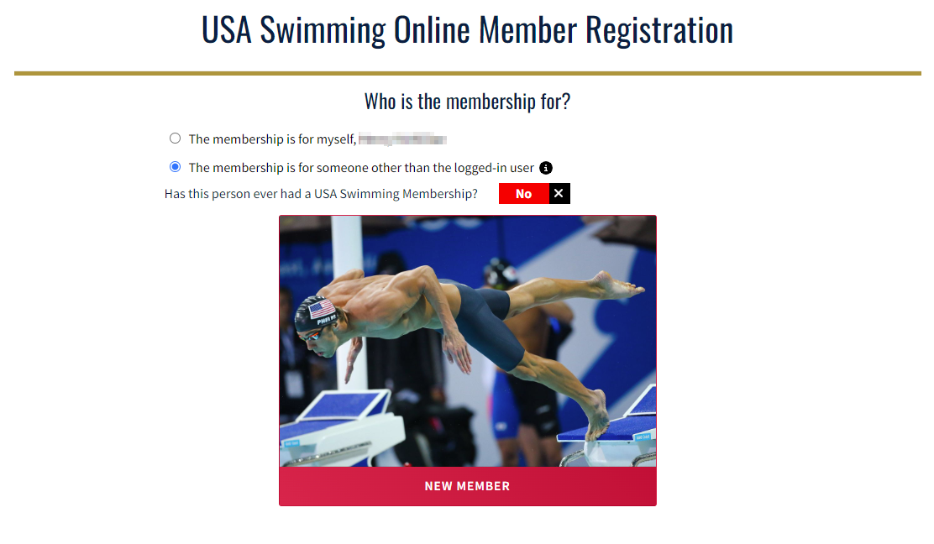

- Enter name, birthday, & citizenship information. Click Continue.

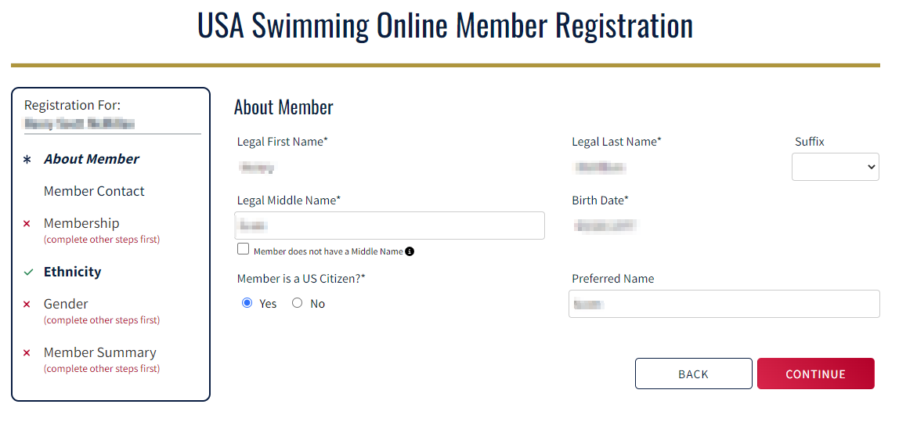

- Enter Contact information. Click Continue

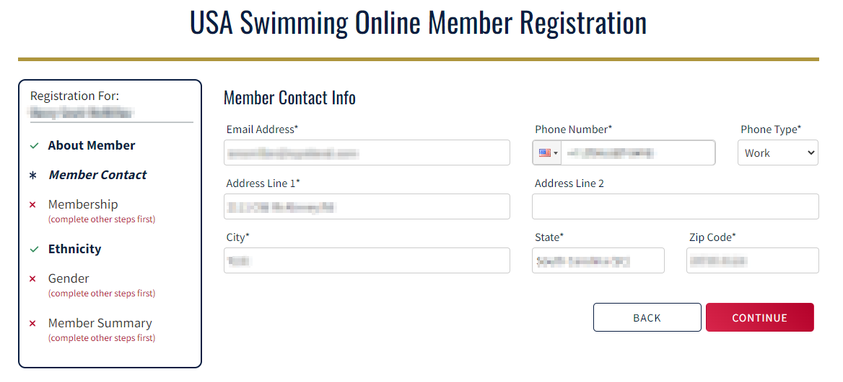

- Enter Emergency Contact Information. Click Continue.

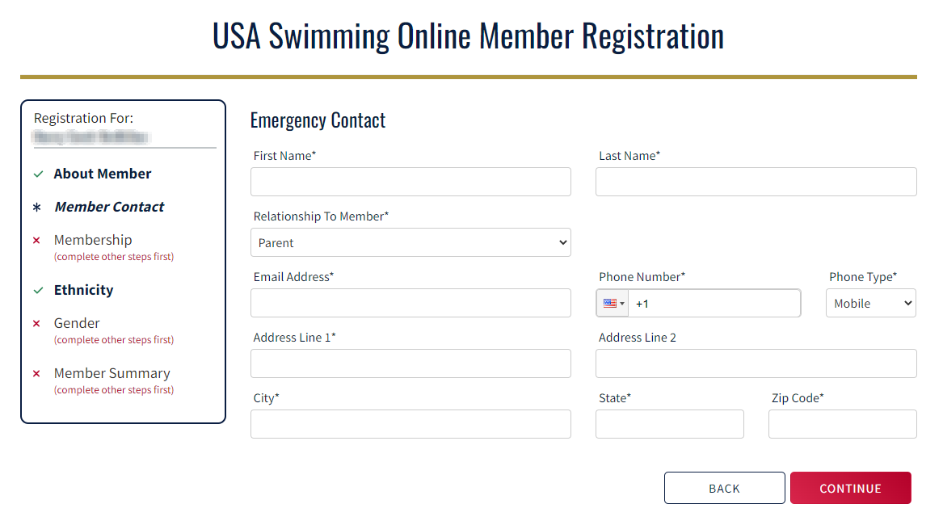

- Select Premium Athlete and click continue.

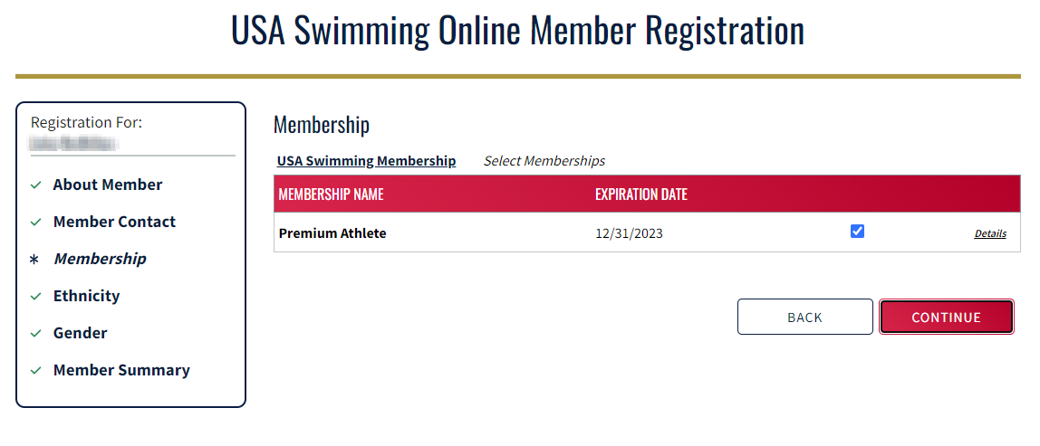

- Enter Ethnicity Information. Click Continue.

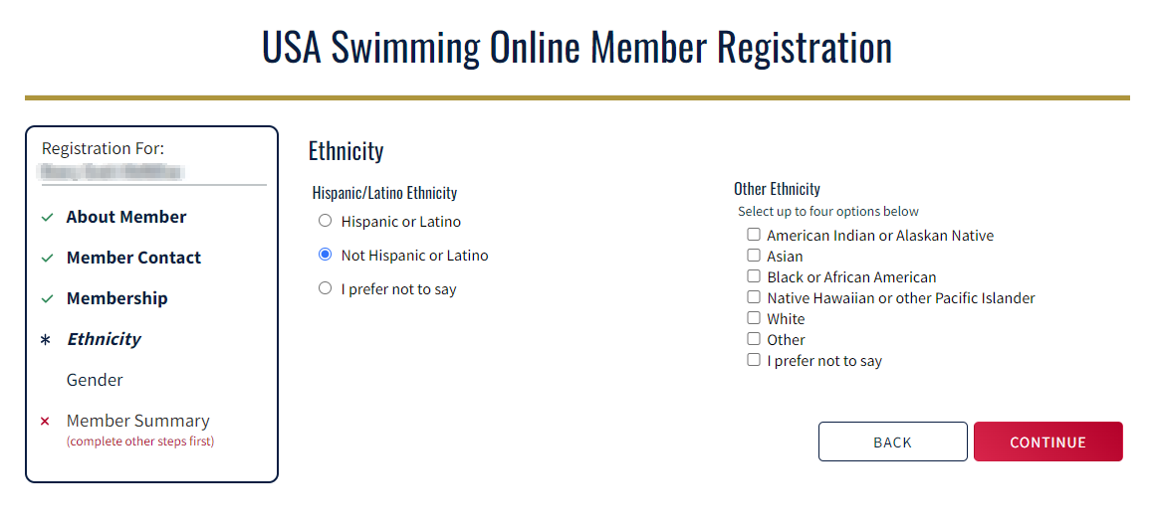

- Enter Gender Information. Click Continue.

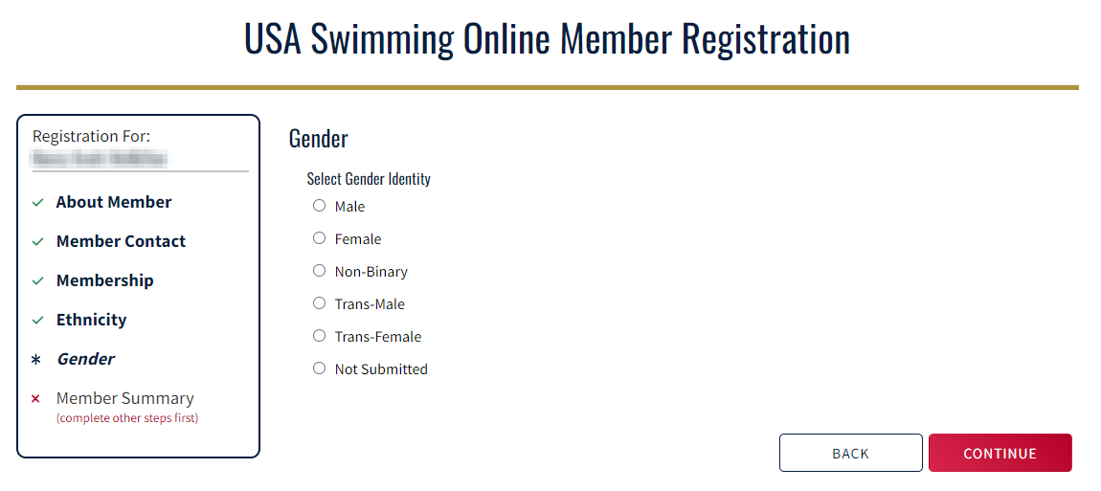

- Click each slider acknowledging that you have read each of the disclaimers and then click continue.
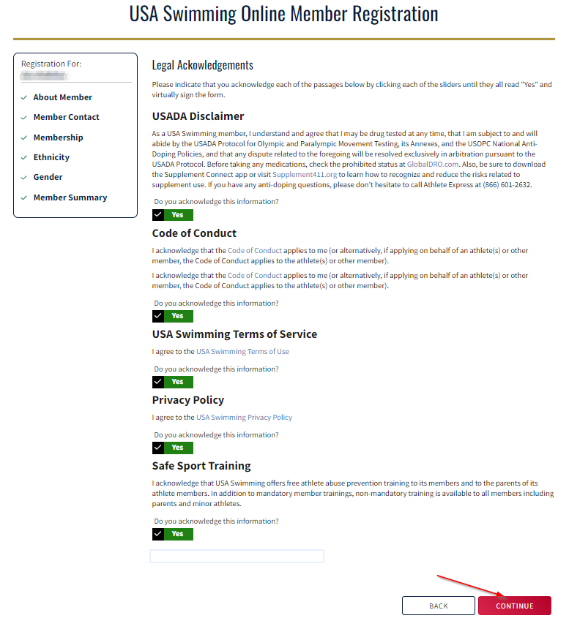
- Type your name to digitally sign these documents.

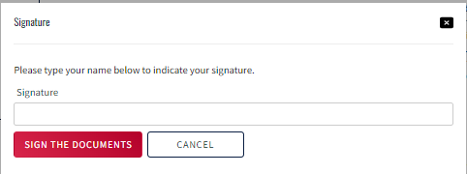
- Verify Information is correct. If you have another swimmer, choose “Add Another Member”. If not, choose “Check Out”.
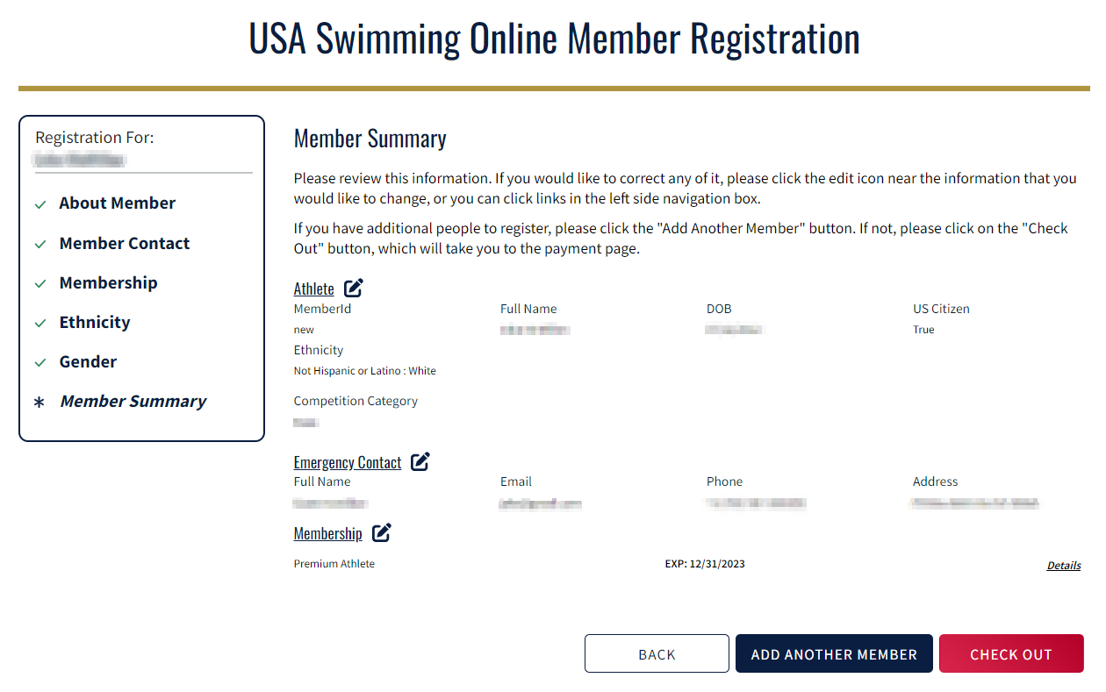
- Verify everything looks good in your Shopping Cart. Click “Check Out” to proceed to payment window.

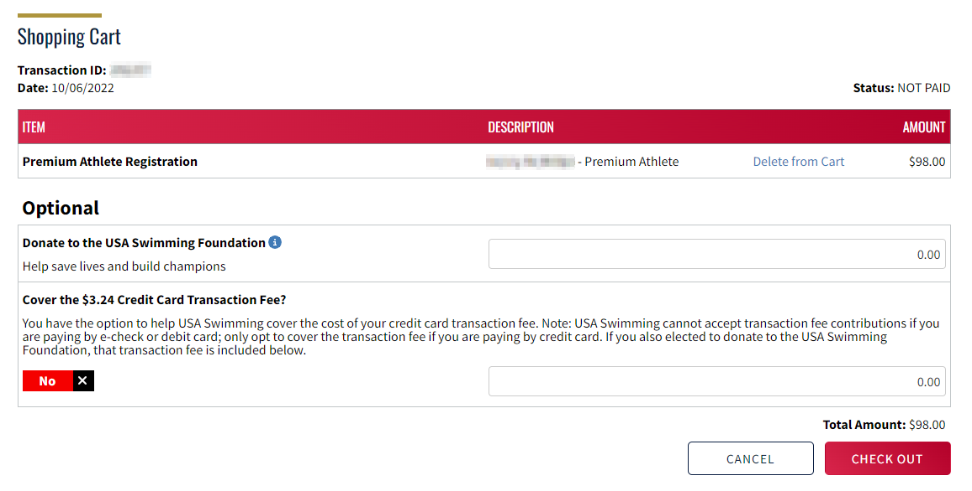

- Enter payment method. You can pay with either a credit card or Google Pay.
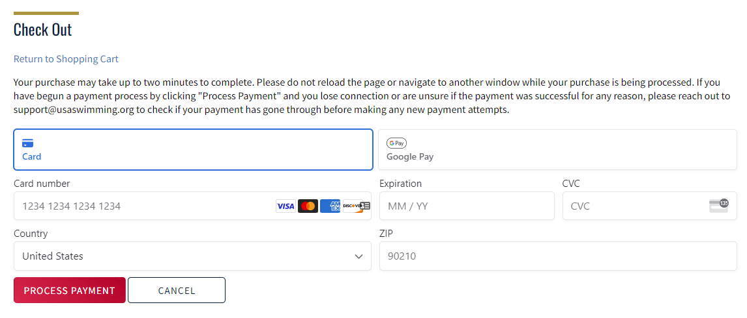
- You will receive the following message after completing your payment.
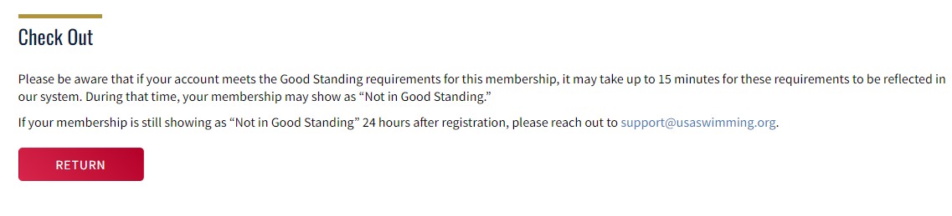
- After 15 minutes, return to your Dashboard and click “View” next to your swimmer. This will open up the “Member Info” for the athlete.
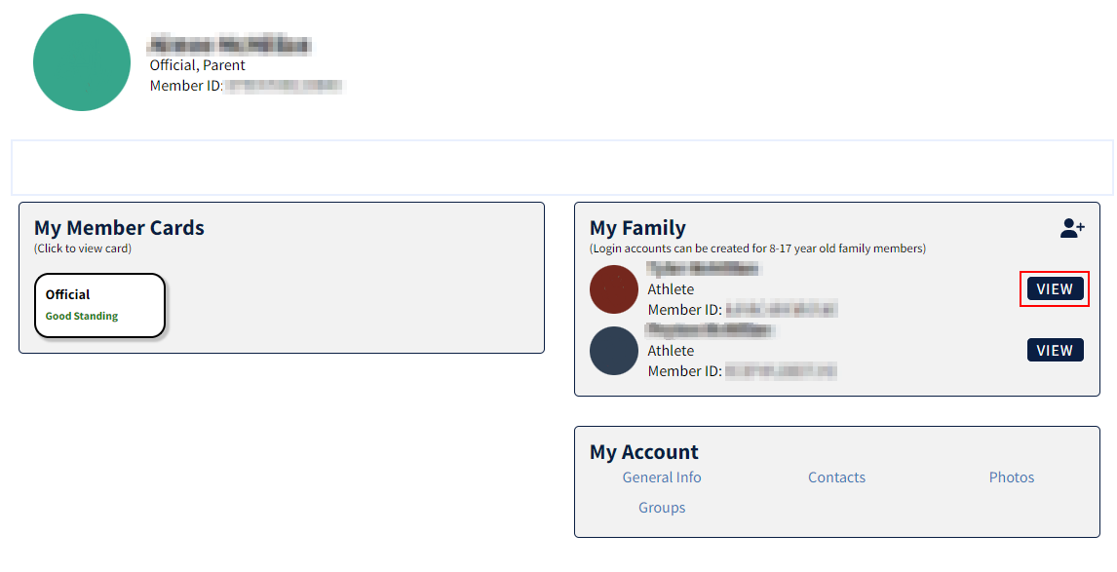

- From this screen, you will be able to upload the birth certificate for your athlete by clicking on the “Upload Birth Certificate” button. Once you have uploaded the birth certificate, click “Save”.
