Workouts for two weeks while PVAC is on break

Stretching:
Stretch every day for at least 10 minutes, twice a day.

Below, choose one activity each day or make up your own!

Yoga:
Find a 30 minute YouTube video for Yoga
Search for something similar: “30 minute morning beginner yoga”

Running:
Distance (Anywhere):
Stretch first, then go for a 5k (3.1 Miles). Work up from a light jog to running.

Interval Training:
The fitness circuit under PVIS. Run around the course and do all the activities listed on the signs (Push ups, situps, pull ups, etc.). When near the hill, sprint up to PVIS and rest at the top, walk slowly back down and continue the circuit.
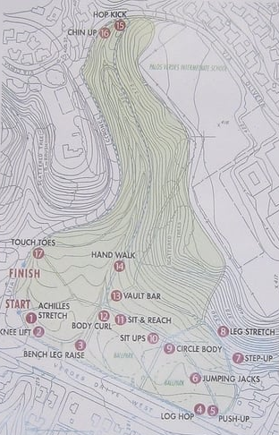

Family Hike:
Hiking Portuguese Bend Reserve (socalhiker.net)

BIKING:
Biking for Beginners (Minimal Traffic on Paseo Del Mar). Going down and back would give you nearly 6 miles.
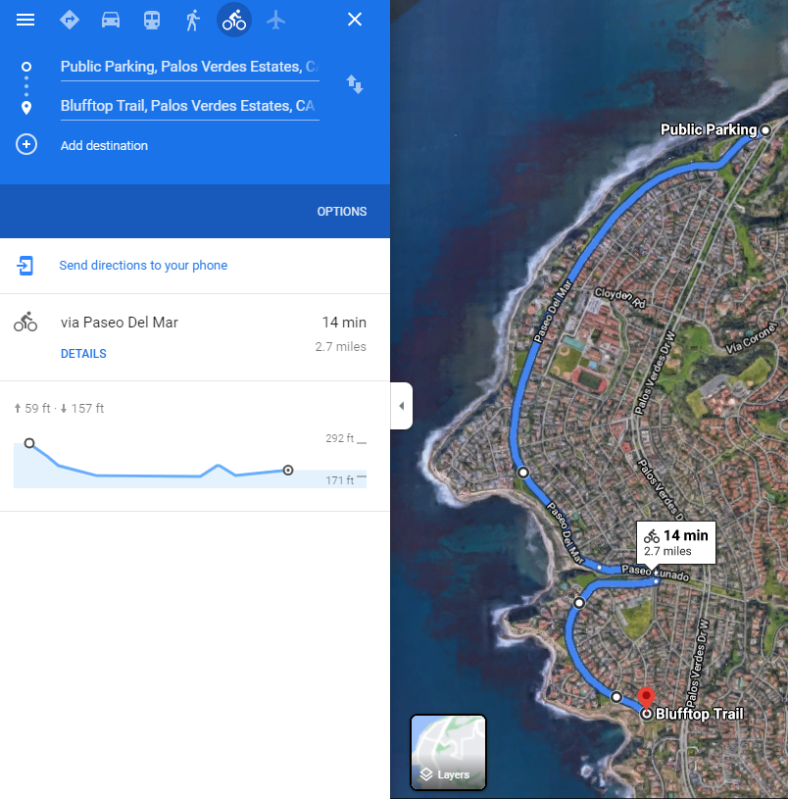
Biking Advanced - From Lunada Bay Elementary to “The Switchbacks” aka the start of Palos Verdes Dr East and back. This route has traffic and bumpy sections. This route is 13 miles total.
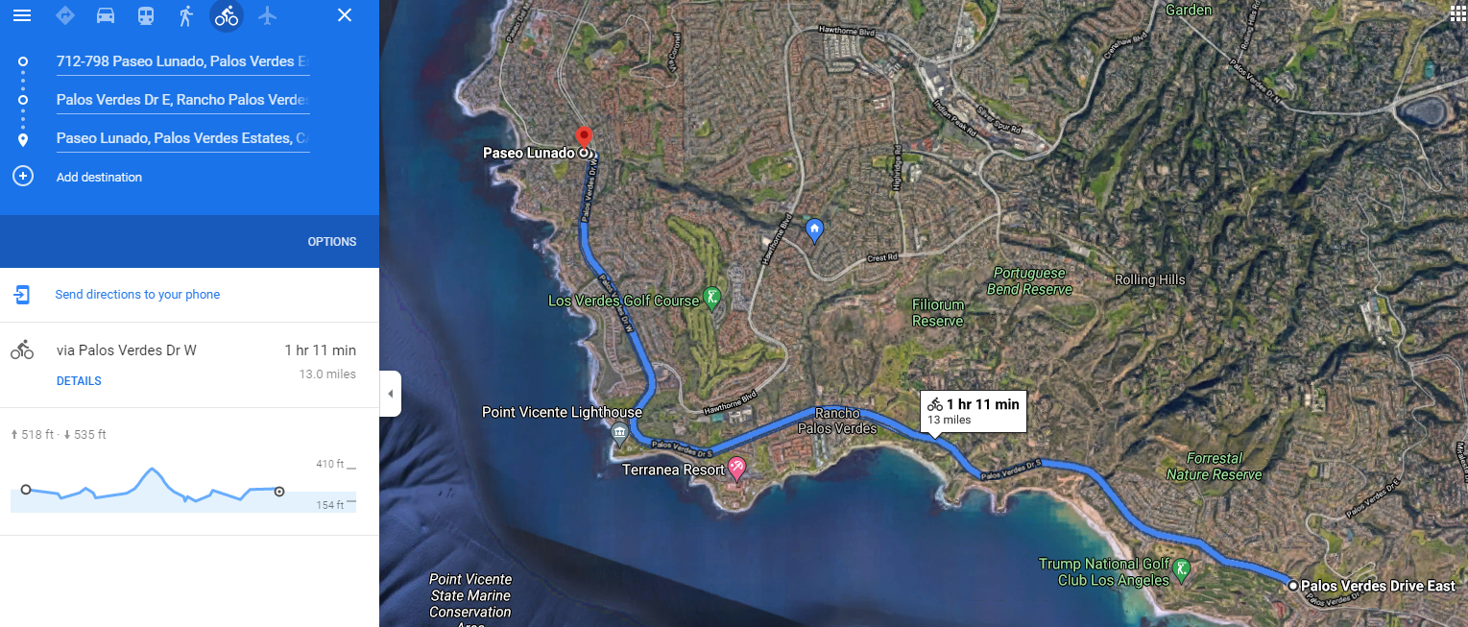

SURFING:
If you know how to surf, that’s an excellent workout - 2+ Hours

SWIMMING:
If you have access to a pool, here are five workouts you can choose from. Cooldown not included in sets. Please be sure to cool down until your heart rate goes back to normal.

Stretch prior to swimming: Try This Stretch Before Your Workout! - YouTube

Mid-distance Day:
500 Warmup
8 x 50 Build Freestyle @ :55
12 x 25 Kick @ :40
8 x 75 Pull @ 1:20
12 x 25 {First 6 - Sprint First Half of Lap
Last 6 - Sprint Last Half of Lap} @ :35
Main Set:
8 x 100 Freestyle @ High Endurance Speed (Less than max) Ex: 1:30
Intermission: 10 x 25 Streamline fly kick on your back @ :55
8 x 100 Freestyle @ High Endurance Speed (At max speed) Ex: 1:20

Stroke Work Day (after warmup and the first two sets, no more freestyle)
500 Warmup
8 x 50 Drill/Swim @ 1:10
8 x 50 Kick/Swim @ 1:10
6 x75 in+out (Fast in and out of walls) @ 1:45
good amount of rest so you can sprint your walls and streamlines)
From the middle, 12 x 25 (fast turns, long streamlines) @ :40
10 x 50 Build first lap, sprint second lap @ 1:30 (Lots of rest)
4 x 75 fast (can be IM with no free) @ 1:30
12 x 25 Streamline dolphin kick as far as you can on stomach underwater.
Once surfaced, switch to your back for dolphin kick @ 1:00

IM Day:
500 Warmup
8 x 75 Kick Drill / Swim (IM Order) @ 1:35
14 x 25 From the middle, (200 IM Transitions) @ :40

Two Cycles:
100 IM @ 1:45 (Hit your walls like your hitting a touchpad)
100 Freestyle @ 1:30 (long, stretched out strokes)
200 IM @ 3:30 (Hit your walls like your hitting a touchpad)
200 Freestyle @ 3:00 (long, stretched out strokes)
4 x 25 {25 Fly, 25 Back, 25 Breast, 25 Free} @ :35
4 x 50 {50 Fly, 50 Back, 50 Breast, 50 Free} @ 1:10

Sprint Day:
500 Warmup
10 x 50 Freestyle with paddles
12 x 25 Kick {First 6 - Sprint First Half of Lap, Head down
Last 6 - Sprint Last Half of Lap into finish hard } @ :40
4 Cycles:
8 x 25 Freestyle Fast on @:30 (Race pace for all 25s)
100 Kick (w/ or w/o kickboard) @ 1:45
75 all out - try to stay at or under your best psycho 75 (~0:52)
100 easy with paddles

Saturday Morning Workout:
400 Swim, 300 Pull, 200 Kick, 100 Sprint
8 x 50 Build Freestyle
200 Warm Up In’s and Out’s
400 In’s and Out’s
Situp Set: 10 Crunch - 20 Twists - 10 Leg ups
Other side:
Explosive Squats x 10
Pushups x 5
Burpees x 5
30 seconds of wall sits or planks
Jump rope (30 seconds)
If you still have energy:
3 Cycles x { 100 Freestyle Sprint
100 Broken Freestyle Sprint (by 25s, 5 seconds rest on each wall)
Compare your times
}

