5th Annual MIKE MILLER FAMILY RELAY EVENT 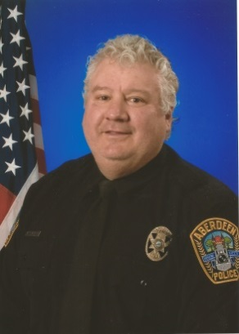
What: 200 Free Relay
When: Saturday after the completion of the afternoon session (approximately 4 pm).
Who: A family from any team may form a relay team. Each relay team must have a minimum of 4 swimmers with at least one adult over the age of 18 (so 19 & above). Family members can be Mom, Dad, Brother, Sister, Aunt, Uncle, Cousin, Grandma, Grandpa, Niece or Nephew. Each team may have 1 unrelated team member (so 3 must be related).
We will also allow teams that do not meet the “family” requirement above. However, they will not be eligible for the trophy and bragging rights. Please indicate this on your sign-up sheet.
Where: Aberdeen Aquatic Center – Aberdeen, SD
Register: Registration will be taken at the Friday evening session and all day Saturday until 3 pm.
Why: In honor and memory of Mike Miller who lost his short battle with cancer in March of 2014. Mike was the “voice” of ASC for many years announcing at our swim meets. His daughter Michyl swam for many years and was an ASC assistant coach.
Mike was an advocate for education and served on the Aberdeen School Board as the President and was recently elected to the South Dakota High School Activities Association. He was also a member of the Aberdeen Police Reserves as well as the dive and rescue team.
Donation: ASC is requesting that participating teams make a donation to the Mike’s Mafia Team for the American Cancer Society Relay for Life in Brown County, SD. A donation basket will be at the timing table where you sign up. However, a donation is not required to participate.

Disclaimer and Fine Print: The Family Relay is not part of the sanctioned swim meet! It is a fun event for family participation. Entrants in this event must do so at their own risk. The Aberdeen Swim Club, City of Aberdeen and the Aberdeen Parks & Rec will not be held responsible for any injury or accident as a result of participation in this event!

