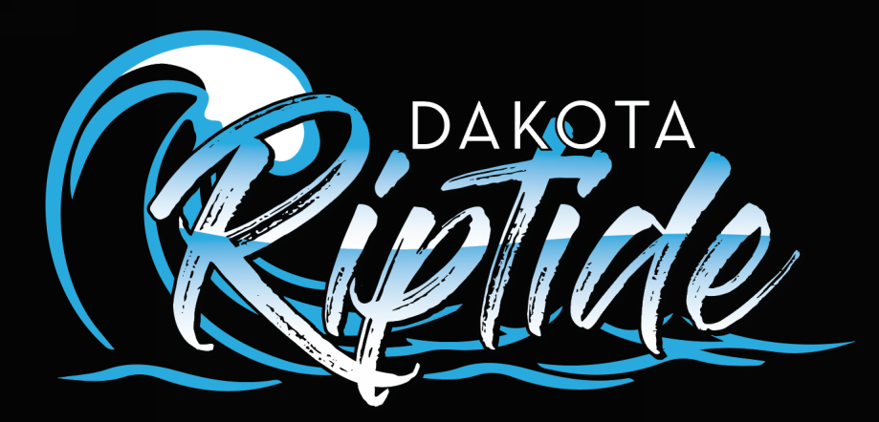

Dakota Riptide Code of Conduct, Disciplinary Procedures

Code of Conduct: Athletes

Whereas the Dakota Riptide is established to promote the sport of swimming and in the process help to develop the character of the individual swimmers,

Whereas, for the orderly operation of the Dakota Riptide certain rules and regulations and procedures for enforcing same must be established,

Whereas, it is the expressed intention of the Dakota Riptide to set forth procedures that will aid in identifying behavior the club finds undesirable and define a process for addressing an alleged occurrence.

Therefore, be it resolved that the following shall be the Disciplinary Code and Procedures:

This Disciplinary Code shall apply to all behavior occurring or at an activity or function that is associated with the Dakota Riptide including but not limited to: swim practice, swim meets, team trips, team outings, or individual group outings and addresses objectionable behavior by members of the Dakota Riptide occurring outside of club activities.

The types of objectionable behavior shall be divided into three (3) classifications:

CLASS I - Shall deal with the behavior that is considered very severe and disruptive, possibly life threatening and/or in direct violation of governmental laws. These are actions that are so detrimental that it is not desirable to have such a person associated with the team.

CLASS II - Shall deal with behavior that is considered disruptive; having a detrimental effect on one’s self, other members of the team, or the general public; causes significant damage to the reputation of the club and/or their coaches; leading to possible injury of self or other persons.

CLASS III - Shall deal with behavior that is somewhat disruptive; does not portray the Dakota Riptide in a good light; and other actions that are not in compliance for good behavior as a member of a team or society in general.

CLASS I Objectionable Behavior:

Unacceptable Behavior (including, but not limited to): Sale or distribution of illegal drugs, conviction of felony and fighting that results in the severe bodily injury of any person (regardless of whether or not this behavior takes place at a club activity).

Disciplinary Procedure:

- Board shall send notice of disciplinary hearing to parent/guardian and swimmer via e-mail.
- Following a Class I accusation, dependent on an individual case by case basis, a hearing before quorum of Board of Directors with parent/guardian and swimmer being given the opportunity to be present; the facts shall be presented by the Board President or his/her designee; Head Coach shall be present in advisory role.
- Board decision to be sent via certified mail to the parent/guardian and swimmer within one to two weeks following the disciplinary hearing.
- During this process, the swimmer could be suspended from some or all club activities.

Recommended Discipline:

May result in membership termination or other action as determined by the Board of Directors.

CLASS II Objectionable Behavior:

Unacceptable behavior as a member of the Dakota Riptide at team functions, practices, and meets. This behavior would include, but not limited to: Physical assault of any persons, possession or use of illegal drugs, alcohol or tobacco, theft, or significant vandalism.

Disciplinary Procedure:

- Hearing before Disciplinary Committee consisting of three (3) members of the Board of Directors chosen by a majority of the Board.
- Committee shall send notice of hearing to the Parent/Guardian and swimmer via certified mail with the parent/guardian and swimmer being given the opportunity to be present.
- The facts shall be presented by the Board President or his/her designee; the Head Coach shall be present in an advisory role.
- Board decision to be sent via certified mail to the parent/guardian and swimmer within one week.

Recommended Discipline:

1st Offense – Suspension * from the team for a minimum period of ten (10) to maximum period of thirty
(30) calendar days of the swimmer’s season (these days may extend into the swimmer’s next season, if needed).

2nd Offense – Shall be considered a violation of Class I Objectionable Behavior and handled according to the disciplinary proceedings of Class I Objectionable Behavior.

*Terms of suspension shall be spelled out by the Board of Directors and must be adhered to by the swimmer/parents in order to be reinstated by the Board at the end of the suspension period. During the periods of suspension, swimmers remain a member of the Dakota Riptide and thereby all dues and fees are still due in full from the swimmer. The swimmer cannot be reinstated until any fees and/or dues that are in arrears are paid in full.

CLASS III Objectionable Behavior:

Unacceptable behavior at Dakota Riptide practices, competitions and team functions that include, but are not limited to: minor vandalism, being disruptive in practices or meets, abusive language or behavior, insubordination to members of the coaching staff, chaperones or others, other acts of misconduct as determined by the coaching staff.

Disciplinary procedure:

- Handled by the Coaching staff (Parents will be notified of repeated incidents of misconduct).

Recommended Discipline:

As determined by the coaching staff (including but not limited to, duties as assigned by the coaching staff, suspensions from practice, and/or suspension from meet(s). Suspensions may range from 1-10 days with written notification from the coach(es) to the parent(s) and board president. Repeated Class III offenses may result in the offense being considered a Class II Objectionable Behavior.

During all investigations into allegations of Class I & II offenses involving questioning or interviewing of the subject swimmer, a parent or guardian of such swimmer shall be present.

