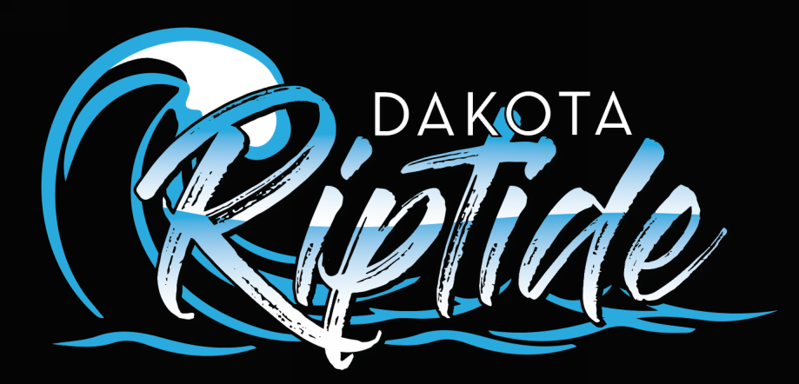
Disciplinary & Complaints Procedure
The aim of these procedures is to allow a swift and just outcome to a complaint or protest made by a Swimmer, Parent/Guardian or Coach, in good faith, regarding conduct during practice, swim meets or related Dakota Riptide activities.
Complaints by Swimmers
- Complaints by Swimmers raised as a formal complaint should be taken no less seriously because they are a Minor, than if raised by a Senior Swimmer. Raising an issue of concern is not easy and the Coaches should be sensitive to the difficulties this poses for the Swimmer, particularly if they feel their action will lead to discrimination. Swimmers should be encouraged to voice their concerns informally to the Coach as soon as possible, and should expect a mature response from the Coach. If they remain dissatisfied, they should then raise their concern with the Head Coach, or in his absence the Head Teacher. Swimmers should feel able to have these conversations without intervention from others, but if they wish to be accompanied then this should be respected.

- If this does not resolve the matter, a formal complaint should be lodged. In the case of Swimmers under 18, it would be expected that this is with their Parent’s consent. This should be in writing either to the Head Coach, if he/she is not involved in the dispute, or to the Dakota Riptide Board. The matter will then be investigated and a formal resolution meeting established. Following the meeting, a record of the meeting and subsequent recommendations will be given in writing to all participants.

Complaints by Parents regarding Coaching/Swimming issues
- Complaints by Parents should be raised with the Coach informally as soon as possible after the alleged incident/issue occurs. This ensures that misunderstandings can be more readily addressed whilst they are clear in everyone’s minds. It is expected that Parents will raise the issue directly with the Coach concerned, before discussing it with other Parents and Swimmers. Complaints are bad for morale and need to be sorted out quickly and fairly. This becomes much more difficult once views are polarized and others become involved. We see complaints as an important tool to improve our club.

- If the Parent is dissatisfied with the Coach’s explanation, or feels that the problem is recurring; this should then be raised formally in writing with the Head Coach. If he/she is involved in the complaint then the complaint will be handled to the Dakota Riptide secretary. Following discussion and investigation, a formal resolution meeting will take place. A record of the meeting and subsequent recommendations will be given in writing to all participants.

- Where there is concern that a Parent has a fundamental problem with the approach taken by a Coach, the complaint investigation has not upheld the complaint, and the Parent is unwilling to accept this decision, then the relationship between the Parent and Coach may be deemed to have broken down irretrievably. In these circumstances, the Coach will retain the right to request suspension of the child from their respective practice group.

- This would be a measure of last resort, but may be necessary to protect the Coach from a deteriorating relationship with the Parent, and therefore the Swimmer. In extreme cases, the Swimmer could be asked to leave the Club, after review of the situation with the Dakota Riptide Board, Coach(s) and Parents, and if applicable swimmer.

Complaints by Parents regarding Dakota Riptide issues
- Complaints by Parents regarding Dakota Riptide issues can be raised informally with any member of the Dakota Riptide Board. A decision will be made between both parties as to whether this requires discussion at the Dakota Riptide Board meeting, and in what format. Formal complaints should be made in writing to the Co-Presidents of the Dakota Riptide Board.

Complaints by Coaches

Complaints by Coaches will follow the same procedure as above. Coaches like Swimmers and Parents, have the right to be treated with dignity and respect

- Where Coaches feel a Swimmer is not acting in accordance with the Dakota Riptide Code of Conduct, they will have the right to exclude the Swimmer for a specified period. The duration of this will be clearly stated. Where the Swimmer continues to misbehave, a formal record of this will be sent to their parents. If this does not improve behavior, the Coach will undertake a formal meeting with the Swimmer and Parents at which a written agreement will be agreed to by all parties. Any further problems which arise during the time defined in the agreement could lead to the swimmer being asked to leave Dakota Riptide.

- It must be remembered that Coaches’ time spent on trying to maintain discipline and improving behavior is time unavailable to other Swimmers. Where Coaches have a complaint against a Parent, a meeting should be set up as quickly as possible to resolve the problem. If this does not resolve the problem satisfactorily, a formal meeting will be established as above with both the Head Coach and another representative of the Dakota Riptide Board.
It is not anticipated that these procedures will be used with any frequency. The aim of all involved in Swimming is to encourage the tripartite relationship of Swimmer, Coach and Parent working together to assist the Swimmer to reach their maximum potential. Sometimes this relationship temporarily breaks down, and everyone must be committed to maturely identifying the cause and then repairing it, in order that the Swimmer can continue effectively. In using this procedure, it is expected that Complaints are made in good faith and will not be externally lodged until the procedure has been exhausted. Malicious complaints, if so identified, will not be tolerated and will lead to exclusion on a permanent basis.

