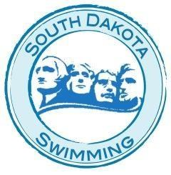
SOUTH DAKOTA SWIMMING, INC.

Summary of Changes to Policies and Procedures As Approved at the

2017 HOD Meeting

Spring 2017
- Rule 3 Increase amount for Central Zones
- Rule 11 Increase amount for Work Sessions

Fall 2017
- Add Health Awareness Heading to Meet Invitations
- Rule 9.3.1 Increase time the pool is available
- Rule 9.9 Format of Short Course State Meet
- Rule 9.15 Change to State Qualifying Time

