North Dakota LSC
Sunday, May 6, 2018 – 9:00a-12:30pm
Expressway Inn & Suites – 4303 17th Ave. S – Fargo, ND 58103
Randy Julian, USA Swimming Sport Development Consultant

USA Swimming offers this exciting and unique workshop for coaches and board members to learn how to be effective in leading and governing their team. Swim Club leaders work together in learning about new strategies to improve their club.
This course is required for all new clubs. However, it is also highly recommended for all existing programs and is open to everyone. If you are a Board Governed program it is recommended that both the Board Chair and the Head Coach attend.

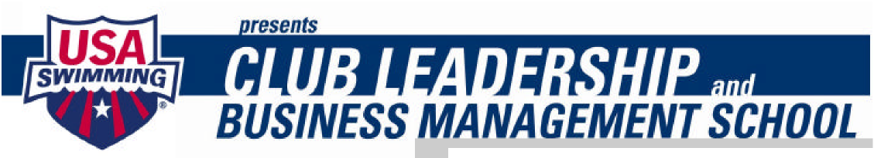

“I really wasn’t looking forward to spending a beautiful weekend indoors listening to lectures. When the seminar concluded, I walked away re-excited about our team and with a lot of good ideas.”

COURSE OUTLINE  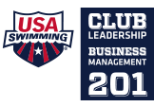  - Mission and structure  - Finances, budgets and fundraising  - Policy setting  - Strategies for the future  - Staff & BOD responsibilities  - Using task forces & committees  - Engaging volunteers  - Meetings & agendas  - Developing leaders  - Insurance issues for clubs  - Safe Sport review | DURING THE COURSE YOU WILL LEARN  - Effective ways to communicate on your team  - Items to look for when developing a budget  - Understanding fiduciary responsibility  - Fundraising suggestions  - How to govern more and manage less  - Ten basic responsibilities of a board  - Three legal duties of a board  - Available resources

CLBMS 201 is an in-person course which is required prior to the second year of club membership and strongly encouraged for all club leaders. Completion of the 101 online course is advisable prior to attending a 201 course.

CLBMS 101 - To register for CLBMS 101 Online, click HERE. The class takes about 1 hour.

For more information, contact:  Shane Peterson  North Dakota Swimming General Chair  shane@diamondnd.com | Please pre-register by May 1, 2018  To register, e-mail:  Shane Peterson at shane@diamondnd.com  The class is free

