**SD 2019 Athlete Election Proposal**

**Current Bylaw to be changed:**

4.1.4 ATHLETE AT-LARGE HOUSE MEMBERS -A sufficient number of athletes to ensure that Athlete Members constitute at least 20% of the voting membership of the House of Delegates shall be elected by the Athletes as referenced in Article 6.2 and shall hold office from the date of election through the conclusion of the annual meeting of the House of Delegates following such election or until their successors are elected to the House of Delegates.

**Proposed Change**

4.1.4 ATHLETE AT-LARGE HOUSE MEMBERS -A sufficient number of athletes to ensure that Athlete Members constitute at least 20% of the voting membership of the House of Delegates shall be elected by the Athletes at the same time as the Athlete Representatives are elected to the Board as state in Article 6.2.

Athletes to the House of Delegates will be selected with geographical representation.   The state will be split into three different sections. The candidate that receives the most votes from each section will become a House of Delegate representative. The next two candidates that receive the most votes, regardless of section, will fill up the remaining two House of Delegate spots.

Athletes shall hold office from the date of election through the conclusion of the annual meeting of the House of Delegates following such election or until their successors are elected to the House of Delegates.

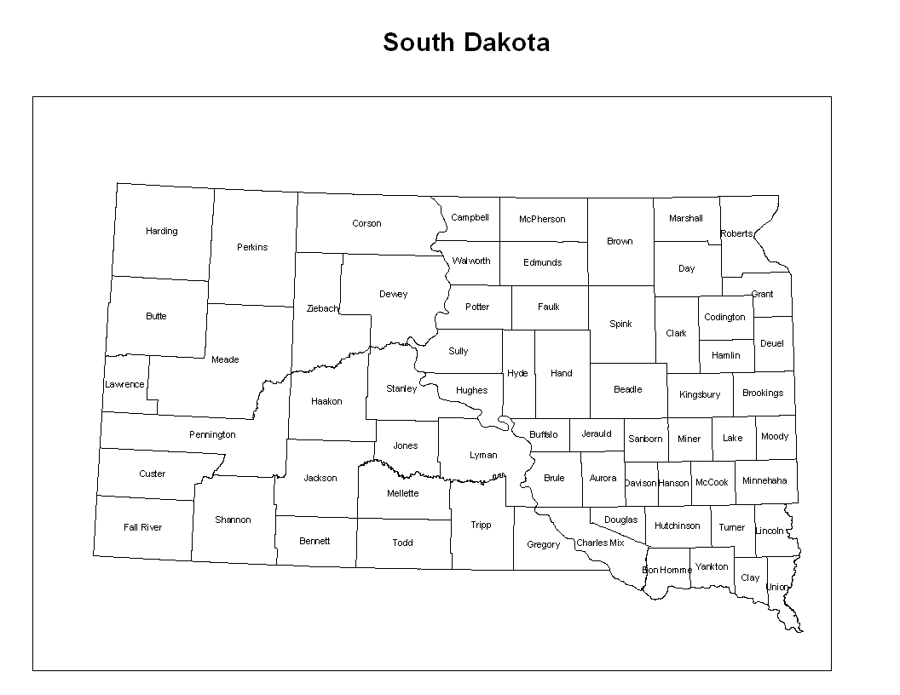**Supporting Information**



1.      There are 5 House of Delegate athlete positions open for election each year.

2.      The state will be split into three different sections. The picture above shows the current idea for how the state could be split based on the population of  thirteen and over swimmers in each section.

3.    Thirteen and over swimmers will be the only ones to vote. Each swimmer will get to vote for five candidates.

4.      The candidate that receives the most votes from each section will become a HOD rep.

5.      The next two candidates that receive the most votes, regardless of section, will fill up the remaining two HOD spots.

6.      If there is no athlete running for a section, that section’s delegate will be given to the next candidate receiving the most votes, regardless of section.

**For BOD, the two candidates that receive the most votes would become the Jr. Athlete Reps for the BOD.**

______________________________________________________________________________

**Section Makeup:**

1. **West**
   1. Teams:Black Hills Gold, Lead-Deadwood, Rapid City Racers, Greater Rapid City Ellsworth, Fall River Swim Team, Pierre Swim Team, Sturgis Swim Team
      1. Seasonal: Chamberlain Swim Team
   2. Number of thirteen and over swimmers: **171 total - 147 annual, 24 seasonal**
2. **North**
   1. Brookings Swim Club, Watertown Area Swim Club, Aberdeen Swim Club,
      1. Seasonal: Sisseton, Webster, Miller
   2. Number of thirteen and over swimmers: **221 total - 165 annual, 41 seasonal**
3. **South**
   1. Huron/Mitchell, Madison Makos, Sioux Falls Swim Team, Vermillion Area Swim Team, Yankton Swim Team
   2. Number of thirteen and over swimmers: **191 total - 0 seasonal**

