**Minutes - SD BOD Meeting**

**9pm cst/8pm mst– February 3, 2020**

**Conference Call**

**Phone: 712-770-3721**

**Access Code: 327979**

**Mission:** Providing swimmers opportunities to achieve success for a lifetime

**Vision:** Inspiring Excellence, Transforming Lives

**Core Values:** Stewardship, Integrity, Commitment

1. Roll Call
   * Joel
   * Laura
   * Trish
   * Cassi
   * Martin
   * Clyde
   * Brenda
   * Bonnie
   * Robin
   * Caleb
   * Mason
   * Kyle
   * Karry
   * Jamie
   * Cole
2. Consent Agenda Motion Cassi, Bonnie 2nd, all in favor.
   1. Approval of Agenda
   2. Approval of previous BOD meeting minutes (12/2/19)
   3. Approval of previous BOD meeting minutes (12/12/19)
   4. Reports as presented, updated top 16 and sent them to Trish.
   5. Clyde Zones Diversity Camp, once it’s open, he will send out info. In report. Closes March 16th. 4 swimmers 2 boys 2 girls.
3. New Business
   1. State Qualifying Times (Biel, Margheim). Both SC and LC would be recommended. Bonnie sent out info after last meeting. Kyle and Bonnie to draft a proposal for HOD in April.
   2. Election proposal (Swanson, Anderson, Kincart, Timmer) See Proposal below, Kyle moved to make this an action item, Cole second. All in favor. To be presented at HOD in April
   3. Leadership Summit Application Committee (Swanson, Anderson, Kincart, Timmer) both ND and SD have received the grant, both states get $2,000 to go toward Leadership Summit. Stage we need non-Athlete help. Released application a week ago not a lot of applicants yet but they need to get the word out. Need help with planning and selection. Robin would be happy to help with the budget. Clyde willing to help. Trish would like something for the website. When should the application be due? Date June 18-19 Thursday- Friday. End of March would be a good time to have applications due. Geared towards high schoolers. Brenda and Kyle would help with the selection process.
   4. Sanctions, some changes have been made to the sanctions template. Possibly have a line in there saying that if the 4-hour rule is reach we will remove X races to accommodate the 4-hour rule. It needs to be in the sanction or you need to call a meeting of the coaches. Rule changes and eliminating redundancies. Lisa moves to approve the sanction template as presented, Kyle 2nd. Where is the google doc stored, under Sanction Chair Google email Drive. Martin, suggest that there may be an issue if it is a scored meet, Cassie is willing to add wording to exclude scored events, or wording that the admin will make arrangement for swimmer to swim in another event. All in Favor. Approved as a board item and not carry it over to the HOD <https://forms.gle/LFZ1u9ahfpmdnrUX8>
4. Workshop Items
   1. Strategic Plan Initiatives
      1. To Increase athlete performance and retention of upper level swimmers. (Margheim, Swanson)
      2. To increase 11 and Over athlete performance and retention of mid-level swimmers (Hendricks, Baechler, Swanson) Some talk trying to narrow down how to make it an LSC leave ideas.
      3. Host an annual awards banquet (Pietz and Timmer) waiting till the Leadership summit is done.
      4. Governance (Kincart and Schmidt)
      5. Improve communication within the LSC (Pineiro, Harrell, Sorbe)
   2. Nominations
      1. **General Chair**, Joel Kincart (GREA) - Completed 1 of 2 possible terms
      2. **Age Group Vice Chair**, Bonnie Biel - Term limited, actively looking for a nomination.
      3. **Finance Vice Chair**, Shelly Anderson (MAC) - Completed 1 of 2 possible terms
      4. **Secretary**, Laura Pineiro (GREA) - No term limit
      5. **Safe Sport Chair**, Carrie Ward (PST) - Finished a previous term, so 0 of 2 possible terms
      6. **Officials Chair**, Jamie White (HPRW) - Finished a previous term, so 0 of 2 possible terms
      7. **Records/Top Times Chair**, Scott Kuck (ASC) - Completed 1 of 2 possible terms
5. Adjournment

Next Meeting: February 2, 9:00pm cst/8pm mst. Conference Call

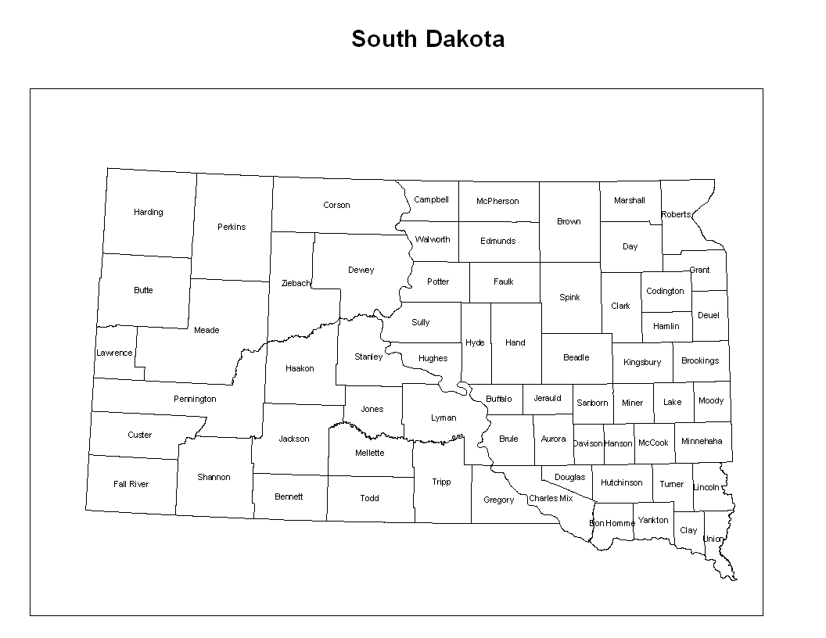**SD 2019 Athlete Election Proposal**



1.      There are 5 House of Delegate athlete positions open for election each year.

2.      The state will be split into three different sections. The picture above shows the current idea for how the state could be split based on the population of thirteen and over swimmers in each section.

3.    Thirteen and over swimmers will be the only ones to vote. Each swimmer will get to vote for five candidates.

4.      The candidate that receives the most votes from each section will become a HOD rep.

5.      The next two candidates that receive the most votes, regardless of section, will fill up the remaining two HOD spots.

6.      If there is no athlete running for a section, that section’s delegate will be given to the next candidate receiving the most votes, regardless of section.

**For BOD, the two candidates that receive the most votes would become the Jr. Athlete Reps.**

______________________________________________________________________________

**Section Makeup:**

1. **West**
   1. Teams:Black Hills Gold, Lead-Deadwood, Rapid City Racers, Greater Rapid City Ellsworth, Fall River Swim Team, Pierre Swim Team, Sturgis Swim Team
      1. Seasonal: Chamberlain Swim Team
   2. Number of thirteen and over swimmers: **171 total - 147 annual, 24 seasonal**
2. **North**
3. Brookings Swim Club, Watertown Area Swim Club, Aberdeen Swim Club,

i. Seasonal: Sisseton, Webster, Miller

1. Number of thirteen and over swimmers: **221 total - 165 annual, 41 seasonal**
2. **South**
3. Huron/Mitchell, Madison Makos, Sioux Falls Swim Team, Vermillion Area Swim Team, Yankton Swim Team
4. Number of thirteen and over swimmers: **191 total - 0 seasonal**

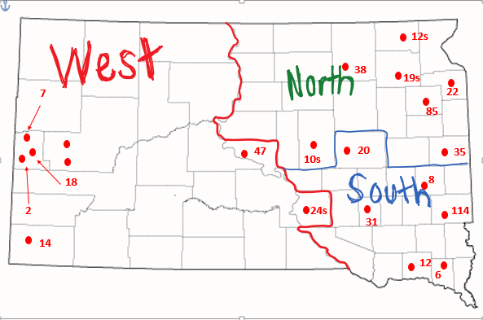

|  |  |
| --- | --- |
| **Goal** | **Objectives** |
| To Increase athlete performance and retention of upper level swimmers. | 1. Increase in number of people qualifying for meets at a level outside of South Dakota, and above the state qualifying standards. 2. Swimmers making an impact (placing) in regional and national meets. 3. Increase in number of swimmers continuing swimming in college 4. Regularly host a Select Camp |
| To increase 11 and Over athlete performance and retention of mid-level swimmers ( | 1. Increase 11 and over athlete attendance at State A meets 2. Get mid-level swimmers excited to be around swimming (maybe a midlevel camp) 3. Encourage the hosting of exciting meets for mid-level swimmers (duals, pentathlons, relay meets) |
| Host an annual awards banquet |  |
| Governance | 1. Improve LSC recruitment by effectively using a Governance Committee. 2. Run effective and productive Board and House of Delegate meetings. 3. Increase the use of committees to improve board succession planning. |
| Improve communication within the LSC | 1. Create a communication committee 2. Educate people on the role of the LSC 3. Improve use of social media to communicate 4. Establish a communication path where the LSC can communicate directly with families. |