USA SWIMMING – 2022 CLUB APPLICATION
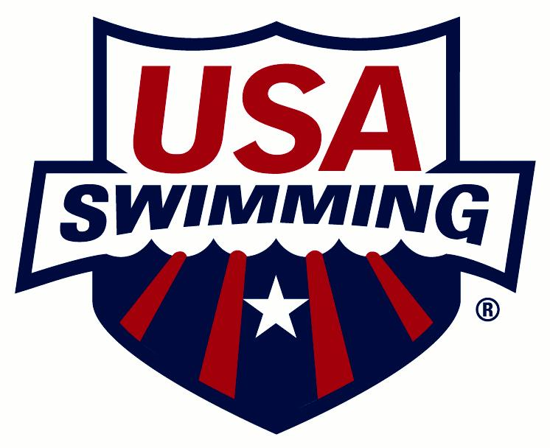

CLUB CODE: CLUB NAME:
NAME OF OWNER/BUSINESS/LEGAL ENTITY IF DIFFERENT FROM CLUB NAME:
1. 4.
2. 5.
3.
CLUB SETTING: ☐ Rural ☐ Suburban ☐ Urban
PLEASE CHECK ONE:
☐ NEW CLUB ☐ RENEWING CLUB
(Club is defined as a group with athletes and coaches. Insurance certificate will be issued.)
FIRST YEAR AS A USA SWIMMING CLUB:
NEAREST MAJOR CITY: CLUB WEB SITE:
PRE-EMPLOYMENT SCREENING
☐ By checking this box and signing below (e-signatures are acceptable), I formally acknowledge that this club is conducting pre-employment screening as required in Article 2.6.11 of the USA Swimming Corporate Bylaws, which requires all member clubs to comply with the USA Swimming Pre-Employment Screening Procedures for New Employees for all new employees who are required to be USA Swimming members under Articles 2.6.6 and 2.6.7 of the USA Swimming Corporate Bylaws.
Signature: Date:
Failure to check this box and sign this statement will result in the club application being rejected.
RACING START CERTIFICATION
☐ By checking this box and signing below (e-signatures are acceptable), I formally acknowledge that this club complies with all Racing Start Certification requirements as stated in the USA Swimming Rules & Regulations, Article 103.2.2 and maintains records for its athlete members.
Head Coach Signature: Date:
Failure to check this box and sign this statement will result in the club application being rejected.
STATE CONCUSSION LAWS
☐ By checking this box and signing below (e-signatures are acceptable), I formally acknowledge that this club is following the state concussion laws regarding training coaches and providing educational information to athletes, parents, and guardians as required.
Signature: Date:
Failure to check this box and sign this statement will result in the club application being rejected.
MINOR ATHLETE ABUSE PREVENTION POLICY
☐ By checking this box and signing below (e-signatures are acceptable), I formally acknowledge that this club has implemented the USA Swimming Minor Athlete Abuse Prevention Policy, and require all athletes, parents, coaches, and other non-athlete members of the club to review and agree to the Policy on an annual basis with such written agreement to be retained by the club.
Signature: Date:
Failure to check this box and sign this statement will result in the club application being rejected.
CLUB MAILING ADDRESS with CONTACT/REPRESENTATIVE (This person will receive USA Swimming mailings and be responsible for distributing the information.)
CLUB/MARKETING CONTACT/REPRESENTATIVE:
POSITION (board president, owner, coach, etc.):
ADDRESS:
CITY: STATE: ZIP:
HOME PHONE: BUSINESS: MOBILE:
FAX: EMAIL:

PRIMARY ORGANIZATIONAL AFFILIATION, WHO OWNS THE CLUB, CLUB TAX LISTING (To register as a club, a selection must be made for Primary Organizational Affiliation, Who Owns the Club and Club Tax Listing.)

CLUB’S FEDERAL TAX ID NUMBER:
CLUB TAX LISTING
(Please list the club’s main tax listing and not the parent/booster organization’s if it is a separate entity)
☐Sole Proprietor ☐501(c)(3) Non-Profit Corporation
☐Partnership ☐Other 501(c) Non-Profit
☐LLC ☐Other Non-Profit Corporation
☐Sub-S Corporation ☐Other For-Profit Corporation
☐Does Not Apply
☐ Check if registered last year and there are no changes to the Primary Organizational Affiliation, Who Owns the Club and Club Tax Listing that were listed last year.

PRIMARY ORGANIZATIONAL AFFILIATION
(Please note the club’s primary relationship/affiliation with any one of the following organizations. Choose one only.)
☐Not Applicable ☐Private School
☐Boys & Girls Club ☐Public School/District
☐College/University ☐Summer Club or Homeowner’s Association
☐Country Club ☐YMCA
☐Health & Fitness Club ☐YWCA
☐Hospital ☐Jewish Community Center
☐Park & Recreation Department ☐Other (Please Specify: )

WHO OWNS THE CLUB
☐ Check here if club ownership has changed since prior registration.
☐Not Applicable ☐Park & Recreation Department
☐Boys & Girls Club ☐Private School
☐Coach Owned ☐Public School/District
☐College/University ☐Summer Club or Homeowner’s Association
☐Country Club ☐YMCA
☐Health & Fitness Club ☐YWCA
☐Hospital ☐Jewish Community Center
☐Other (Please Specify: )

NAME OF COACH OWNER
**NAME OF COACH OWNER:
COACH’S USA SWIMMING ID#:

***Bylaw 2.6.6: All employees, including individuals serving on the board, of USA Swimming member clubs must be non-athlete members of USA Swimming.
***CLUB HAS A BOARD OF DIRECTORS OR OTHER GOVERNING BODY RESPONSIBLE FOR DAY-TO-DAY OVERSIGHT OF CLUB OPERATIONS
☐ Yes ☐ No. If no, please name second coach member in next section.

If yes, please list the names (first, last) of board and/or governing body members (all must be non-athlete members in good standing): Add additional sheet if needed.

V

Bylaw 2.6.12: All clubs must have either (i) at least one member coach plus a board of directors or other governing body; or (ii) at least two member coaches to ensure that there are at least two adult authorities at each member club for communication and accountability purposes.
**NAME OF ADDITIONAL NON-ATHLETE COACH MEMBER
NAME OF SECOND COACH MEMBER
COACH’S USA SWIMMING ID#:
Bylaw 2.6.6: All adult employees of USA Swimming member clubs must be non-athlete members of USA Swimming.
*NAMES OF ADDITIONAL ADULT NON-COACHING CLUB STAFF:

Please list the names (first, last) of all additional adult staff members (all must be non-athlete members in good standing): Add additional sheet if needed.

LEARN TO SWIM PROGRAM
Does the club or coach own and operate a Learn to Swim Program? ☐ Yes ☐ No
If yes, is the club a current Make a Splash Local Partner? ☐ Yes ☐ No
If no, is the club associated with a Learn to Swim Program? ☐ Yes ☐ No

If “yes”, please identify associated Learn to Swim Program and provide primary contact’s name and phone number:

____________________________________________________________________________________________________

FIND-A-CLUB CONTACT (To register as a club, a Find-a-Club Contact must be listed. Information will appear on the Find-A-Team page of USA Swimming’s website.)
FIND-A-CLUB CONTACT:
PHONE: EMAIL:
REGISTRATION DATE AND TYPE
REGISTRATION DATE: (For LSC Office Use Only)
PLEASE CHECK ONE:
☐ YEAR-ROUND CLUB ☐ SEASON 1 CLUB ☐ SEASON 2 CLUB
HEAD COACH
COACH:
ADDRESS:
CITY: STATE: ZIP:
HOME PHONE: BUSINESS: MOBILE:
FAX: EMAIL:
SAFE SPORT COORDINATOR
NAME:
ADDRESS:
CITY: STATE: ZIP:
HOME PHONE: BUSINESS: MOBILE:
FAX: EMAIL:
CLUB PRESIDENT
CLUB PRESIDENT:
ADDRESS:
CITY: STATE: ZIP:
HOME PHONE: BUSINESS: MOBILE:
FAX: EMAIL:

FACILITIES USED BY YOUR CLUB – LIST ALL FACILITIES (To register as a club, a facility must be listed. If additional space is needed to list facilities, use a separate sheet of paper and attach to the application.)
☐ Check if registered last year and there are no changes to the facilities that were listed last year.
If a facility is no longer in use by the club, list the facility name and the word “Delete” (example: Nathan Natatorium – Delete).
FACILITY NAME:
ADDRESS:
CITY: STATE: ZIP:
POOLS AT THIS FACILITY:
Pool 1: Length: ______ ☐ Yards ☐ Meters Width: ______ ☐ Yards ☐ Meters ☐ Indoor ☐ Outdoor
# of Lanes: ______ # of Lanes: ______ ☐ L-shaped pool
Pool 2: Length: ______ ☐ Yards ☐ Meters Width: ______ ☐ Yards ☐ Meters ☐ Indoor ☐ Outdoor
# of Lanes: ______ # of Lanes: ______ ☐ L-shaped pool

FACILITY NAME:
ADDRESS:
CITY: STATE: ZIP:
POOLS AT THIS FACILITY:
Pool 1: Length: ______ ☐ Yards ☐ Meters Width: ______ ☐ Yards ☐ Meters ☐ Indoor ☐ Outdoor
# of Lanes: ______ # of Lanes: ______ ☐ L-shaped pool
Pool 2: Length: ______ ☐ Yards ☐ Meters Width: ______ ☐ Yards ☐ Meters ☐ Indoor ☐ Outdoor
# of Lanes: ______ # of Lanes: ______ ☐ L-shaped pool
FACILITY NAME:
ADDRESS:
CITY: STATE: ZIP:
POOLS AT THIS FACILITY:
Pool 1: Length: ______ ☐ Yards ☐ Meters Width: ______ ☐ Yards ☐ Meters ☐ Indoor ☐ Outdoor
# of Lanes: ______ # of Lanes: ______ ☐ L-shaped pool
Pool 2: Length: ______ ☐ Yards ☐ Meters Width: ______ ☐ Yards ☐ Meters ☐ Indoor ☐ Outdoor
# of Lanes: ______ # of Lanes: ______ ☐ L-shaped pool
FACILITY NAME:
ADDRESS:
CITY: STATE: ZIP:
POOLS AT THIS FACILITY:
Pool 1: Length: ______ ☐ Yards ☐ Meters Width: ______ ☐ Yards ☐ Meters ☐ Indoor ☐ Outdoor
# of Lanes: ______ # of Lanes: ______ ☐ L-shaped pool
Pool 2: Length: ______ ☐ Yards ☐ Meters Width: ______ ☐ Yards ☐ Meters ☐ Indoor ☐ Outdoor
# of Lanes: ______ # of Lanes: ______ ☐ L-shaped pool
If any of the above information changes, please notify your LSC Registration Chair.

