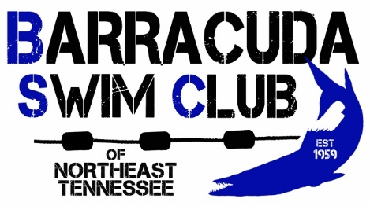
BARRACUDA SUMMER SWIM PROGRAM
Looking for an activity to be involved in this summer? Do you enjoy being in the water? Want a fun way to improve your swimming skills under the direction of certified coaches? Just seeing if being on a swim team is the sport for you?
Then join the Barracuda Swim Club of Northeast Tennessee! Our team has a special Summer Swim Program tailored to meet the needs of more novice swimmers while providing all the fun, coaching expertise and camaraderie of our year-round team.
Summer Program dates: May 28 – July 27
Locations:
Johnson City at Freedom Hall Pool
Kingsport at Sullivan South High School
Prerequisites: A child should be comfortable in the water, able to put his/her face in the water without trepidation, and able to swim one length of the pool (25 yards) in some manner.
Practice Times:
Johnson City: 6:00 – 7:00 PM, Monday through Thursday (except on summer league meet nights*)
Kingsport: 5:00 – 6:00 PM, Monday through Thursday (except on summer league meet nights*)
* There will be no summer-only group practices held on days when our team has a scheduled Summer League Meet. Swimmers may elect to participate in the Summer League Meet (see below).
Cost: $165 for the entire summer. Includes Barracuda team shirt, swim cap, practice sessions, and entry into all summer league meets, if desired.
Summer League Meet availability: As members of the Barracuda Swim Club, Summer Program members may participate in the East Tennessee Summer Swim League meets, including the Championship Meet on Saturday, July 27, at no additional cost. See our Summer League Information for more details.
Registration: Register online at www.BarracudaSwimClub.org Click the Online Registration button to get started.
For more information contact:
Coach Will McDavitt (Johnson City) Coach Gian Polignano (Kingsport)
316-847-1765 301-717-7883
wjm21aguilas@yahoo.com GianPolignano@hotmail.com

