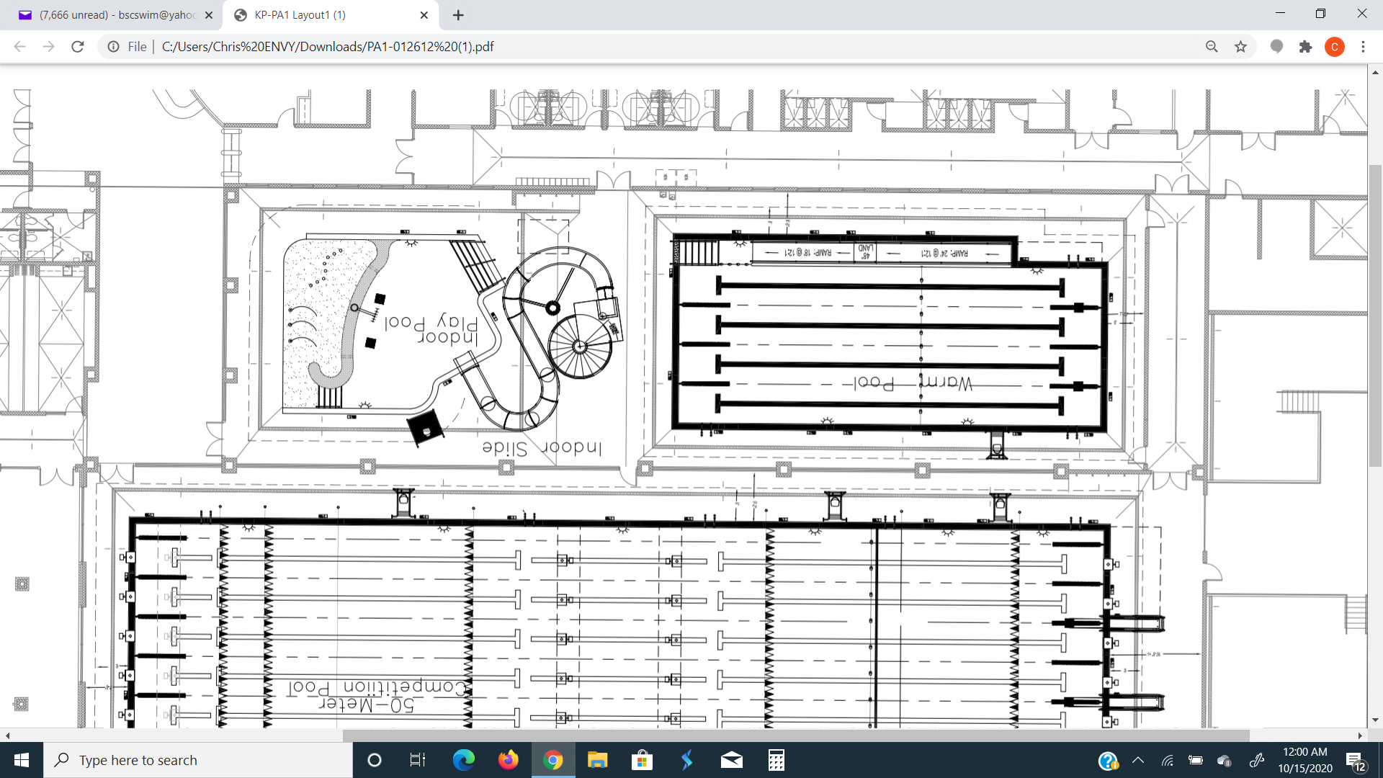

**CLOSED FOR**

**SWIM LESSONS**

**SAT AM**

**ONLY**

**SEVIER AC**

**MTSC**

**ACAC**

**ATOMIC CITY**

**HIGHBRIDGE**

**BARRACUDA SC**

**LOBBY**

**LOCKER ROOMS**