WRITTEN PERMISSION FOR AN UNRELATED APPLICABLE ADULT TO TRAVEL TO COMPETITION ALONE WITH MINOR ATHLETE

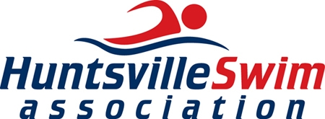

I, , legal guardian of , a minor athlete, give express written permission, and grant an exception to the Minor Athlete Abuse Prevention Policy for (minor athlete), to travel with _________________________ (Applicable Adult), to travel from ___________ (point of origin) to _____________ (destination) to attend the _______________________________ (name of competition)
from ______________ to _____________________ (dates of travel to competition).
I acknowledge that (minor athlete) cannot share a hotel room, sleeping arrangement or other overnight lodging location with ___________ (Applicable Adult) at any time. I further acknowledge that this written permission is valid only for the dates and location specified herein.

Legal Guardian Signature:
Date:

