IM READY (IMR)
The first step in the IMX Challenge is IM Ready (or IMR). To get "IM Ready," swimmers compete in a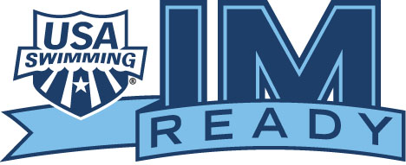 series of five events at shorter distances. Below, we've listed the line-up by age groups.
9 & Under; 10-year olds: 100 Free, 50 Back, 50 Breast, 50 Fly, 100 IM (SC) or 200 IM (LC)
11-year olds; 12-year olds: 200 Free, 50 Back, 50 Breast, 50 Fly, 100 IM (SC) or 200 IM (LC)
13, 14, 15, 16, 17, & 18-year olds: 200 Free, 100 Back, 100 Breast, 100 Fly, 200 IM
Once you've swum each event at least once at an official meet, you can log-in to your Deck Pass Account, and find out where you rank against all the other swimmers on your club team. You do not need to complete the IM Ready program to participate in the IM Xtreme. It is simply a stepping stone.

IM XTREME (IMX)
Ready to move forward? The next step is IM Xtreme (IMX). The IMX ranking includes a series of five or six events at longer distances. Once you've completed the IMX program, you can find out where your IMX score ranks nationally, within your zone, within your LSC rank and on your club.
9 & Under; 10-year olds: 200 Free, 100 Back, 100 Breast, 100 Fly, 200 IM
11-year olds; 12-year olds: 400 Free (LC) or 500 Free (SC), 100 Back, 100 Breast, 100 Fly, 200 IM
13, 14, 15, 16, 17, & 18-year olds: 400 Free (LC) or 500 Free (SC), 200 Back, 200 Breast, 200 Fly, 200 IM, 400 IM

