When | Meet | Location | Who?
October 6-7 | Fall Face-Off | Nashville, TN | All
November 3-4 | Newburgh Invite | Newburg, IN | All
Nov 30- Dec 2 | Music City Invite | Nashville, TN | Qualifiers
Dec 5-8 | Junior Nationals* | Greensboro, NC | Qualifiers
January -TBD | TBD | TBD | All
January | Highschool Region | Nashville, TN | Highschool qualifiers
Feb 8-9 | State Championship | Nashville, TN | Highschool qualifiers
March 1-3 | Southern Premier* | Knoxville | Qualifiers
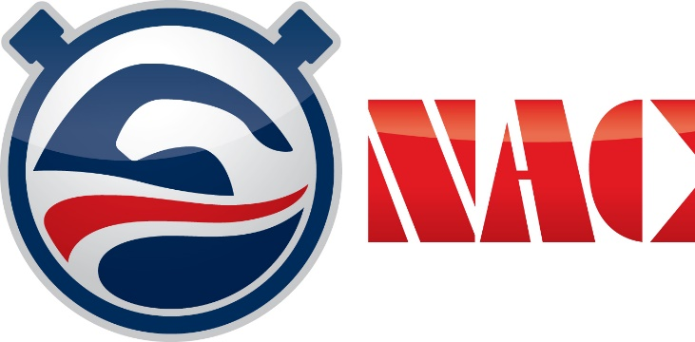
2018 Preliminary
Short Course Meet Schedule

*All Qualifying times are posted online at www.SwimNAC.com >”Competitive Team”>”Swimmer Resources”> “Time Standards”. Please check with your coach regarding specifics for your athlete.

