2017-2018 INFORMATION PACKET

TRIAL PERIOD - TNAQ offers a free two-week trial for all competitive team groups and the high school group from August 21 to September 7.

TEAM REGISTRATION – The TNAQ registration fee, of $125 is paid annually. This covers web subscription costs, administration costs, and the USA Swimming annual registration fee. Each swimmer’s USA Swimming Registrations covers insurance for events and training sessions as well as a subscription to SPLASH magazine. For the 2017-2018, this fee also includes 3 new TNAQ T-Shirts (Gray, Black, Orange).

2017-2018 GROUP PARENT MEETINGS (After the Two-Week Trial)
These meetings will help new and returning parents find answers to any questions they might have. We will be discussing general information for the upcoming season (e.g. volunteer requirements, fees, fundraising, etc.). Additionally, we will be discussing any new information or changes from previous seasons. All parents are responsible for information given during group parent meetings.

Allan Jones Pool (AJ)
Gray 1 Monday, Sept. 11, 6:00pm-7:00pm
Senior 3 - Tuesday, Sept. 12, 6:00pm-7:00pm
Senior 2 - Wednesday, Sept. 13, 6:00pm-7:00pm
Senior 1 -Thursday, Sept. 14, 6:00pm-7:00pm

Student Aquatic Ctr. (SAC)
Gray 2 - Monday, Sept.11 , 6:00-6:45pm
Gray 3 - Tuesday, Sept. 12 , 6:00pm-6:45pm
Orange 1 - Tuesday, Sept. 12, 5:15pm-6:00pm
Orange 2 & 3 - Wed., Sept 13 or Thurs., Sept. 14, 5:15pm-6:00pm

SWIM FEES – Annual fees vary by training group. Swimmers are assigned to training groups by the coaching staff according to grade, age, and ability. All fees are paid online during your registration process. The payment terms are stated on the attached 2017-2018 Fee Schedule. In the event that a family moves out of the community during the course of the swimming season, a prorated refund may be requested if the fees were paid initially at the start of the season in a lump sum. We will have payment plans, monthly payments, and the option of paying with credit cards. All credit card and automatic debit fees will be passed onto the families. Refunds after the start of the season will be given for medical conditions, injuries, and moving more than 50 miles away.

FUND RAISING – Families whose swimmers participate in the competitive training groups have an annual fundraising requirement in addition to the annual swim fees as noted on the attached 2017-2018 Fee Fundraising Commitment included in the packet. Families who decide to leave the team during the swim season are still responsible for their prorated portion of their fundraising requirement.
Orange 2, Orange 3: $100
Orange 1, Gray 2, Gray 3: $250
Gray 1, Senior 1, Senior 2, Senior 3: $400
*(Only your oldest swimmer applies)

TEAM REGISTRATION-The Tennessee Aquatics website, www.tnaquatics.com is our system for billing, entries, fundraising, etc. Registration will open on August 21 for returning families. For all new families, registrations will open on September 7th. Ideally, all registration and initial payments are received prior to September 13th. This ensures athletes receive their t-shirts on time and can be entered in the first meet All families will be required to have a current credit card/ACH on file for meet entry fees, dues, etc.

HOME SWIM MEETS - Home swim meets are not merely competitions, they are also essential TNAQ fundraisers. Each family has specific work assignments (for the entire weekend) for which they are responsible. Please read the document “Family Participation Requirements” in your TNAQ packet. If you are unable to fulfill your family’s assignment, it is your responsibility to find your own replacement or pay a $50 fine per volunteer session missed--but we want your help, not your money!

AWAY SWIM MEETS - The meet schedule is posted on our web site and posted below. However, changes in our schedule do happen! TNAQ will offer a list of recommended hotels for parents to choose from if needed. TNAQ occasionally takes a team trip where the swimmers and coaches travel together AS A TEAM by bus and/or vans. Away meets are available for all competitive groups but not required. Please talk to coach on what meets you should attend.

2017-2018 (tentative) Short Course Meet Schedule
Orange Group Available Meets:
September 23-24: ACAC - Oak Ridge, TN
October 13-15: Ensworth - Nashville, TN
November 10-12: TNAQ Home Invite - Knoxville, TN
December 1-3: Music City Invite - Nashville, TN
January 12-14: Pilot Flying-J Invitational - Knoxville, TN
February 3: TNAQ Home Meet - Knoxville, TN
February 16-18: Baylor Regionals - Chattanooga, TN (if not going to Premier)
March 2-4: Southern Premier Meet - Nashville, TN (time standards all groups)

Gray Group Available Meets:
September 23-24: ACAC - Oak Ridge, TN
October 13-15: Ensworth - Nashville, TN
November 10-12: TNAQ Home Invite - Knoxville, TN
December 1-3: Music City Invite - Nashville, TN
January 12-14: Pilot Flying-J Invitational - Knoxville, TN
February 3: TNAQ Home Meet - Knoxville, TN
February 16-18: Baylor Regionals - Chattanooga, TN (if not going to Premier)
March 2-4: Southern Premier Meet - Nashville, TN (time standards all groups)

Senior Group Available Meets:
September 23-24: ACAC - Oak Ridge, TN
October 13-15: Ensworth - Nashville, TN
November 10-12: TNAQ Home Invite - Knoxville, TN
December 1-3: Music City Invite - Nashville, TN
December 6-9: Winter Jr. Nationals (time standards)
January 12-14: Pilot Flying-J Invitational - Knoxville, TN
February 3: TNAQ Home Meet - Knoxville, TN
February 10-11: TN High School State Meet - Knoxville, TN
February 16-18: Baylor Regionals - Chattanooga, TN (if not going to Premier)
March 2-4: Southern Premier Meet - Nashville, TN (time standards all groups)
APPAREL - All Swimmers are required to wear appropriate suits and caps at all TNAQ swim meets. Swimmers are expected to wear TNAQ T-shirts and gear at the meets as well. We will be giving caps and T-shirts to all new swimmers during week of September 26th.
Apparel Schedule for meets unless otherwise notified.
“GBO” Go Big Orange!
Gray First day
Black Second Day
Orange Third Day
PARKING FOR THE SAC and AJAC AQUATIC CENTERS - In order to park on campus in UT parking lots, you need to obtain a parking permit from UT Parking Services. TNAQ families are eligible to purchase UT Evening Parking Passes which will allow parking in the C22 designated lot. These passes are $40.00 and are good from August through the middle of May.

Where to Park:
UT Parking services has a new lot available for TNAQ. Our lot is C22. The evening permit allows for parking in commuter lots after 3:00 pm and unreserved staff lots after 4:00 pm. Do not park in the garage (it is non-commuter) or the AJAC staff lot at any time. Metered street parking on campus is also available, these meters are monitored by the City of Knoxville.

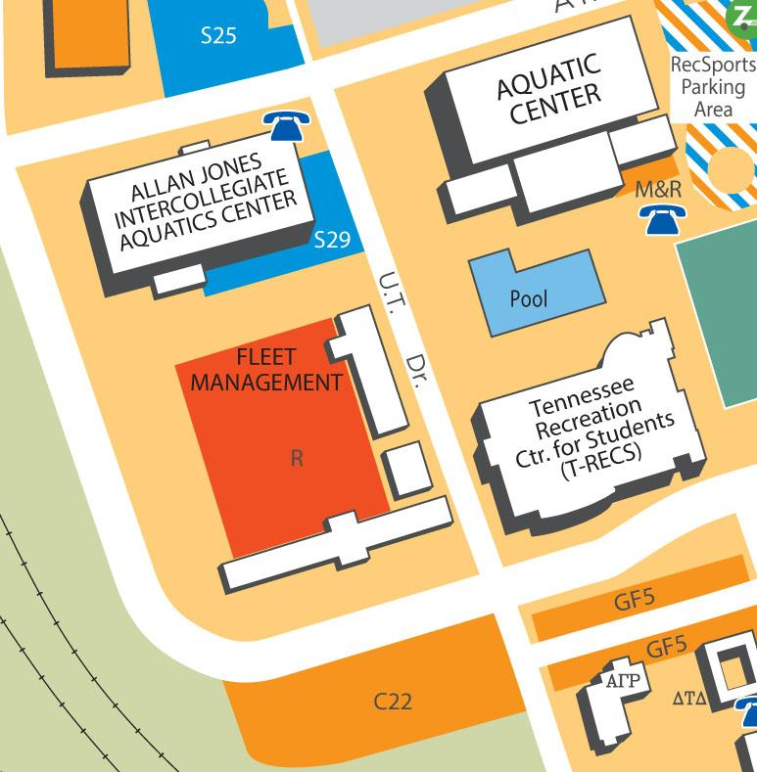

Attention, SATURDAY parking: For Saturday parking, everyone must park on the street only. You could receive a ticket anywhere else if you have an evening pass or special senior group permit.
UT Parking Services – 974-6031
2121 Stephenson Drive (off Neyland Drive) - 7:30 am - 4:45 pm

BULK ORDER for PARKING PERMITS – For those who aren’t able to purchase the permits due to work constraints, etc., TNAQ will place two bulk orders for parking permits.
Turn Forms and checks into Jackie Bertucci or Jamie Haman for bulk permits by the following dates:
August 31st - Thursday
September 7th - Thursday
September 14th -Thursday
Forms are in your packet and will be available at the team file cabinet at each pool to fill out.

To complete your order for your permit, turn in forms to parking services and $40.00 check payable to UT Parking Services. Please understand that you will be “parking at your own risk” until you receive your permit.

COMMUNICATION - We are trying to go paperless as much as possible. Our main form of communication will be our website. It will be updated on a regular basis with all our team information. Visit us at www.tnaquatics.com.

EMAIL: The TNAQ mass e-mail system is used weekly by our board members and coaches. Emails sent pertain only to Tennessee Aquatics and we do not solicit your emails. This is our only way for reliable communication between parents, coaches, and board members. Please make sure that TNAQ has a reliable email address for your family at home and work and that you check your email regularly.
Each week you will receive the team weekly update.
Every other week you will receive an email from your swimmers appropriate group coach.

TEXT: If you wish to receive updates via text, please opt-in by adding your cell phone number in your personal Team Unify portal.

SOCIAL MEDIA: We will be utilizing our Facebook, Twitter (#TNAQ), and Instagram accounts for updates on team, meet or practice information. However, in compliance with USA Swimming policies, the TNAQ coaching staff is prohibited from using personal social media accounts to communicate with TNAQ families or athletes.

CONTACT PERSONS BY GROUP- For any coaching and/or team questions please contact the coach or staff member associated with your specific group.
Senior Program: Larry Hough, lhough@tnaquatics.com, (865)-232-1790

Gray Group Program & Club Operations: Jackie Bertucci at (865) 207-7297 or jbertucci@tnaquatics.com,

Orange Group Program & Billing Questions: Lizzie Fleming at (865) 271-8471, lfleming@tnaquatics.com.
If we cannot answer your questions we will help you find the answer.

Coaching Staff
Larry Hough  Head Coach  lhough@tnaquatics.com.865-232-1790  Jamie Tannhauser Haman  Swim Clinics & Youth Fit Director  Gray 1  jhaman@tnaquatics.com  Rob Collins  Senior 3 & Masters Program  rcollins@tnaquatics.com  Brett Tannhauser  Youth Fit  btannhauser@tnaquatics.com  Bennett Monroe  Grey 2 Asst. & Orange 3  bmonroe@tnaquatics.com  Michael Hamann  Senior Assistant  mhamann2@vols.utk.edu | Jacqueline Bussard-Bertucci  Head Age Group Coach & Dir. of Operations  Gray 2  jbertucci@tnaquatics.com, 865-207-7297  Lizzie Fleming  Orange Group Director  Orange 2 & 3  lfleming@tnaquatics.com, 865-232-1790  Lars Hondorf  Orange 1  lhondorf@tnaquatics.com  Chris Goodman  Gray 3  cgoodman@tnaquatics.com  Chris Franklin  Assistant Coach  cfranklin@tnaquatics.com

