Y League Meet Entry Procedure – Mission Valley
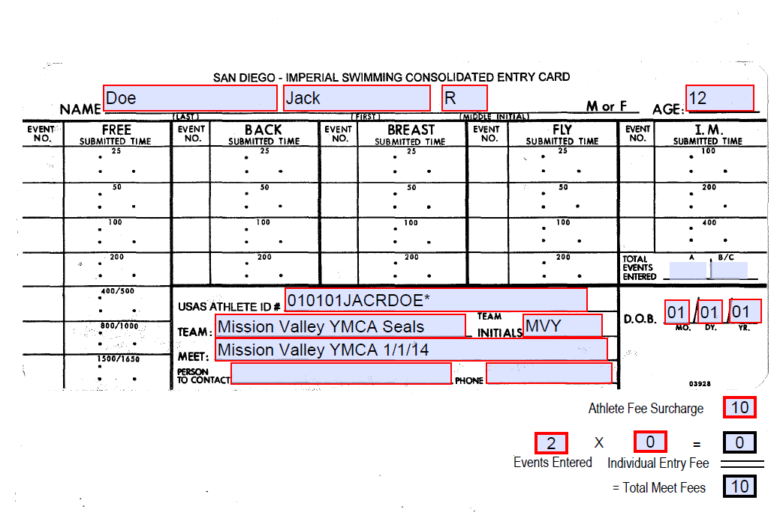
Fill out a Meet Entry Sheet
J
I
H
G
D
F
E
C
B
A
NT
34.42
12
2
- Fill in your swimmer’s Last Name, First Name and Middle Initial
- Circle the gender as appropriate
- Swimmers age on the first day of the meet
- Swimmer’s birthdate
- If applicable, fill in the USAS Athlete ID#
  - If the swimmer has a USA Swimming ID, enter here.
  - If the swimmer does not have an ID, leave blank.
- The name of the meet from the meet information sheet
- The Event Number from the Meet Information sheet and the swimmer’s best time for that course (SCY, SCM or LCM). If the swimmer has swam the distance but on a different course, you can enter the converted time.
- This is an example if the swimmer has not established a time in an event; enter NT
- The meet fee from the Meet Information sheet ($10 as of 2014 Winter)
- The Total Events Entered and an event Charge of 0 for League meets
The total meet fees should be equal to the charge indicated on the meet information sheet
Place the meet entry sheet with a check for the amount in Total Meet Fees in the black mailbox outside the Aquatics Office (Mission Valley outdoor pool). Make the check payable to, Mission Valley YMCA.

