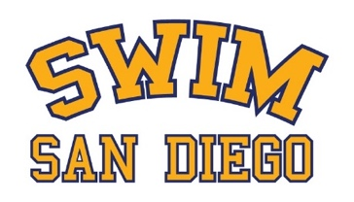

SWIM SAN DIEGO CODE OF CONDUCT: PARENTS

The purpose of a code of conduct for parents is to establish consistent expectations for behavior by parents. As a parent/guardian, I understand the important growth and developmental support that my child’s participation fosters. I also understand that it is essential to provide the coaching staff with respect and the authority to coach the team. I agree with the following statements:

- I will set the right example for our children by demonstrating sportsmanship and showing respect and common courtesy at all times to the team members, coaches, competitors, officials, parents, and all facilities.
- I will get involved by volunteering, observing practices, cheering at meets, and talking with my child and their coach about their progress.
- I will refrain from coaching my child from the stands during practices or meets.
- I understand that criticizing, name-calling, use of abusive language or gestures directed toward coaches, officials, volunteers, and/or any participating swimmer will not be tolerated.
- I will respect the integrity of the officials.
- I will direct my concerns to first to site coach then, if not satisfied, to the Team Director.

I understand the above expectations and that my failure to adhere to them may result in disciplinary action.

___________________________________ _____________________
Parent’s signature Date

