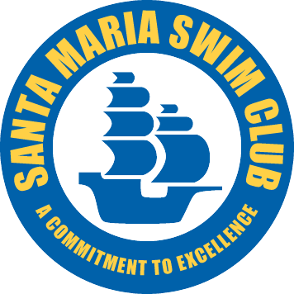
EMPLOYEE WELCOME BACK LETTER
(COVID-19 RETURN TO PRACTICE AT THE PAUL NELSON AQUATICS CENTER)

Welcome back SMSC Families!
You’ll notice various changes in the way our workplace looks as well as new protocols. We understand these changes may be difficult and we are here to support you. Our goal is to collaboratively ensure you feel safe and secure so together we can navigate the complexities of our “new normal.”
Here are some things SMSC is implementing to help keep the Paul Nelsen Aquatic Center safe and to support you:
- More frequent cleaning and sanitizing. We need your help with this when coaching.
- Access to hand sanitizer and disinfectant wipes in the office.
- Staggered coaching times so fewer people coaching at one time
- Limited numbers of coaches in the SMSC office to practice safe distancing
- You will be required to wear a mask or face shield when coaching. We ask that you purchase something appropriate that makes you comfortable.

- Here are some things we expect you to implement to keep our workplace safe:
- Go/stay home if you feel sick. This includes symptoms like frequent cough, sneezing, fever, difficulty breathing, chills, muscle pain, headache, sore throat, recent loss of smell or taste. You should not feel obligated to cover a coaching shift if you are sick – please contact Mike or a Board member to make sure the pool deck is covered.
- Stay home and inform Mike or a Board member immediately if you or someone in your household is self-monitoring or suspect possible exposure to COVID-19.
- Wash your hands often and for the recommended 20 seconds. You should wash your hands before entering and when leaving the office, before and after eating, after using the restroom, after removing your face mask, after helping any athlete where you have touched them or their things. Avoid touching eyes, nose, and mouth with unwashed hands.
- Stay at least 6 feet apart when moving through the workplace and on deck with athletes and members.
- You are required to wear a face mask or cloth face covering or face shield on the pool deck. You may wear a mask or face covering in the SMSC office if others are present. Face masks should completely cover your mouth and nose. Do not lay your face mask on any surface that may contaminate either the surface or the covering.
- Coaches should do their own administrative work from home and only come to the SMSC office to coach groups. Call, email, message or video conferencing as much as possible. Staff meetings will still be held via Zoom until further notice.
- It is discouraged to bring your children to work at this time.
- It is discouraged to travel outside of California or to a high-risk area (Los Angeles county) at this time. If you do travel, please inform your Mike or a Board member.
- Restroom usage is allowed at the single use restrooms only. Anyone using these facilities must sanitize after each use. Supplies will be provided. Locker rooms will remain closed until further notice.
- Wipe down the office desk and door handles and other high touch surfaces after using the SMSC office.
- When facility is open, keep the office door open. Clean office door handles before and after each group.
- We will be expecting staff to do many new tasks during this time. We are all in this together. We need your help to keep SMSC in business and to continue to deliver aquatics to our membership.
- Speak with your Mike or a Board member if you have questions or concerns

If you choose not to return to SMSC at this time due to medical vulnerability or childcare concerns, please discuss your options with Mike or a Board member. Your signature to these new and temporary policies is an agreement to these workplace guidelines.

Thank you for being part of the SMSC Coaching Staff and welcome back!

- Name _____________________________________________________________Date____________________________________

- Signature _______________________________________________________Cell Phone __________________________________

