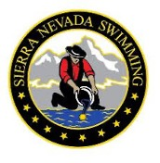SIERRA NEVADA SWIMMING COMMITTEE/CHAIR/BOARD MEMBER REPORT
To be submitted to Scott Hastings (SNS Secretary) scottlhastings@gmail.com and Alex Ongaco (SNS Executive Director) alex.ongaco@snswimming.org the Sunday prior to the next BOD meeting

Committee/Chair/Board Member:
Date of Board Meeting: Date of last Committee Meeting:

Members Present:

Date of Next Meeting:

Action Items Completed:

Action Items In-Progress / Pending:

Announcements:

Questions for the Board / Larger Group:

Notes/ Other:

