Sent via email to:

To the ---,

The Aquatics Coalition, representing water safety organizations and competitive water sports, asks you to prioritize opening swimming pools for instructional, purpose-driven aquatics with a return to water in the earliest possible phase, and to encourage local communities to follow this guidance. We define purposeful aquatics as those used for learning-to-swim/water safety, competitive sport, rehabilitative exercise, and lifeguard education/certification. To be clear, this Coalition is not advocating to open pools for large crowds or unrestricted recreational use.

We stand firmly for the opening of pools for instructional purposes under four tenets:

- Safety: Drowning rates spike in the warm summer months, and the current facility shutdown during this pandemic is exacerbating this reality. The need for trained lifeguards is most critical now, but hands-on lifeguard training is waning as this is not a skill one can acquire solely through virtual learning. Initial studies show that COVID-19 is not transmitted through chlorinated water, and by paying greater attention to proper air quality measures and distancing techniques, the spread of respiratory disease can be mitigated.

- Swim Lessons: Providing swim lessons is critical during the summer months. According to the CDC, drowning remains the leading cause of death among children ages 1 – 4 and the second leading cause of unintentional death among children ages 1-14 in the U.S. In fact, to date, at least 86 children in the United States have died by drowning in 2020… and summer has not yet begun. The closing of aquatic venues has abruptly halted the conduct of learn-to-swim programs for children who most need those lessons. Swim lesson providers have already developed comprehensive plans and protocols to reduce transmission risk during these vital activities.

- Mental and Physical Health: Exercise done in water such as physical therapy, lap swimming, competitive swimming, water aerobics, and other aquatic instruction are critical activities for mental and physical health. Further, regular exercise can reduce risk factors for severe COVID-19. Like with walking, running, and cycling, aquatic sports under instruction can easily comply with standards for social distancing and safety. On the national and local level, we have created safety plans that allow aquatic facilities to promote physical and mental health opportunities that are compliant with public health directives.

- Economic Impact: The COVID-19 crisis has been devastating to local and national businesses in the aquatics space. Swim lesson providers and coaches have been furloughed or laid off, and revenues for facilities, teams and organizations that rely on operational venues have completely halted. These small, often family-owned businesses are at risk of unrecoverable economic damage if services do not resume soon.

Many states have recognized these key points and have allowed a measured return to purpose-driven, structured aquatics. Together, we implore all states and local communities to follow suit by putting swimming pools in the most imminent phase of their reopening plans. Time is of the essence to ensure safety in and around the water, and a return to mental, physical, and economic health for our communities.

The undersigned organizations of the Aquatics Coalition stand ready to advise and assist where municipalities seek more information on a safer return to purposeful water use. The safety plans from USA Swimming and the U.S. Swim School Association are attached for your reference, as is a succinct notice of safety protocols that should be followed in all venues.

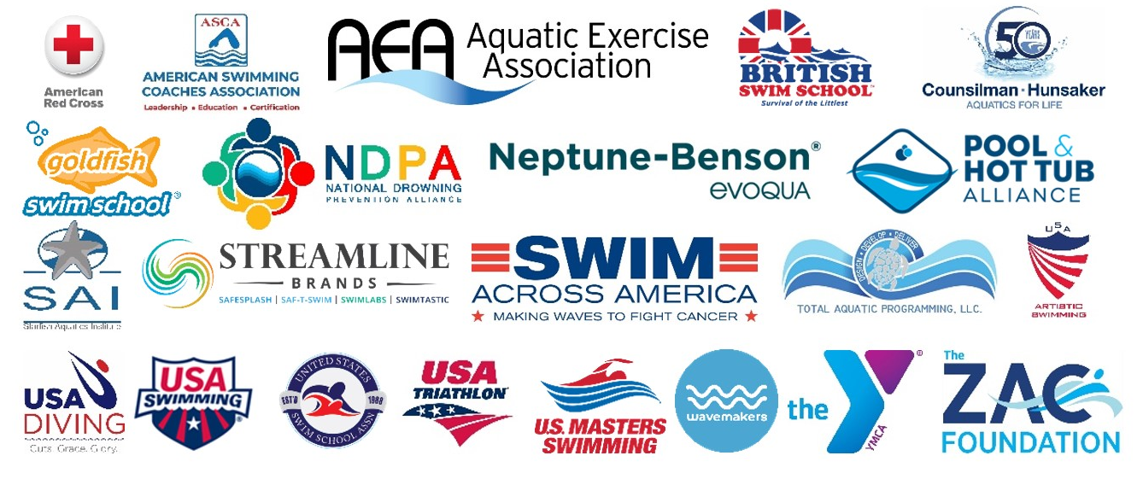

https://www.cdc.gov/healthywater/swimming/index.html
https://www.cdc.gov/homeandrecreationalsafety/water-safety/waterinjuries-factsheet.html
United States Swim Schools Association COVID19 Action Plan: www.aquatics-coalition.org ,select “Safety Protocols”
https://www.cdc.gov/coronavirus/2019-ncov/need-extra-precautions/people-at-higher-risk.html
Visit www.aquatics-coalition.org for a library of documentation and links to assist venues to open safely

