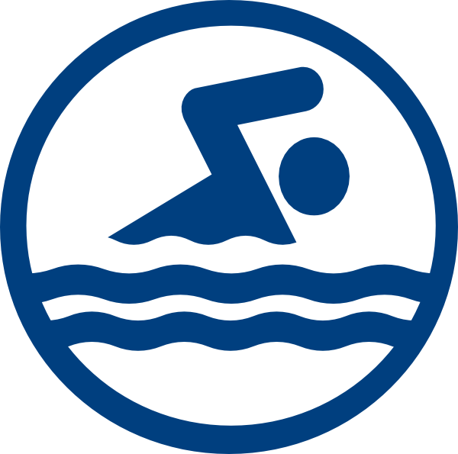
So It’s Your First Swim Meet?

If you’ve never been to a swim meet before, we bet you’re more nervous than your swimmer! Don’t fret! This short guide will help you get through your first swim meet! Don’t forget that there are plenty of experienced families who will be around to help you and your swimmer We want you and your family to have an enjoyable first swim meet experience!

NIGHT BEFORE
- Make sure your swimmer eats a balanced meal with carbs and protein like pasta with a salad.
- HYDRATE: make sure that your swimmer has been staying hydrated throughout the day and drinks water with dinner!
- SLEEP! A full night’s rest is important! Make sure your swimmer doesn’t have any distractions that might keep them up and that they get at least 8 hours of sleep!

MEET DAY
- Start the day right! Eat a light breakfast is competing in the morning like oatmeal, fruit, toast, and yogurt. Opt for a heavier breakfast if you don’t race until the afternoon.
- What to bring:
  - Team swimsuit, goggles, cap
  - Clothes to change into, shoes, socks, slippers
  - Towel/parka
  - Sharpie
  - Canopy/tent (if you have one), chairs or blanket to sit on
  - Jackets, sweatshirts, blankets (for cold/rainy meets)
  - Food- you’ll need snacks for in between events. Some good snacks: fruit, veggies, nuts, deli meats, bread, pretzels, dry cereal, hard boiled eggs, dried fruit, hummus, peanut butter, etc. DON’T FORGET TO BRING WATER! It’s important to stay hydrated!
- What to wear to the meet: swimsuit, warm up gear (sweats or team warm up suit)
- Arriving at the pool: You’ll want to get there at least an hour to 30 min prior because you’ll need to look for parking and set up your canopy/tent if you weren’t able to set it up on the first day of the meet
- Checking in: look for the check in tables near the entrance. They usually have signs up indicating which table and line is for boys, girls, as well as last name (example: girls A-M). You cannot sign in for your swimmer. Your swimmer will have to initial next to every event that they are competing in. They should write down the number of the events that they are competing in on their arm (see the next section about “marking”).
- Warm up: warm ups start 30 minutes to an hour before the meet starts. Be sure to check the meet sheet for specific times. You don’t want your swimmer to miss warm up!

COMPETING
- The Heat Sheet- Find out where the heat sheet board is located. This is where all of the events and heats will be posted. You’ll look for the event number that your swimmer is competing in, and it will have the heat number and what lane they will be swimming in. Teach your swimmer how to read it so they can mark their events, heats, and lanes themselves! If you don’t know how to read one, you can ask any swim parents that may be standing around.
- Marking: You’ll notice a lot of swimmers with writing on their forearms. This helps them remember what event, heat, and lane they are in. You can set it up like this (using a sharpie):

Event | Heat | Lane
- You can also buy temporary tattoos:
  - http://www.swimoutlet.com/p/h2o-toos-swim-tattoos-event-participation-5190/
- Paying Attention- If you hear the announcer come on, always pay attention! The announcer is the one who will announce what event is currently competing, what event is coming up, what heat is up, lost and found, etc. Once you and your swimmer hear that their event number is next, they should check in with their coach and then head over to the starting blocks and line up behind the timers in the lane they were assigned to so that they can check in.
- Check in with Coaches- checking in with the coaches gives them a heads up to pay attention the heat/lane
- SWIM!!
- Check in…. again- after your swimmer competes, they should check back in with the coaches. This is when they’ll talk to your swimmer about the great job they just did along with any tips to improve for the next time or what they’ll work on next practice
- Do it all over again! At meets, they don’t post all of the event heat sheets at once because they have to generate the reports after the swimmers have checked in, account for scratches, deck entries, etc. Check every 20 minutes for heat sheets to be posted until all of the events your swimmer is competing in have been posted.
- Results- The results for all events are posted in another area, most likely near where the head sheets are posted. This is where you can see the place and time your swimmer posted for the event they raced in. Usually 1st through 8th place qualify for an award!

If your swimmer forgot goggles, there is always a swim shop on deck selling swim gear like parkas, goggles, fun swim caps, and even swimsuits.

When your swimmer isn’t in the pool or resting, make sure they are wearing their slippers/shoes when walking around so they don’t hurt their feet stepping on something by accident!

Again, if you don’t have a tent or canopy, look for the Vacaville Swim Club canopy. All families are welcome to hang out there, just bring your chair/blanket to sit on!

