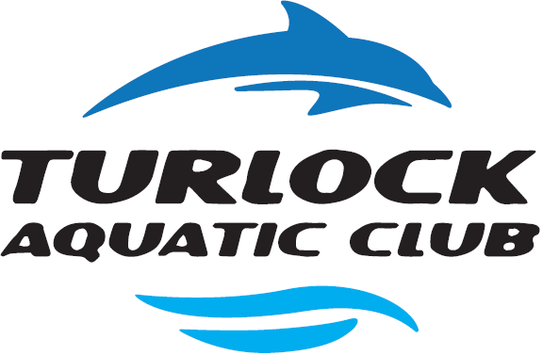

2019 Fundraising Requirements
All summer and year around swimmers are required to fundraise $100 per family.
All fundraising money and opt out money needs to be turned in by Thursday July 11th. If we do not receive your money, your check that you gave us at signups will be cashed on Thursday July 18th. TAC offers several opportunities to fundraise.

- Aquathon on Thursday, June 27th: Lap swimming for donations. Find a few friends or family to sponsor your swimmer. All money goes towards your fundraising obligation. Money due Thursday,
July 11th.

- Fireworks Vouchers: Available June-July 3rd. Purchase $10 vouchers to buy fireworks at the Kiwanis Booth. 50% of your purchase goes towards your fundraising obligation. For example, purchase $100 in fireworks vouchers $50 goes towards your fundraising obligation. Text Kelly Logsdon (209-262-7500) and she can meet you on deck to purchase your vouchers. Vouchers will also be for sale at our home meet coming up on Saturday, June 15th. These sell out quick so don’t wait!

- Fast Track Carwash: Purchase $12 car wash vouchers. 50% of your purchase goes towards your fundraising obligation. For example, buy 5 car wash vouchers for $60 and $30 goes towards your fundraising obligation. Text Kelly Logsdon (209-262-7500) and she can meet you on deck to purchase your vouchers.

- Sponsorship: Know a business that would like to be a TAC sponsor? Collect $500 in total sponsors and you’ve fulfilled your fundraising obligation. A $500 sponsor will highlight the business name on the back of our team shirt and on our social media page. A $250 sponsor will see their business name on our team shirt. All sponsors and money due Thursday, April 25th.

- Opt Out: Don’t want to fundraise you can opt out now and pay your $100 fundraising obligation. Opt out money due July 11th.

Families can do one or more of the opportunities above to meet the fundraising requirement.

