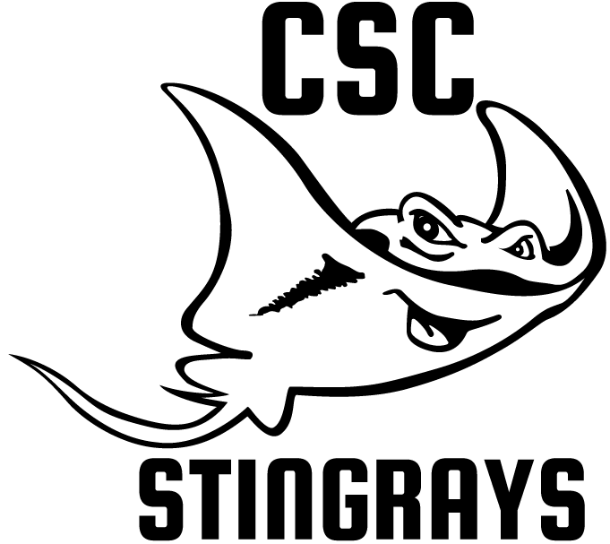

August 2021

Dear Friend,

Since 1935 Caldwell Swim Club (CSC) has provided an affordable competitive swim program for the greater Caldwell community. Our swim club is small but growing and we need your help to continue to grow, provide excellent coaching for our kids, and reach kids in need.
Caldwell Swim Club holds an important place in our community—if you talk to many of the community leaders who grew up here, they were part of Caldwell Swim Club in their youth! Swimming is a wonderful sport that builds skills for a lifetime – incredible work ethic, perseverance, teamwork, and the skill of swimming itself opens many doors through life. We would like to partner with you. Your sponsorship will allow us to keep swimming affordable for families in financial need and offer training for our coaches and referees/officials.
Thank you in advance for your support—together we’ll continue to provide a successful competitive swim program for our community.

Sincerely,

Betsy Hunsicker
Board President
Caldwell Swim Club

Caldwell Swim Club 2020 Sponsorship
Thank you for your interest in supporting CSC. As a non-profit organization our goal is to continue to provide an affordable, quality swim program for families in our community. Our 501(c)3 tax id is 82-0445011.

Sponsorship | Recognition
Copper  $100 | - Logo posted on CSC Website with link to sponsor website  - Facebook thank you once per year
Bronze  $250 | - Logo posted on CSC Website with link to sponsor website  - Facebook thank you twice per year  - Quarter-page heat sheet ad at home swim meets (1-2 x/year)
Silver  $500 | - Logo posted on CSC Website with link to sponsor website  - Facebook thank you twice per year  - Half-page heat sheet ad at home swim meets (1-2 x/year)  - Recognition on swimmer team shirts
Gold  $1000 | - Logo posted on CSC Website with link to sponsor website  - Facebook thank you 4x per year  - Full-page heat sheet ad at home swim meets (1-2 x/year)  - Recognition on swimmer team shirts
Platinum  $2500 | - Logo posted on CSC Website with link to sponsor website  - Facebook thank you monthly  - Full-page heat sheet ad at home swim meets (1-2 x/year)  - Banner at home swim meets  - Recognition on swimmer team shirts
Other | All support is welcome

Yes! I’ll sponsor Caldwell Swim Club!

Total Enclosed:
Name for Sponsorship Recognition:
Website for link (if applicable):
Contact Name, Title:
Email: Phone:
Mailing Address:
Return to: Caldwell Swim Club • PO BOX 125 • Caldwell, ID 83606

Questions? Contact Betsy Hunsicker at caldwellstingrays@gmail.com or 208-369-3716

