2019 Psych – Up Week
Every year before Snake River Winter/Summer Champs we host our team Psych – Up week in order to promote team spirit, excitement and fast racing! All Swimmers can participate even if they are not competing at the 2019 SRS Summer Championship meet! (But we encourage all athletes who are eligible, to compete). Each activity will take place during regular practice time but might run over a bit! Parents please watch for volunteer hour opportunities to sign up for on the website! Thank you for your support!
THEME: This year the theme for the week will be “FLASHBACK!” We will be taking a look back at the most famous Olympic swimmers over the years! This will be a fun way to learn about the history of the sport as well as getting Psyched up to race fast as Summer Champs!
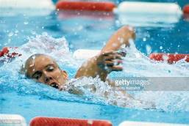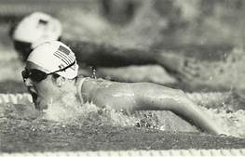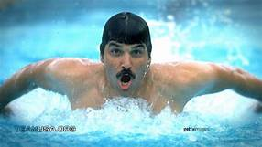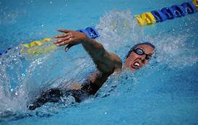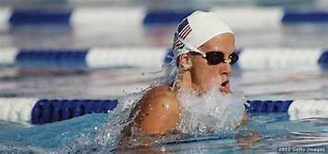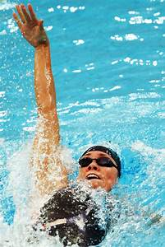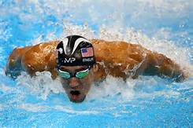
ACTIVITIES:
FRIDAY JULY 12th (PM): Drag Day is where you get to dress up in clothes for swim practice! Dress in this year’s FLASHBACK theme by picking a decade from the past (1960-1970-1980-1990) and dressing up in the style from that decade! Have fun with it! The crazier the better! You can wear things like t – shirts, tank tops, shorts, tights, pants, socks, etc.!
SATURDAY JULY 13th ⁽PM): We will have an open Water practice at Rigby Lake from 1:00 – 3:00 PM. Let me know if you need a ride and we can set up some carpool options (Groups include Senior 1 -2, Firebolts 1-2).
MONDAY JULY 15TH (PM): We will be decorating poster boards and cheering signs for SRS Summer Champs! 3:30 groups will do this at the end of practice. 4:30 groups will do it before they get in the water
TUESDAY FEB. 12TH (PM): Relays /Cheer off during regular practice times
Cupcakes and Good Luck Party at the end of practice
WEDNESDAY FEB 13TH:
AM: We will have breakfast at the pool during practice time!
PM: Water Polo Tournament from 3:30 – 4:30PM

THURSDAY FEB 14th: Race strategy Practice

FRIDAY FEB 15TH: No Practice (first day of Summer Champs)

