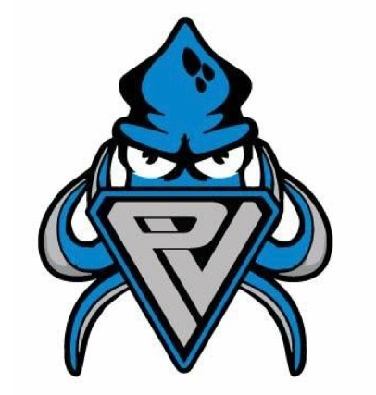
PVST Athlete
Code of Conduct

As a representative of PVST, I will…

- Swim to improve my abilities and times because I love the sport, not to please my parents or coach.
- Be modest and generous when I win and gracious when I lose.
- Respect the sport of swimming and the rules that govern the sport. I will learn and follow these rules.
- Work for the good of my team and give my best effort at all times.
- Show respect for the authority of officials and coaches, even though I may sometimes disagree.
- Show good sportsmanship before, during, and after meets.
- Conduct myself with honor and dignity and treat other swimmers as I would like to be treated.
- Help my parents understand the rules of the sport so they can watch and enjoy the meets.
- Control my temper and not retaliate, even if I believe I have been wronged.
- Not use or possess tobacco, alcohol, or illegal or performance-enhancing drugs.

