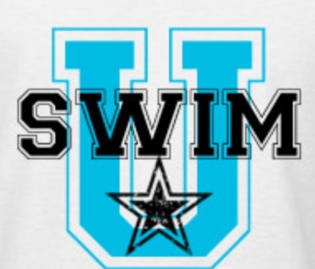

WHO? Brentwood HOME SCHOOL swim team is a non-competitive group that is geared towards swimmers who want to get or stay in competitive shape by learning the most up to date competitive techniques.

Beginner (14 & Under) M/W/F 1:15-2:00 PM
Intermediate (14 & Under) M/W/F 2:00-3:00 PM
Advanced (10 and Over) M/W/F 1:15-3:00 PM

THESE ARE NOT SWIM LESSONS!
SWIMMERS MUST COMPLETE 1 LAP FREESTYLE WITH FACE IN THE WATER TO PARTICIPATE IN BEGINNER GROUP, HAVE A WORKING KNOWLEDGE OF BREAST AND FLY FOR INTERMEDIATE GROUP AND COMPLETE 2 LAPS OF ALL FOUR STROKES TO PARTICIPATE IN ADVANCED

WHERE? Brentwood Indoor Sports Complex
920 Heritage Way
Brentwood, TN 37027

SESSION Session I no class Sept 21 Sept 5, 2018 – Nov 2, 2018
Session II no class Nov 19,21,23 Nov 5, 2018 – Dec 21, 2018 and 30, Dec 7
Session III no class Jan 11 Jan 7, 2019 – March 15, 2019
Session IV no class April 19 March 25, 2019- May 22, 2019

PRICE? $25 Registration Fee (1 time per year) *NEW - includes swim cap and t-shirt
Session I Wed only $75 2 days $140 3 days $200
Session II Wed only $50 2 days $100 3 days $140
Session III Wed only $80 2 days $160 3 days $240
Session IV Wed only $75 2 days $145 3 days $190

The Swim U program is a non-competitive training group designed as a transition from summer league to competitive team. Swimmers will learn competitive techniques in all four competitive strokes, turns and dives. High School Swimmers can receive a P.E credit for participating in Swim U.

Online registration at EXCELAQUATICS2.ORG opens July 15, 2018 and spots are LIMITED!
Please contact Dawn Van Ryckeghem at coachdawn@excelaquatics.org with questions.

