Williamson County Parks & Recreation
Summer Recreational Competitive Swim Team
Ages 5 – 18 Years
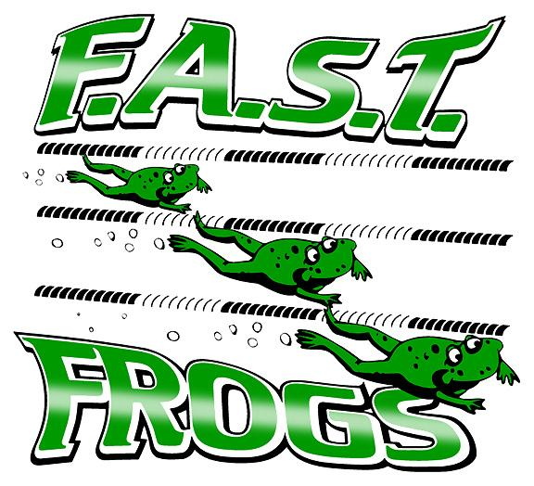
Franklin Area Swim Team 2016
Franklin Recreation Complex

REGISTRATION: February 15th-May 31st
Registration is now Online!!! www.excelaquatics.org

New Swimmer Evaluation and Returning Swimmer Practice - (1 week ONLY)
May 23rd-27th
Please come as many days this week as you can! Our season starts quickly!

Ages 6 and under 4:00-4:30
Ages 7 – 8 year olds 4:30-5:00
Ages 9-10 year olds 5:00-5:45
Ages 11 and up 5:45-6:30

ALL Swimmers MUST Meet the Following Swimming Levels to Participate on F.A.S.T.
(stroke does not need to look perfect, but there needs to be a demonstrated potential to learn the stroke)
8 & Under – Ability to swim entire length of the pool Freestyle
9 & 10year olds – Ability to swim entire length of pool Freestyle, Backstroke & Breaststroke
11 & Older – Ability to swim 2 lengths of pool Freestyle, Backstroke & Breaststroke
Meet Schedule
Tues., June 7th FYMCA @FAST
Tues., June 14th FAST @ Nolensville
Tues., June 21st FAST @ Comets
Tues., June 28th BYMCA @ FAST
Tues., July 5th FAST @ Longview

Championship Meet-July 15th- 16th Swimmers participate in one session of the 2 days. This meet is divided by age groups.
TEAM FEE
$140.00 per swimmer (includes team cap)
Team Suit—required
Purchase suits at:
All American Swim Supply Brentwood, TN
(615) 309-7636
NO Refunds after May 31st

Practice Schedule
May 30th -July 14th
Outdoor Pool
Monday – Friday (exception: Meet Days)
Ages 11 and Older 7:00am – 7:55am
Ages 9 & 10 7:55am – 8:40am
Ages 7 & 8 8:40am – 9:20am
Ages 6 & Under 9:20am – 9:50am

**SWIMMERS ARE REQUIRED TO PARTICPATE IN 3 SWIM MEETS**
Parent Participation is Required: Parents will be required to volunteer for a minimum of 3 meets plus the Championship Meet July 15th &16th .

Questions???? Please e-mail
Head Coach Christina Swart
fastcoaches@gmail.com

