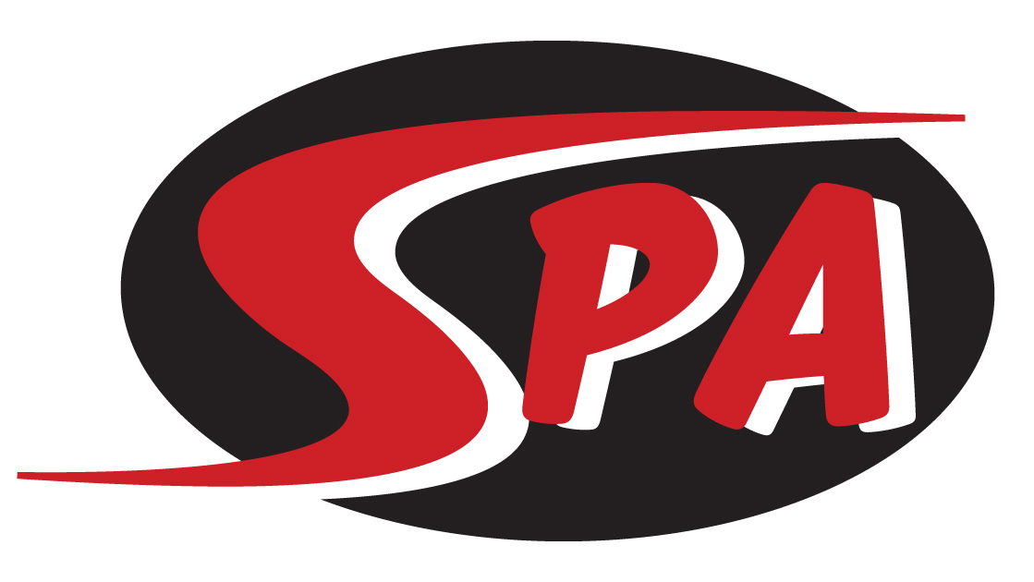
Bronze 1 Group

The Bronze 1 Group is for swimmers that are ages 7-10 that are competent in all four strokes. This group has competed in meets before, and has demonstrated a desire to take their swimming commitment to a more competitive level. Bronze 1 swimmers will continue to focus on technique while learning racing techniques and strategies to help them achieve at a higher level. Bronze 1 swimmers will work on season and long-term goals with their coach.

Practice & Meet Commitment
Bronze 1 Group workouts are offered 5 days a week for 1-1.25 hours. For best results we recommend coming to at least 4 workouts a week. Our practices are focused on stroke technique and race strategies and dry land will continue to build on core strength, coordination and flexibility while introducing body weight exercises. Swim meets are a key part of the commitment for Bronze 1. All meets are posted on the SPA website under the “Meets” tab and are typically 1-2 times per month. Bronze 1 swimmers are encouraged to attend as many meets as possible, including championship meets each season.

Group Expectation
Swimmers placed in Bronze 1 will be able to:
- Swim a legal Freestyle, Backstroke, Breaststroke, and Butterfly
- show a track record of meet participation
- Complete 6 x 50 Free on an interval
- Complete 6 x 50 Kick on an interval

Swimmers in Bronze 1 are expected to:
- attend 4-5 workouts per week.
- work toward achieving “BB” and “A” National Motivational Times as well as Gulf Age Group and TAGS time standards
- compete in Gulf Championship meets in December, February and July

Next Steps
From Bronze 1 swimmers will be moved to the Silver 1 or Silver 2 groups as they progress. Moves to these groups may happen when the swimmer is turning 10 or 11.

Training equipment - Required
- Mesh Equipment Bag
- Goggles (2 pairs)
- Fins
- Kick Board
- Pull Buoy
- Swim Cap
- Practice Suits – no board shorts of two-piece suits
- Water Bottle
- Athletic Shoes and clothes for Dry Land

Competition Apparel – Required

- SPA Racing Suit
- SPA Swim Cap
- SPA T-shirt and/or SPA warm ups.

($130 per month includes facility fee)

